
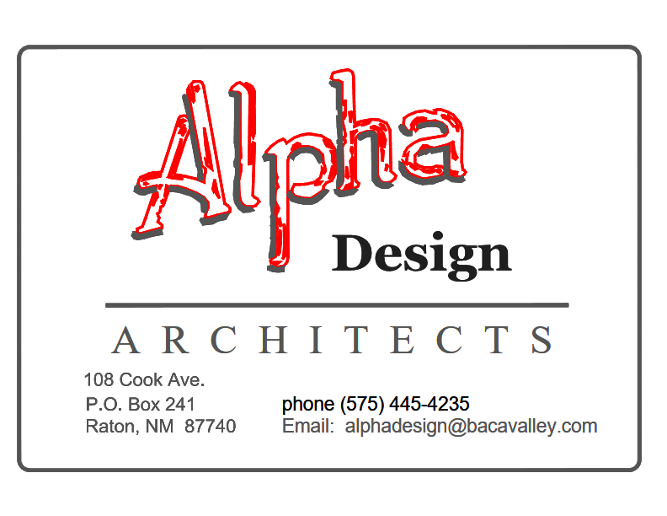
Contents
Executive Summary 7
Part One: ADA Overview 7
Site Map #1 19
Site Map #2 20
General Prioritization Method 21
Curb Ramp Prioritization Method 21
Part Two: First and Third Street Right of Way; Raton Jurisdiction 22
2.A. First and Third Street Right of Way (City Jurisdiction) General Notes 22
2.B. Downtown City Right-Of-Way Pedestrian Path Surfaces 23
2.C. Downtown City Right-Of-Way Accessible Parking 24
2.D. Second Street Right-Of-Way Detectable Warning Surfaces at Crosswalks 26
2.E. First Street Right-Of-Way 300 block N. 1st Street Including adjacent Savage Ave. 27
2.F. First Street Right-Of-Way 200 Block North First St. including Clark Ave 27
2.G. First Street Right of Way100 Block North First Street 28
2.H. First Street Right of Way 100 block South First Street & adjacent Cook Ave. 29
2.I. First Street Right-Of-Way 200 North First St. including adjacent Rio Grande Ave. 29
Part Three: Second Street Right of Way NMDOT Jurisdiction 29
3.A. General Notes 29
3.B. Second Street Right-Of-Way Pedestrian Path Surfaces 31
3.C. Second Street Right-Of-Way Pedestrian Path Width 31
3.D. Accessible Parking on and near Second Street Between Savage Avenue and Rio Grande Avenue. 32
3.E. Second Street Right-Of-Way Crosswalks with Pedestrian Signal Heads 33
3.F. Second Street Right of Way Curb Ramps, top landing obstructed by location of pole 34
3.G. Recommendation to leave Second Street Planter Undisturbed 34
3.H. Second Street Right-Of-Way Curb Ramps at Crosswalks 35
3.I. Second Street Right-Of-Way Detectable Warning Surfaces at Crosswalks 38
3.J. Second Street North Right-Of-Way 400 block N. 2nd Street, Sidewalk Cracked and Buckled 38
3.K. Second Street Right-Of-Way 300 block N. 2nd Street Including adjacent railroad underpass and east side of underpass 39
3.K. Second Street Right-Of-Way 42
3.K.1 200 block N. 2nd Street 42
3.K.2. Second Street Right-Of-Way 100 block N. 2nd Street 42
3.K.3. Second Street Right-Of-Way 100 block S. 2nd Street 42
3.K.4. Second Street Right-Of-Way 200 block S. 2nd Street 44
3.K.5 Second Street Right-Of-Way 300 block S. 2nd Street 44
3.K.6. Second Street Right-Of-Way 400 block S. 2nd Street 45
3.K.7. Second Street Right-Of-Way 500 block S. 2nd Street 46
3.K.8. Second Street Right-Of-Way 600 block S. 2nd Street 46
3.K.9. Second Street Right-Of-Way 700 block S. 2nd Street 47
3.K.10. Second Street Right-Of-Way 800 block S. 2nd Street 48
3.K.11. Second Street Right-Of-Way 900 block S. 2nd Street 49
3.K.12. Second Street South Right-Of-Way 900 block S. 2nd Street 51
3.K.13. Second Street Right-Of-Way 1000 block S. 2nd Street 51
3.K.14. Second Street Right-Of-Way 1100 block S. 2nd Street 56
3.K.15. Second Street Right-Of-Way 1200 block S. 2nd Street 57
3.K.16. Second Street Right-Of-Way 1300 block S. 2nd Street 59
3.L. Third Street Right-Of-Way 61
3.L.1. Third Street Right-Of-Way300 block N. 3rd Including adjacent Savage Ave. 61
3.L.2. Third Street Right-Of-Way 200 block N. 3rd Including adjacent Clark Ave. 62
3.L.3. Third Street Right-Of-Way 100 block N. 3rd Including adjacent Park Ave. 63
3.L.4. Third Street Right-Of-Way 100 block S. 3rd Including adjacent Cook Ave. 64
3.L.5. Third Street Right-Of-Way 200 block S. 3rd Including adjacent Rio Grande Ave. 64
3.L.6. Third Street Right-Of-Way 300 block S. 3rd Including adjacent Apache Ave. 65
Part Four: Parks 67
4.A Climax Canyon 67
4.B. Legion Park 67
4.C. Optimist Park 72
4.D. Tennis and Pickle Ball Courts 75
4. E. Ripley Park 76
4.F. Romero Park 79
4.G. Roundhouse Memorial Park 82
4.H. Veteran’s Park 86
Part Five: City Facilities 88
5.A. Raton Animal Shelter 88
5.B. Aquatic Center 89
5.C. Raton City Hall 93
5.D. City Administration Building 101
5.E. Raton Convention Center 105
5.F. Fire and Emergency Station #1 111
5.G.Fire and Emergency Station #2 113
5.H. Fire and Emergency Station #4 116
5.I. Kearney School/El Raton Media Works 119
5.J. Arthur Johnson Memorial Library 119
5.K. Parish Hall 124
5.L. Raton Senior Center 127
5.M. Shuler Theater 130
5.N. Transportation – Raton Municipal Airport 137
5.O. Transportation – Raton Bus Stop 141
5.P. Transportation – Raton Amtrak Station 142
5.L.Visitor Center 145
Part Six: Itemized Correction Priority Table 152
Part Seven: Grievance Procedures 168
7.A. Draft ADA Public Notice 168
7.B. The Americans With Disabilities Act (ADA) Public Notice 168
7.C.Draft ADA Grievance Procedure 169
7.D. The Americans With Disabilities Act (ADA) Grievance Procedure 169
7.E. Sample ADA Grievance Form 171
7.F. Public Outreach 173

Executive Summary

Part One: ADA Overview

Introduction to the ADA Transition Plan, Raton, New Mexico
This Self-Evaluation Report for an ADA Transition Plan prepared for the City of Raton, New Mexico in 2025 is intended to identify where the Americans With Disabilities Act (ADA) of 1990 can be more fully complied with by way of the services currently provided by the city and at indoor and outdoor facilities owned and operated by the City of Raton.
The Americans with Disabilities Act (ADA) of 1990 is a civil rights law prohibiting discrimination based on someone’s disability. According to Title II of the Act, municipalities are required to have a plan to make accommodations accessible for everyone. The City of Raton is committed to city- wide ADA compliance.
The purpose of the Transition Plan is to provide the framework for achieving equal access to the City of Raton’s Programs, Services, and Activities (PSAs) within a reasonable timeframe. The City's elected officials and staff believe that accommodating people with disabilities is essential to ensure the quality of life that residents seek to enjoy. This self-evaluation Report for the ADA Transition Plan has been prepared after careful study of all the City's programs, services, activities, and evaluations of the City facilities that are most used and enjoyed by the general population.
North Central New Mexico Economic Development District (NCNMEDD) based in Santa Fe NM contracted with Alpha Design based in Raton NM to conduct surveys and prepare this Report for the City of Raton. NCNMEDD is an association of local government entities and other organizations created to encourage and allow regional cooperation on a multitude of issues in the eight counties of Colfax, Los Alamos, Mora, Rio Arriba, San Miguel, Sandoval, Santa Fe, and Taos.
This Self-Evaluation Report provides the City of Raton with a list of improvements that are to be completed to meet current standards, and projected cost estimates. The ADA Transition Plan will be an integral component in the overall short term and long term planning for the City.
This Transition Plan and Self Evaluation does not demand that the City address every item noted and does not instruct the City Administration or others about the order that corrections should be made or identify how to fund corrections. It is up to the City Administration to determine if and how to address the items noted in this Evaluation. As the Administration reviews this ADA Plan and Self Evaluation then begins implementation of the Raton ADA Transition Plan the City may determine that:
- Some of the items noted are an undue burden to the City until a major alteration to the program or facility is planned and budgeted.
- Some services, activities, or facilities will be left unaltered in the short term or long term because the non-complying items or features are not severely out of compliance and the City determines that it is more productive to address more urgent ADA compliance with the available resources over time.
- Altering a facility for accessibility is not needed when the public or disabled staff don’t use the affected parts of a facility. When the City Administration determines that corrections are not readily achievable, especially in facilities that were constructed before 1991 when ADA first became law, ADA allows the non- compliance to remain until a facility or the non-complying component is significantly altered. If this happens then the City Administration might conclude that the activities and services provided at that facility should be altered or moved to another location to better provide accessibility.

Americans With Disabilities Act
Millions of Americans have disabilities. People with disabilities in Raton, like all Americans, participate in a variety of programs, services, and activities provided by the City. People with disabilities have often been excluded from enjoying basic civic activities like using public transportation, participating in public activities, serving on public boards or committees, or simply attending public and school events. The Americans with Disabilities Act (ADA) is a Federal civil rights law that prohibits discrimination against people with disabilities. Under the ADA, people with disabilities are entitled to all the rights, privileges, advantages, and opportunities that others have when participating in civic activities.

The Americans with Disabilities Act (ADA) became effective on July 26, 1990 and it extended legislation intended to eliminate discrimination against individuals with disabilities in federally funded facilities under the Rehab Act to all activities of State and local governments regardless of whether these entities receive Federal financial assistance. It provides for equal access and equal opportunities for individuals with disabilities to participate in programs, services, and activities provided by public entities such as those offered by the City of Raton.

The ADA is divided into five sections, which are referred to as titles.
- Employment (Title I) Title I requires covered employers to provide reasonable accommodations for applicants and employees with disabilities and prohibits discrimination on the basis of disability in all aspects of employment. Reasonable accommodation includes, for example, restructuring jobs, making worksites and workstations accessible, modifying schedules, providing services such as interpreters, and modifying equipment and policies. Title I also regulates medical examinations and inquires.
- Public Services (Title II) Under Title II, public services (which include state and local government agencies) cannot deny services to people with disabilities or deny participation in programs or activities that are available to people without disabilities. In addition, public transportation systems, such as public transit buses, must be accessible to individuals with disabilities.
- Public Accommodations (Title III) Public accommodations include facilities such as restaurants, hotels, grocery stores, retail stores, etc., as well as privately owned transportation systems. Title III requires that all new construction and modifications must be accessible to individuals with disabilities. For existing facilities, barriers to services must be removed if readily achievable.
- Telecommunications (Title IV) Telecommunications companies offering telephone service to the public must have telephone relay service to individuals who use telecommunication devices for the deaf (TTYs) or similar devices.
- Miscellaneous (Title V) This title includes a provision prohibiting either (a) coercing or threatening or (b) retaliating against individuals with disabilities or those attempting to aid people with disabilities in asserting their rights under the ADA. The US Department of Justice (DOJ) revised its regulations implementing the ADA in September 2010. The new rules clarify issues that arose over the previous 20 years and contain new requirements, including the 2010 ADA Standards for Accessible Design (2010 Standards). This document provides general guidance to assist State and local governments in understanding and complying with the ADA's requirements.
For more comprehensive information about specific requirements, the public and City officials can consult the ADA title II regulations, the 2010 ADA Standards for Accessible Design, and the Department of Justice ADA technical assistance publications.

ADA and its Relationship to Other Laws
Title II of ADA is companion legislation to two previous federal statutes and regulations: the Architectural Barriers Act (ABA) of 1968 and Section 504 of the Rehabilitation Act of 1973.
The Architectural Barriers Act of 1968 is a Federal law that requires facilities designed, built, altered, or leased with Federal funds to be accessible.
Section 504 of the Rehabilitation Act of 1973 is a Federal law that protects qualified individuals from discrimination based on their disability. The nondiscrimination requirements of the law apply to employers and organizations that receive financial assistance from any Federal department or agency. Title II of ADA extended this coverage to all state and local government entities, regardless of whether they receive federal funding or not.

Federal Accessibility Requirements
The US Access Board was established by section 502 of the Rehabilitation Act of 1973 (Rehab Act). The Board consists of 25 total members made up of heads of some Federal agencies and of disabled members of the public. Originally, the Access Board was established to develop and maintain accessibility guidelines for facilities designed, constructed, altered, or leased using Federal funds under the Architectural Barriers Act of 1968 (ABA). The passage of the ADA in 1990 expanded the Access Board’s responsibilities to “issue minimum guidelines that shall supplement the existing Minimum Guidelines and Requirements for Accessible Design to ensure that buildings, facilities, rail passenger cars, and vehicles are accessible, in terms of architecture and design, transportation, and communication, to individuals with disabilities”
The US Department Of Justice (DOJ) issues and enforces accessibility standards applicable to facilities subject to ADA title II that are consistent with the “minimum guidelines’’ issued by the Access Board.
The Access Board began revising their 1990 standards in 1994 by establishing an advisory committee composed of members of the design and construction industry, the building code community, and State and local government entities, as well as individuals with disabilities. In 1998 the Access Board added specific guidelines on State and local government facilities and building elements designed for use by children. Other updates to the 1990 ADA Standards have been made with the final version being compiled in the 2004 ADA/ABA Guidelines. The 2004 ADA/ABA Guidelines were the culmination of a long-term effort to facilitate ADA compliance by eliminating inconsistencies among Federal accessibility requirements (ADA C ABA Standards) and between Federal accessibility requirements and State and local building codes. In support of this effort, the US DOJ amended its regulation implementing title II and adopted standards consistent with 2004 ADA/ABA Guidelines, naming them the 2010 ADA Standards for Accessible Design which this Self-Evaluation Report is mostly based on when reviewing facilities for compliance.
On March 15, 2011, the final rule on the 2010 ADA Standards for Accessible Design became effective to revise the 1990 regulations that implement title II of the ADA that prohibits discrimination on the basis of disability in State and local government services. The final rule was issued to adopt enforceable accessibility standards under the ADA that are more consistent with the minimum guidelines and requirements issued by the Access Board, and to update or amend certain provisions of the title II regulation so that they better reflect the Department’s legal and practical experiences in enforcing the ADA since 1991. These new regulations provide a higher degree of clarity to State and local agencies who put forth the effort to comply with the spirit and intent of the ADA.

ADA Self-Evaluation and Transition Plan Requirements
Title II of the ADA applies to all State and local governments and all departments, agencies, special purpose districts, and other instrumentalities of State or local government (“public entities”). It applies to all programs, services, or activities of public entities, from adoption services to zoning regulation. Title II entities that contract with other entities to provide public services, such as non- profit organizations that operate drug treatment programs, also have an obligation to ensure that their contractors do not discriminate against people with disabilities.
Access to civic life by people with disabilities is a fundamental goal of the Americans with Disabilities Act (ADA). To ensure that this goal is met Title II of the ADA requires Raton to make its programs and services accessible to persons with disabilities. This requirement extends not only to physical access at Raton government facilities, programs, and events -- but also to policy changes that Raton is expected make to ensure that all people with disabilities can take part in and benefit from City programs and services. In addition the City must ensure effective communication -- including the provision of necessary auxiliary aids and services -- so that individuals with disabilities can participate in the City’s civic activities.

ADA Title II Exceptions
The ADA does not require the City to make each existing facility accessible. Title II requires city governments to ensure that all their programs, services, and activities, when viewed in their entirety, are accessible to people with disabilities. Program access is intended to remove physical barriers to city services, programs, and activities, but it generally does not require that a city government make each facility, or each part of a facility, accessible. For example, each restroom in an existing facility does not need to be made fully accessible. However, signage directing people with disabilities to the accessible features and spaces in a facility should be provided.
Program accessibility may be achieved in a variety of ways. City governments may choose to make structural changes to existing facilities to achieve access, or City governments can also pursue alternatives to structural changes to achieve program accessibility. For example, city governments can move public meetings to accessible buildings and can relocate services for individuals with disabilities to accessible levels or parts of buildings. When choosing between possible methods of program accessibility, however, city governments must give priority to the choices that offer services, programs, and activities in the most integrated setting appropriate. In addition, all newly constructed city facilities must be fully accessible to people with disabilities.
- ADA does not require the City to fundamentally alter services, programs, or activities
- ADA does not require the City to create hazardous conditions
- ADA does not require the City to incur undue Financial and administrative burden
- ADA does not require anything that impacts the historic significance of historic property.

When programs, services, or activities are located in City facilities, the City must make sure that they are also available to persons with disabilities, unless to do so would fundamentally alter a program, service, or activity or result in undue financial or administrative burdens. When a service, program, or activity is located in a building that is not accessible the City government can achieve program accessibility in several ways. It can:
- Relocate the program or activity to an accessible facility.
- Provide the activity, service, or benefit in another manner that meets ADA requirements, or
- Make modifications to the building or facility itself to provide accessibility.

Historic Properties
The ADA does not require physical changes to a historical property that impacts the historic significance of the property. Historically significant facilities are those facilities or properties that are listed or eligible for listing in the National Register of Historic Places or properties designated as historic under State or local law. Structural changes to these facilities that would threaten or destroy the historical significance of the property or would fundamentally change the program being offered at the historic facility need not be undertaken. Nevertheless, a city must consider alternatives to structural changes in these instances, including using audio-visual materials to depict the inaccessible portions of the facility and other innovative solutions.

Programs and Services Viewed in Their Entirety
Title II of the ADA requires that programs must be accessible when “viewed in their entirety.” A key concept is that public programs and services, when viewed in their entirety, must be accessible to people with disabilities, but not all facilities must necessarily be made accessible. For example, if a city has multiple public swimming pools and limited resources, it can decide which pools to make accessible based on factors such as the geographic distribution of the sites, the availability of public transportation, the hours of operation, and the programs offered at each site so that the swimming program is accessible to and usable by people with disabilities.

Fundamental Alteration of a Service or Program
A fundamental alteration is a modification that is so significant that it alters the essential nature of the goods, services, facilities, privileges, advantages, or accommodations offered. If a public entity can demonstrate that the modification would fundamentally alter the nature of its service, program, or activity, it is not required to make the modification. Example: If a city requires a 12-foot set-back from the curb in the central business district, it may be reasonable to grant a 3-foot variance resulting in a 9-foot setback for a store wishing to install a 3-foot wide ramp at its entrance to meet its ADA obligations. If the set-back is smaller and the ramp would obstruct pedestrian traffic, granting the variance may "fundamentally alter" the purpose of the public sidewalk

Undue Financial and Administrative Burden
Undue burden is described as requiring significant difficulty or expense to make a service or program accessible to people with disabilities. While it is rare that the City may not be able to provide program access, there are some instances where it is permissible under the ADA. Program access does not require each facility be made physically accessible, in all instances. However, physical accessibility is a requirement for new facilities intended to house City programs. The City is not required to incur undue financial or administrative burden. If a public entity believes that a modification to a service or program to achieve accessibility would fundamentally alter the service or program or would result in an undue burden, then the public entity has the burden of proving that it would result in a fundamental alteration of the service or an undue burden. That decision must be made by the head of the public entity or his or her designee after considering all the resources available for use in the funding and operation of the service program or activity and must be accompanied by a written statement of the reasons for reaching that decision. Even if there is a conclusion of undue burden, the City will still need to perform all other remediations that would not result in an undue burden but would improve accessibility to the maximum extent possible.

ADA Requirements for the City of Raton
Under Title II the City of Raton must meet these general requirements:
- Must operate their programs so that, when viewed in their entirety, the programs are accessible to and useable by individuals with disabilities.
- May not refuse to allow a person with a disability to participate in a service, program, or activity simply because the person has a disability.
- Must make reasonable modifications in policies, practices and procedures that deny equal access to individuals with disabilities unless a fundamental alteration in the program would result.
- May not provide services or benefits to individuals with disabilities through programs that are separate or different unless the separate or different measures are necessary to ensure that benefits and services are equally effective.
- Must take appropriate steps to ensure that communications with applicants, participants, and members of the public with disabilities are as effective as communications with others.
- Must designate at least one responsible employee to coordinate ADA compliance. This person is typically referred to as the ADA Coordinator. The public entity must provide the ADA Coordinator's name, office address, and telephone number to all interested individuals.
- Must provide notice of ADA requirements. All public entities, regardless of size, must provide information about the rights and protections of Title II to applicants, participants, beneficiaries, employees, and other interested persons. The notice must include the identification of the employee serving as the ADA Coordinator and must provide this information on an ongoing basis.
- Must establish a grievance procedure. Public entities must adopt and publish grievance procedures providing for prompt and equitable resolution of complaints. This requirement provides for a timely resolution of all problems or conflicts related to ADA compliance before they escalate to litigation and/or the federal complaint process.

Physical Access and Program Access
Physical access requires a facility be free of physical barriers and conditions preventing participation. Program access is defined by ADA Title II, Section 35.150(a)3 and may include physical accessibility but also covers policies, practices, communications, and procedures.

Designation of Responsibility
In accordance with 28 CFR 35.107(a), the City of Raton has designated Jaden Welch to serve as ADA Title II Coordinator to oversee the City's policies and procedures, and as ADA Transition Plan Implementation Coordinator to monitor the City’s progress and manage review and updates of this document.

ADA Self-Evaluation and Transition Plan Overview
Under Title II of the ADA, public entities are required to perform a self-evaluation of their current services, policies, and practices regarding accessibility. The goal of the self-evaluation is to verify that, in managing its programs and facilities, the City of Raton is providing accessibility and not adversely affecting the full participation of individuals with disabilities.
The intent of this ADA self-evaluation is to review the City of Raton’s entire public program including all facilities on public property and within public rights-of-way, and to identify any obstacles or barriers to accessibility that need to be addressed. The general categories of items to be evaluated include:
- Communications, Information C Facility Signage.
- Building Facilities – these include offices, parks, garages, and other types of buildings.
- Pedestrian Facilities (Pedestrian Circulation Routes / Pedestrian Access Routes) – these include sidewalks, curb ramps, bicycle/pedestrian trails, and traffic control signals that are located within the City’s rights-of-way.

Public entities are required to provide an opportunity for interested persons, including individuals with disabilities or organizations representing individuals with disabilities, to participate in the self- evaluation process by submitting comments.
Furthermore, a public entity that employs 50 or more persons is required, for at least three years following the completion of the self-evaluation, to maintain on file and make available for public inspection:
- A list of the interested persons consulted.
- A description of areas evaluated, and any problems identified.
- A description of any modifications made.

Scope of Raton’s ADA Self-evaluation and Transition Plan is a comprehensive evaluation of its policies, programs, and facilities to determine the extent to which individuals with disabilities may be restricted in their access to City services and activities. This document describes the process developed to complete the evaluation of the City’s activities, provides policy and program recommendations, and presents a Transition Plan for the modification of facilities, public rights-of way, and programs to ensure accessibility, which will guide the planning and implementation of necessary program and facility modifications over the next 10 years. The ADA Self-evaluation and Transition Plan is significant in that it establishes the City’s ongoing commitment to the development and maintenance of policies, programs, and facilities that include all of the Raton community.

Transition Plan Management
This Transition Plan is a living document that will continue to be updated as conditions within the City evolve. The initial schedule is to formally review the complete document (main body and appendices) at least once per year, to identify any need for updates. Updates to the appendices or attachments may be made more frequently as needed. Any major updates to the main body of this document will include a public comment period to continue the City's public outreach efforts.
The City of Raton recognizes that ADA compliance is an ongoing responsibility which will require monitoring to identify future accessibility issues that may be encountered. For example, facilities that currently meet ADA requirements could fall out of compliance in the future due to factors such as damage, disrepair, or changes within public rights-of-way that could create new accessibility obstacles. Therefore, the ADA Title II Coordinator and Transition Plan Implementation Coordinator will establish an on-going monitoring/inspection program or process to ensure that facilities continue to comply with ADA requirements. City employees will also be encouraged to report any accessibility concerns or deficiencies that are identified.

Funding Sources
Some of the potential funding sources for ADA compliance are included on the following page

SITES | FUNDING  SOURCES
Curb Ramps,  Streets | RTP,TAP,CMAQ, CRP  www.dot.nm.gov/planning-research-multimodal-and-safety/planning-division/multimodal-planning-and-programs-bureau/ | Capital Outlay  www.nmdfa.State.nm.us/dfa-dashboards/capital-outlay-dashboard/ | Highway Safety Improvement Program www.highways.dot.gov/safety/hsip | Transportation Project Fund  www.dot.nm.gov/business-support/project-oversight-division/ | Local Government Road Fund  www.dot.nm.gov/business-support/project-oversight-division/
Parks | RTP,TAP,CMAQ, CRP  www.dot.nm.gov/planning-research-multimodal-and-safety/planning-division/multimodal-planning-and-programs-bureau/ | Trails+-https://nmoutside.com/grants/trails-plus/ | Que Linda  https://www.dot.nm.gov/que-linda/ | City Park Improvements Program-https://www.nmdfa.state.nm.us/local-government/grants/7-5m-city-park-improvements-program | Land and Water Conservation Fund-https://www.doi.gov/lwcf
Facilities | Community Development Block Grants  https://www.hud.gov/hud-partners/community-cdbg | New Mexico Department of Homeland Security & Emergency Management  https://www.dhsem.nm.gov/grants/ | Capital Outlay  www.nmdfa.State.nm.us/dfa-dashboards/capital-outlay-dashboard/ | Community Facilities Direct Loan and Grant Program  https://www.rd.usda.gov/programs-services/community-facilities/community-facilities-direct-loan-grant-program
Schuler Theater & other Historic Buildings | New Mexico Historic Preservation Division https://nmhistoricpreservation.org/ | Chronicle Heritage  https://www.chronicleheritage.com | National Park Service  https://www.nps.gov/subjects/historicpreservationfund/project-grants.htm
Raton Airport | FAA Support to Rural Communities--https://www.faa.gov/rural | FAA Airport Terminal Program  Infrastructure Investment and Jobs Act - Airport Terminals Program | Federal Aviation Administration
Other | Build America Bureau  https://www.transportation.gov/buildamerica/ | Rural Economic Development and Loan Program--https://www.rd.usda.gov/programs-services/business-programs/rural-economic-development-loan-grant-programs | New Mexico Main Street https://edd.newmexico.gov/community-development/mainstreet-program/ | Local Economic Assistance And Development Support https://edd.newmexico.gov/community-development/leads/ | T-Mobile Hometown Grant-https://mainstreet.org/about/partner-collaborations/t-mobile-hometown-grants

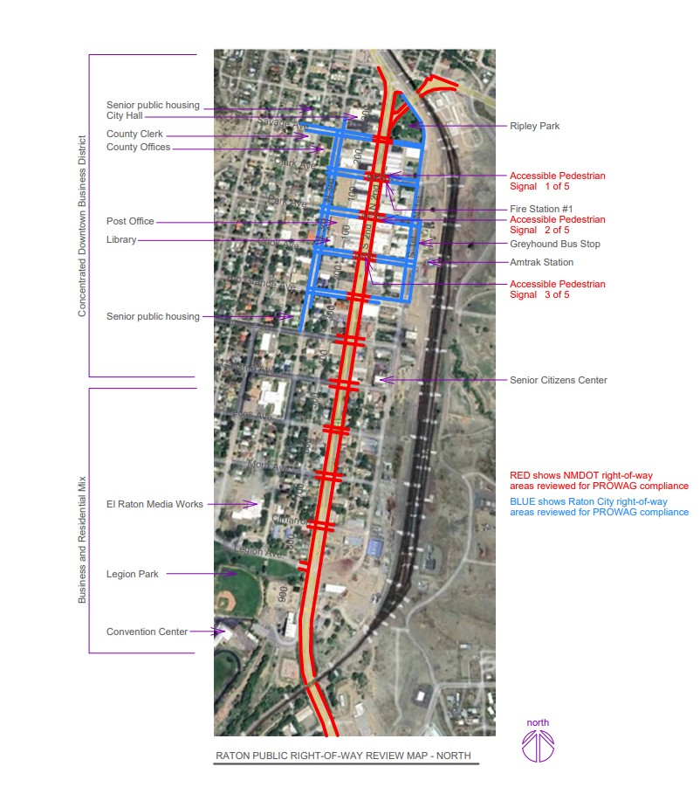
Site Map #1

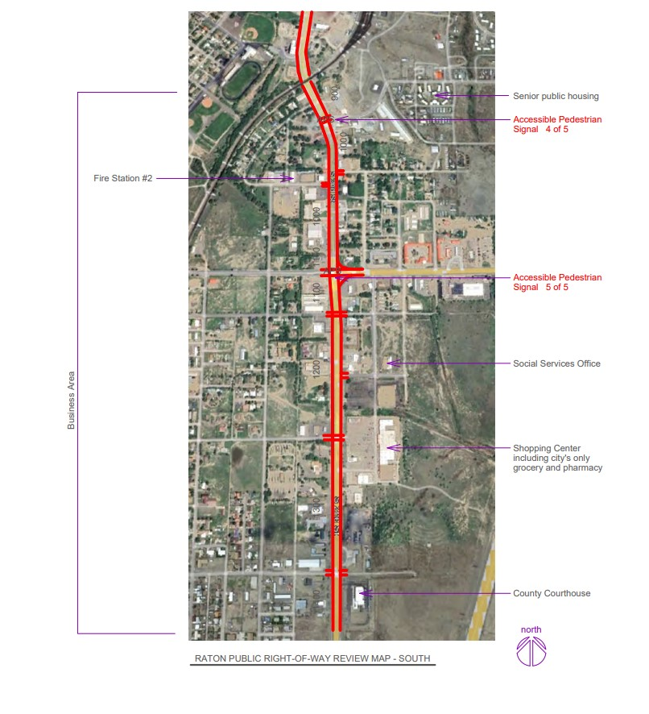
Site Map #2

General Prioritization Method
Prioritization for addressing the non-compliant issues are assigned by evaluating how much the non-compliance negatively affects a user’s ability to access public facilities and services, the number and frequency of users likely negatively affected, and how achievable the corrections are.
Subject to funding and other factors it is suggested that the priorities be accomplished in the following order:
Priority 1 (highest priority) within 2 years
Priority 2 within 5 years
Priority 3 within 10 years
Priority 4 within 15 years
Priority 5 (lowest priority) within 20 years
Alterations with priorities 2 through 5 will need to be addressed over several years. For instance, items listed as priority 5 will need to be addressed over 20 years and cannot all be put off until the 20th year.
The Raton ADA Coordinator may find over time that new items need to be added or priorities need to be changed due to a change in a City program or facility use, or due to facility repairs and alterations not currently anticipated.

Curb Ramp Prioritization Method
Adapted from ADA Transition Plans : A Guide to Best Management Practices
Highest
PRIORITY 1A Existing Curb Ramp with Running Slope Greater than 12% and Location near a Hospital, School, Transit Stop, Government Building, or Similar Facility
PRIORITY 1B No Curb Ramp where Sidewalk or Pedestrian Path Exists and Location near a Hospital, School, Transit Stop, Government Building, or Similar Facility
PRIORITY 2A An Existing Curb Ramp with a Running Slope Greater than 12% (Not Located near a Hospital or Similar Facility)
PRIORITY 2B No Curb Ramp where a Sidewalk or Pedestrian Path Exists (Not Located near a Hospital or Similar Facility)
PRIORITY 3 No Curb Ramp where a Striped Crosswalk exists
PRIORITY 4 One Curb Ramp per Corner and Another is Needed to Serve the Other Crossing Direction
PRIORITY 5A An Existing Curb Ramp with either a Running Slope Greater than 1 to 12 or an Insufficient Landing
PRIORITY 5B An Existing Curb Ramp with Obstructions in the Ramp or Landing
PRIORITY 5C An Existing Curb Ramp with any of the Following Conditions:
- A Cross Slope Greater than 3%
- A Width Less Than 36 Inches
- No Flush Transition, or a Median or Island. Crossings that are Inaccessible
PRIORITY 5D An Existing Curb Ramp with Returned Curbs where Pedestrian Travel Across the Curb is not Permitted
PRIORITY 5E An Existing Diagonal Curb Ramp with the 48 inch Extension in the Crosswalk
PRIORITY 5F An Existing Curb Ramp without Truncated Dome Texture Contrast or without Color Contrast
LOWEST The Pedestrian Push Button is not Accessible from the Sidewalk or from the Ramp

Part Two: First and Third Street Right of Way; Raton Jurisdiction

2.A. First and Third Street Right of Way (City Jurisdiction) General Notes
This portion of the Americans With Disabilities Act (ADA) Transition Plan highlights the non- compliant portions of pedestrian access routes (sidewalks and crosswalks) in the most heavily pedestrian trafficked areas of the Raton Downtown Historic District except for Second Street which is owned and generally maintained by the NM Department of Transportation. Second Street is reviewed in a separate portion of this Transition Plan.
This portion of the ADA Transition Plan reviews the city owned right-of-ways bounded by Third Street on the west, Savage Avenue on the north, First Street on the east, and Rio Grande Avenue on the south.
The same as with older business areas in most other towns, it is rarely feasible to fully comply with ADA requirements for running slopes, cross slopes, and other conditions due to the floor height of adjacent buildings, the elevation of the streets, normal wear and weathering on the walking surfaces, and other factors. It is the intent of this ADA Transition Plan to identify the items that are the most out of compliance which potentially most inhibit use by the disabled population and identify the non-compliant items which are more readily achievable to correct. Non-compliant items which were deemed to be an undue burden or technically not feasible to correct are not identified in this ADA Transition Plan.
The requirements for ADA compliance in the public street right-of-way is found primarily in the 2024 Public Right-Of-Way Accessibility Guidelines (PROWAG) issued by the US Access Board.
PROWAG R101.4 indicates:
“These guidelines do not address existing pedestrian facilities unless the pedestrian facilities are altered at the discretion of a covered entity. The Department of Justice has authority over existing facilities that are subject to the requirement for program access under
title II of the ADA. Any determination that this document applies to existing facilities subject to the program access requirement is solely within the discretion of the Department of Justice and is effective only to the extent required by regulations issued by the Department of Justice.”
However ADA also requires that readily achievable corrections be done when reasonably possible.

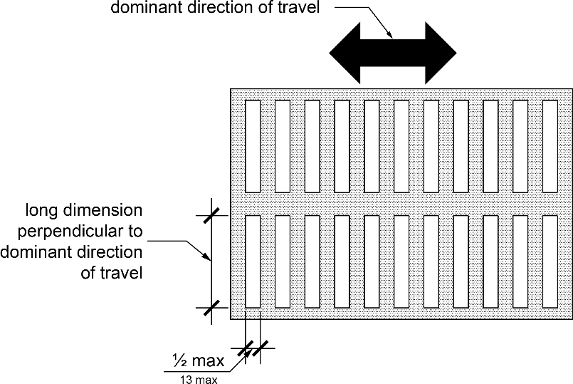
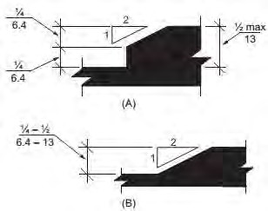
2.B. Downtown City Right-Of-Way Pedestrian Path Surfaces

Allowable vertical offsets and gaps in an accessible pedestrian path of travel
With few exceptions the City owned sidewalks, curb ramps, and crosswalks are in fair to poor condition because of their ages and are in need of replacement. Unlike Second Street which is in overall much better condition and more compliant, there are far too many non-complying locations to identify every place in the City right-of-way that has cracked concrete or settling/heaving concrete causing offsets in the walking surfaces. This review of City right-of ways in parts of the Downtown District is intended to focus on the most out of compliance and missing or non-compliant features.
2024 Public Right-Of-Way Accessibility Guidelines (PROWAG) limits vertical offsets and gaps in the accessible pedestrian path surface as shown below.
Projected cost of correction: $200,000
Priority 5 due to the high number of locations with the non-compliant conditions, how most locations are not adjacent to public buildings or healthcare facilities, and how most non-compliant items are not far out of compliance.

2.C. Downtown City Right-Of-Way Accessible Parking

There is little off-street parking available in the described area so on-street accessible parking is required in each block.
The Second Street parking review found in a separate portion of this ADA Transition Plan suggests providing accessible parking spaces near the Second Street intersections. 2024 Public Right-Of- Way Accessibility Guidelines (PROWAG) R211 requires for every 25 parking spaces that at least one of the 25 spaces should be an accessible parking space with an access aisle beside the accessible space with few exceptions. Since each city block has approximately 50 on-street parking spaces (not including Second Street parking) PROWAG requires at least two accessible parking spaces per block in addition to the accessible parking near the Second Street intersections described in the Second Street right-of-way review.

Maintained accessible on-street parking is currently only found at 3rd and Park (post office) and 3rd and Cook (library). Accessible parking used to be marked and maintained at other locations which in most cases now lack signs and pavement markings.
PROWAG R310 requires that accessible spaces be located so that the marked access aisle beside each accessible parking space be located when possible on the passenger side of the parked vehicle, and located so that the access aisle is located next to a curb ramp or crosswalk so that the user doesn’t have to enter the road lane to reach the sidewalk or crosswalk. Other requirements are found in PROWAG such as dimensions, signs, markings, and allowable slopes.
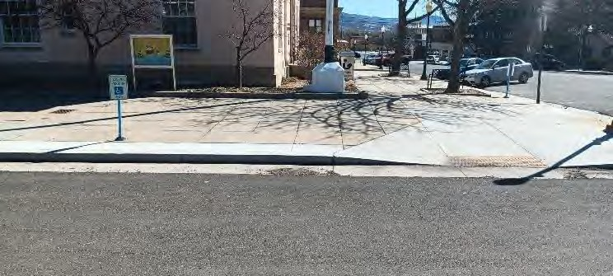
Pictured above existing designated accessible parking near the intersection of South Third Street and Cook Avenue is a complying location since the surface is relatively level and the passenger side of the accessible space is next to a curb ramp. However, the space lacks pavement markings identifying the accessible space and adjacent access aisle, and the pole sign is approximately 2 feet above the sidewalk surface. PROWAG R310.2.5 requires the bottom of the sign to be 5 feet above the sidewalk surface.
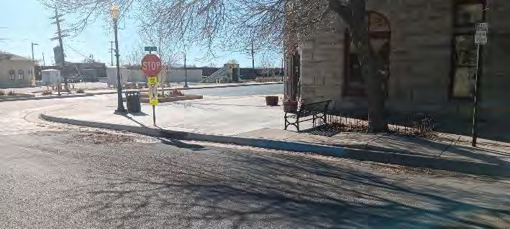
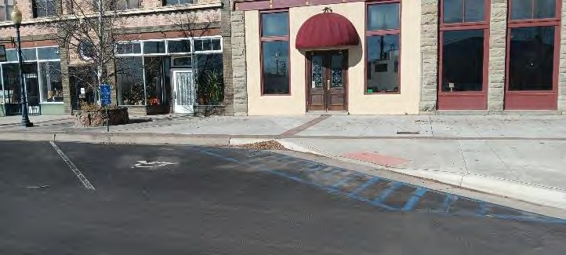
Pictured, above, parking spaces respectively located at the intersection of South First Street and Cook Avenue, and near the intersection of North Third Street and Park Avenue, had previously been marked as accessible spaces at the blue curbs. The designated spaces were beside a crosswalk and curb ramp as required by PROWAG but the crosswalk and ramp were on the driver’s side forcing the user to enter the roadway lane when traveling between the access aisle and the curb ramp
The pictured accessible parking space located near the intersection of South First Street and Cook Avenue mostly complies with PROWAG requirements because it:
  - Has pavement markings designating the correct widths of the accessible parking space and access aisle
  - Has a surface slope of 2% or less in any direction
  - Is located next to a curb ramp so that the user doesn’t have to enter the roadway lane when traveling between the access aisle and the accessible path of travel (sidewalk).

However, the pictured accessible parking sign on a post is mounted at approximately two and a half feet above the sidewalk surface. PROWAG R310.2.5 requires the bottom of the sign to be five feet above the sidewalk surface.
Suggested Solution: Designate accessible parking with signs and pavement markings so that each block has at least two accessible spaces. Unless there are unusual circumstances the accessible spaces should be spread around each block rather than bunched together. Accessible spaces should be located by a curb ramp when possible such as beside a crosswalk ramp or by a new curb ramp constructed specifically for the new parking access aisle. Accessible spaces are sometimes best located after the parking vehicle makes a right hand turn at a street intersection so that a) the access aisle beside the accessible parking space is located on the passenger side of the vehicle, and b) the user can travel between the access aisle to the crosswalk ramp without entering a road lane. Avoid locating the accessible space and access aisle at locations with undesired slopes and where requiring the user to travel across the storm sewer inlet grates beside Second Street that have large openings.
Projected cost of corrections: $50,000
Priority 2 due to the corrections affecting a large number of the public and being relatively low cost.

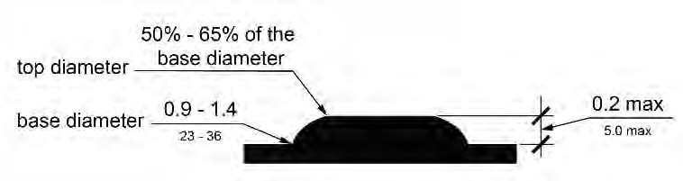
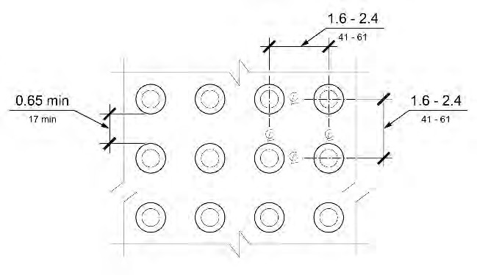
2.D. Second Street Right-Of-Way Detectable Warning Surfaces at Crosswalks
Above, left, detectable warning system to use at crosswalk, right, top view, detectable warning system.
Detectable Warning Surfaces are missing from most City crosswalks.
Suggested Solution: Install detectable warning surfaces at crosswalks where none are present. Replace detectable warning surfaces where they are not securely installed.
Detectable Warning Surfaces required at bottom of curb ramps.
Projected cost of correction: $20,000
Priority 5 per NCHRP guide.

Total Projected Cost of General First Street, Third Street, and Side Avenue Corrections: 270,000 plus tax in addition to specific corrections listed and priced elsewhere

2.E. First Street Right-Of-Way 300 block N. 1st Street Including adjacent Savage Ave.
General Conditions:
- First Street west side in good to fair condition.
- First Street east side no sidewalk present.
- Savage Avenue north side no sidewalk present.
- Savage Avenue south side in mix of fair to poor condition.

- Corner of N. 1st and Savage Ave.
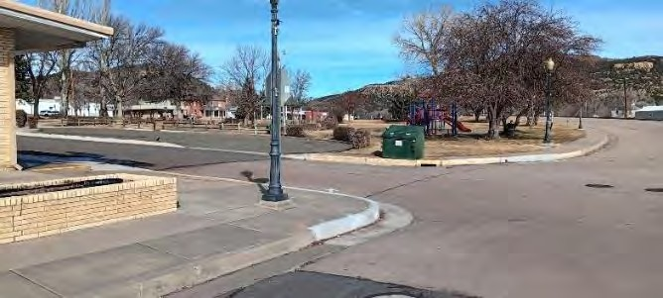
No curb ramp at northwest and southwest corners of N. First Street and Savage Avenue for crossing Savage Ave.
Suggested solution: replace curb with curb ramp.
Projected cost of correction: $8,000
Priority 2 per NCHRP guide.

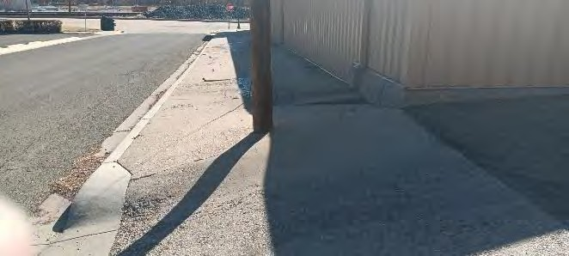
- Savage Ave. south side
Steep cross slope at alley crossing and steep slope at edges of alley crossing.
Suggested solution: Reconstruct north end of alley and adjacent sidewalks.
Projected cost of correction: $50,000.
Priority 2 per NCHRP guide.

2.F. First Street Right-Of-Way 200 Block North First St. including Clark Ave
General Conditions:
- First Street west side in mix of fair to poor condition.
- First Street east side no sidewalk present.
- Clark Avenue north side west of alley in good condition, east of alley in poor condition.
- Clark Avenue south side west of alley in good condition, east of alley in fair to poor condition.

- 1ST St. south end of west sidewalk – Sidewalk missing for 25 feet at south end of block. No curb ramp for crossing Clark Avenue.
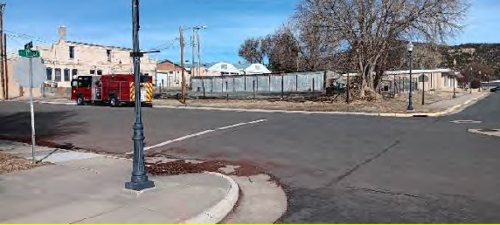
Missing sidewalk and curb ramp North of Clark Avenue.
Solution: Construct missing sidewalk with curb ramp.
Projected cost of correction: $5,000.
Priority 4 per NCHRP guide.

- Clark Avenue south side – no curb ramp at alley crossing.
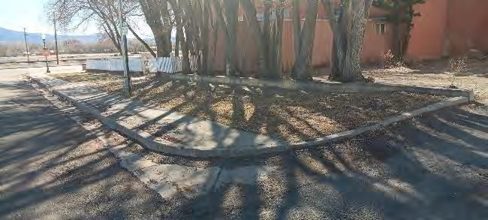
No curb ramp at alley crossing.
Suggested solution: replace curb with curb ramp.
Projected cost of correction: $5,000
Priority 2 per NCHRP guide

2.G. First Street Right of Way100 Block North First Street
General Conditions:
- First Street west side in mix of good to fair condition.
- First Street east side no sidewalk present.
- Park Avenue north side in fair to poor condition.
- Park Avenue south side in mix of good to fair to condition.

2.H. First Street Right of Way 100 block South First Street & adjacent Cook Ave.
General Conditions:
- First Street west side in good condition.
- First Street east side in good condition.
- Cook Avenue north side in mix of good to fair condition.
- Cook Avenue south side in mix of good to fair condition.

- Cook Avenue north side: especially uneven concrete joints.
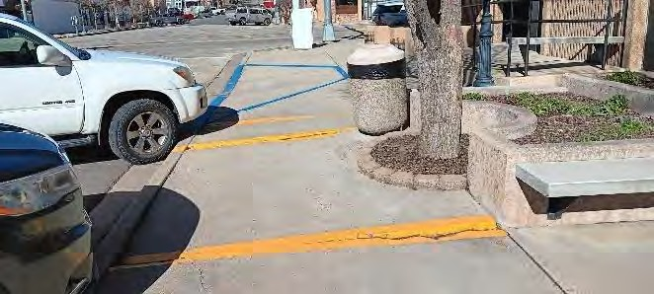
Especially uneven sidewalk joints; heaved surface in yellow.
Suggested solution: replace affected sidewalks.
Projected cost of correction: $5,000
Priority 2 due to degree of non-compliance and location next to curb ramp.

2.I. First Street Right-Of-Way 200 North First St. including adjacent Rio Grande Ave.
General Conditions:
- First Street west side in good condition. First Street east side in good condition.
- Rio Grande Avenue north side in good condition.
- Rio Grande Avenue south side, east of alley in good condition. Rio Grande Avenue south side, west of alley in poor condition.
Total Projected Cost of General First Street, Third Street, and Side Avenue Corrections: $73,000 plus tax in addition to general corrections listed and priced elsewhere

Part Three: Second Street Right of Way NMDOT Jurisdiction

3.A. General Notes
Second Street is under the compliance jurisdiction of the NM Department of Transportation. City owned Pedestrian Paths in other parts of the original Historic Downtown District connected to the Second Street corridor are addressed in a separate section of this ADA Transition Plan.
Review of existing conditions of sidewalks , crosswalks and accessible parking in the Second Street (Interstate 25 Business Route) from near Moulton Avenue on the north to near Kearny Avenue on the south.
The same as with older business areas, it is rarely feasible to fully comply with ADA requirements for running slopes, cross slopes, and other conditions due to the floor height of adjacent buildings, the elevation of the streets, normal wear and weathering on the walking surfaces, and other factors. It is the intent of this ADA Transition Plan to identify the items that are the most out of compliance which potentially most inhibit use by the disabled population and identify the non-compliant items which are more readily achievable to correct. Non-compliant items which were deemed to be an undue burden or technically not feasible to correct are not identified in this ADA Transition Plan.
The requirements for ADA compliance in the public street right-of-way is found primarily in the 2024 Public Right-Of-Way Accessibility Guidelines (PROWAG) issued by the US Access Board. PROWAG R101.4 indicates:
“These guidelines do not address existing pedestrian facilities unless the pedestrian facilities are altered at the discretion of a covered entity. The Department of Justice has authority over existing facilities that are subject to the requirement for program access under title II of the ADA. Any determination that this document applies to existing facilities subject to the program access requirement is solely within the discretion of the Department of Justice and is effective only to the extent required by regulations issued by the Department of Justice.”
However ADA also requires that readily achievable corrections be done when reasonably possible.

3.B. Second Street Right-Of-Way Pedestrian Path Surfaces
Allowable vertical offsets and gaps in an accessible pedestrian path of travel
Most sidewalks, curb ramps, and crosswalks on Second Street were constructed in 1996 and have experienced decades of weathering and wear. There are many vertical offsets and gaps in the walking surfaces that slightly exceed those allowed by PROWAG which are not always noted in this ADA Transition Plan and could usually be corrected by grinding, caulk, or other forms of patching.
Projected cost of correction: $200,000
Priority 4 due to the high number of locations with the non-compliant conditions, how most locations are not adjacent to public buildings or healthcare facilities, and how most noncompliant items are not far out of compliance, but the Second Street sidewalks are the heaviest used sidewalks within Raton.

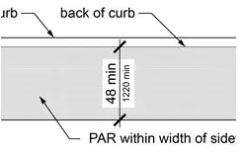
3.C. Second Street Right-Of-Way Pedestrian Path Width
At several locations the sidewalk width is reduced to less than 48 inches by light poles, fences, retaining walls, and other features. PROWAG R302.2 requires a continuous width of at least 48 inches excluding the top of the street curb. This Self Evaluation report does not list all locations where the sidewalk widths are too narrow or restricted. The projected cost and priority listed below does not include specific locations noted elsewhere.
Projected cost of correction: $100,000
Priority 4 due to the high number of locations with the non-compliant conditions, how most locations are not adjacent to public buildings or healthcare facilities, and how most noncompliant items are not far out of compliance, but the Second Street sidewalks are the heaviest used sidewalks within Raton.
Required sidewalk width. PAR = pedestrian access route:

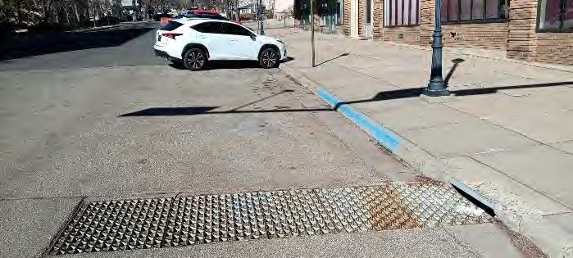
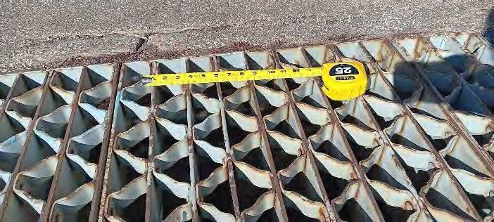
3.D. Accessible Parking on and near Second Street Between Savage Avenue and Rio Grande Avenue.
Previously designated accessible parking Non-complying openings at inlet grate
Since the concentration of businesses on and near Second Street that don’t have off-street parking is in the four blocks between Savage Avenue and Rio Grande Avenue this ADA Transition Plan addresses accessible on-street parking in those four blocks. PROWAG R211 requires for every 25 parking spaces that at least one of the 25 spaces should be an accessible parking space with an access aisle beside the accessible space with few exceptions. Since each side of Second Street in those same four blocks has approximately 12 parallel parking spaces there should be at least one designated accessible parking space per block. Where accessible parking used to be designated in those four blocks they were located on the side avenues adjacent to the crosswalks so that the parking spaces could be accessed using the curb ramps at the crosswalks. Accessible parking signs and pavement markings are now mostly missing. Blue painted curbs are generally all that remains.
Suggested Solution: The new or re-designated accessible parking spaces might best be located southeast of the street intersections at the diagonal parking space closest to the curb ramp. This is suggested in order to 1) allow for an access aisle on the passenger side of the parked vehicle as required by PROWAG R310.4.2 2) avoid requiring the pedestrian user to travel in vehicle traffic lanes to reach a curb ramp, and 3) avoid an accessible route to the adjacent crosswalk from having to cross the storm sewer inlet grates west of the crosswalks on the west side of Second Street. The inlet grates have openings far greater than ½ inch prohibited from accessible routes by PROWAG R302.6.3. If placement in the suggested area isn’t an option due to existing slopes or other factors then designating one of the parallel parking spaces on Second Street in each block for the required accessible parking is allowed in PROWAG R310.2.1 Exception 1. The exception allows for accessible parallel on-street parking without an access aisle beside the accessible space if located next to a curb ramp. Previously designated accessible parking Non-complying openings at inlet grate with steep cross slope and beside inlet grate. between accessible space and curb ramp. Lacks parking sign and pavement markings.
Projected cost of corrections: $50,000
Priority 2 due to the corrections affecting a large number of the public and being relatively low cost.

3.E. Second Street Right-Of-Way Crosswalks with Pedestrian Signal Heads
All five street intersections that have pedestrian signal heads (walk / don’t walk signals) are functioning as designed but do not meet the 2024 Public Right-Of-Way Accessibility Guidelines (PROWAG) requirements for new and altered pedestrian signal heads. PROWAG Preamble 1 Executive Summary states:
“All new and altered pedestrian signal heads installed at crosswalks must include “accessible pedestrian signals” (APS), which have audible and vibrotactile features indicating the walk interval .”
PROWAG R307 requirements for new and altered pedestrian signal heads include but are not limited to:
- Push buttons separated by at least 10 feet, or a passive pedestrian detection device instead of push button activation.
- Vibrotactile push buttons (vibrations at the buttons to indicate status of signal cycle).
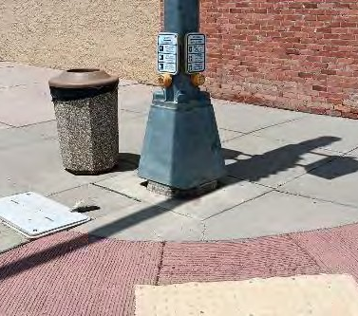
- Audible locator tone and walk indication
Suggested Solution: At the six locations identified either relocate the pole or reconfigure the ramps. Either solution will require the push buttons to be relocated to fully comply with PROWAG 307, and in turn if the installation is altered then it needs to fully comply with 2024 PROWAG requirements for new and altered pedestrian signal heads.
Projected cost of corrections: $1,000,000 including pedestrian signal head replacements
Priority 5 due to the high cost of corrections. Available funds in the shorter term can correct many other deficiencies.

Push buttons mounted on the same pole, no vibrotactile Indications, no audible tone or walk indication. All grandfathered until the signal installations are altered such as if the signal pole is relocated to provide a required landing at the top of the ramp.

Curb ramp deficiencies are noted in the Second Street review by location (for instance 100 block of South Second Street). In addition, there are six curb ramps with top landings obstructed by the location of the pole that supports a streetlight, traffic signal, pedestrian signal head, and push buttons. If the ramp correction includes relocating the pole then the NM Department of Transportation will need to determine if simply relocating the pole, pedestrian signal head, push buttons, and associated wiring constitutes the definition of altering the pedestrian signal heads. If so, then the alteration would trigger the requirement for upgrading the pedestrian signal head system as described in PROWAG 307. If the post is not relocated then the ramp will need to be reconfigured and the push buttons will need to be relocated which would trigger the requirement for upgrading the pedestrian signal head system as described in PROWAG 307

3.F. Second Street Right of Way Curb Ramps, top landing obstructed by location of pole
There are six curb ramps with top landings obstructed by the location of the pole that supports a street light, traffic signal, pedestrian signal head, and push buttons. These curb ramps are located at:
- Clark Avenue northwest and southeast corners
- Park Avenue northwest and southeast corners
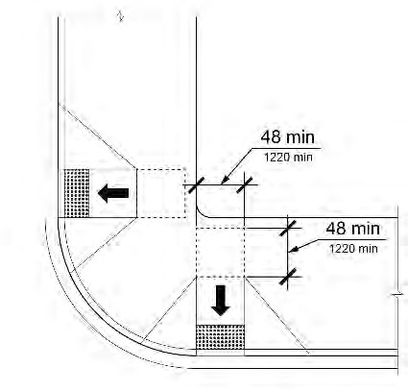
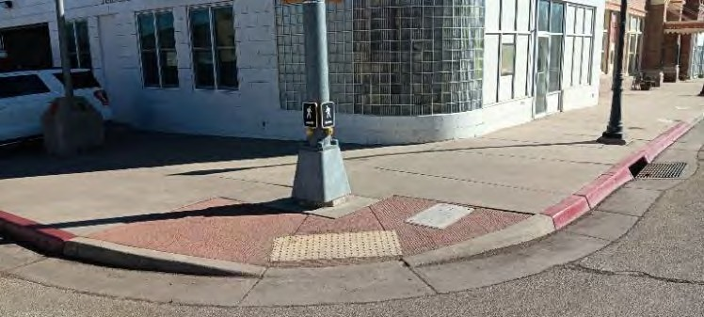
- Cook Avenue northwest and southeast corners
Signal post obstructing ramp landing, six locations.
Suggested solution: relocate pole of reconfigure ramps.
Projected cost of corrections: $1,000,000 including pedestrian signal head replacements
Priority 5 due to the high cost of corrections. Available funds in the shorter term can correct many other deficiencies.

Curb ramp reconfiguration option.

3.G. Recommendation to leave Second Street Planter Undisturbed
The southeast corner of South Second Street and Park Avenue has a raised concrete planter. The planter was constructed by NM Dept of Transportation to reduce the amount of stormwater that rushes down Park Avenue and overflows the storm sewer inlet from reaching the nearby door and building during heavy rain events. It is recommended that the planter remain and not be removed for ramp reconfiguration or for upgrading the pedestrian signal head system.
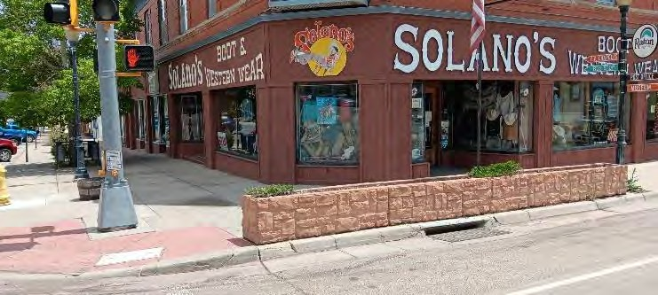
Concrete planter at Southeast corner of second street.
Recommendation: Leave planter as it serves for stormwater control.

3.H. Second Street Right-Of-Way Curb Ramps at Crosswalks
Outside of the older downtown area most Second Street sidewalks are relatively narrow. For narrow sidewalks, most of the curb ramps at crosswalks were constructed with flared sides but no top landing so that the ramp user has to either travel part way up the ramp then turn 90 degrees while still on the ramp to then travel up a side flare, or leave the ramp and paved sidewalk altogether. There are approximately 50 curb ramps at crosswalks on Second Street with this condition. Some of those approximately 50 curb ramps are noted for other non-compliant issues as well.

2024 Public Right-Of-Way Accessibility Guidelines (PROWAG) R304.2.3 requires grade breaks (the line of transition where the running slope changes) to be located at the top and bottom of the ramp, rather than placing a curb, turf, or other obstructions at the top and bottom of the ramp. In other words there is no landing located at the top of most of these ramps.
PROWAG R304.2.5 requires a level landing (maximum slope 2%) at the top of a curb ramp when the user has to change direction after using the ramp. The landing is required to measure at least 48 inches x 48 inches.
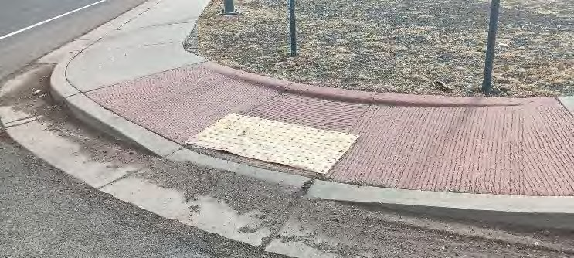
1 of approximately 50 curb ramps with no top landing except at the top of the flared sides.

At the other ramps similar to the one pictured above the required bottom landing of the ramp can’t be located at the location of the yellow detectable warning mat without completely reconstructing the ramp and flared sides because
- the area with the yellow detectable warning mat slopes more than 2% in any direction
- the area with the yellow detectable warning mat measures less than 48” x 48”, and
- the flared sides each side of the yellow detectable warning mat slope more than 8.3% which is the maximum slope allowed for a ramp.

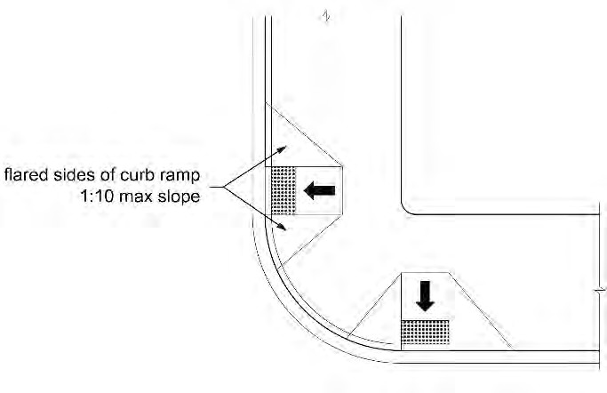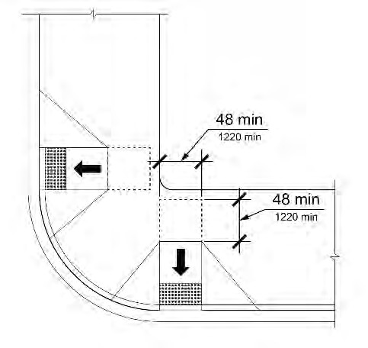
Ramps diagrams shown with required top landings

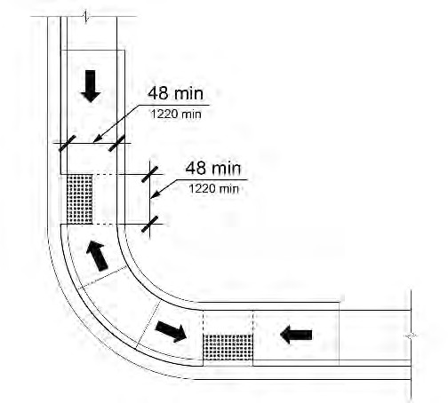
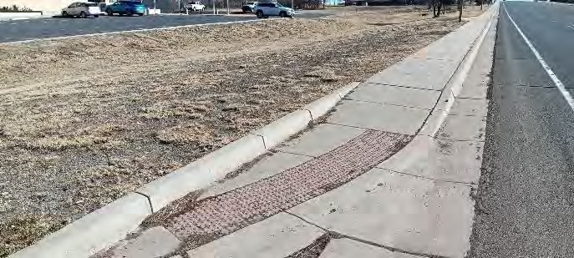
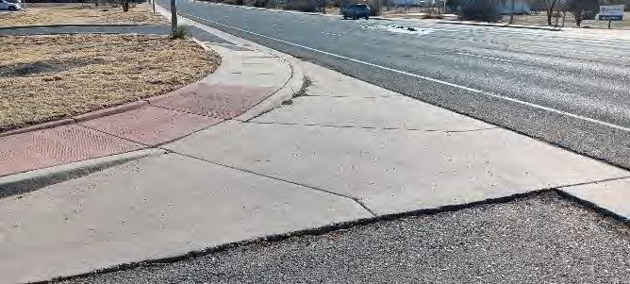
Ramp landing diagram for sidewalks One of the few Second Street curb ramps with complying curb ramp by providing top and bottom landings, allowable slopes and widths, and a detectable warning surface

The curb ramp pictured above would be PROWAG compliant if:
- The red concrete walking surface is at least 4 feet wide.
- The center section of red concrete measures at least 4 feet x 4 feet to act as a bottom landing.
- The center section of red concrete slopes not more than 2% in any direction to act as a bottom landing.
- The sloped sections of red concrete each side of the bottom landing have a running slope down to the bottom landing of not more than 8.3%.
- The sloped sections of red concrete each side of the bottom landing have a cross slope of not more than 2%.
- A detectable warning surface such as a textured yellow mat or textured brick pavers is placed at the bottom landing.

Additional details found in PROWAG apply.
Suggested Solution: Reconstruct the non-compliant curb ramps so that reaching the top landing does not require a ramp user to change direction while traveling up the ramp. In most if not all Second Street cases there is sufficient distance to property lines to reconstruct the ramps and landings for a ramp either perpendicular to the street intersection or parallel to the adjacent street.
Projected cost of corrections: $376,000 in addition to curb ramps specifically identified and priced elsewhere in this report.
Priority 5 per NCHRP guide.

3.I. Second Street Right-Of-Way Detectable Warning Surfaces at Crosswalks
Detectable Warming Surfaces required at bottom of curb ramps
Detectable Warning Surfaces are missing from approximately half of the Second Street crosswalks. Nearly all remaining detectable warning surfaces are yellow rubber mats anchored with strike anchors into the concrete. Where the rubber mats are missing the strike anchors are sometimes still in place causing trip hazards.
Suggested Solution: Install detectable warning surfaces at crosswalks where none are present. Replace detectable warning surfaces where they are not securely installed.
Projected cost of corrections: $10,000
Priority 5 per NCHRP guide.
Total Projected Cost of Second Street corrections: $1,636,100 plus tax in addition to specific corrections listed and priced elsewhere.

3.J. Second Street North Right-Of-Way 400 block N. 2nd Street, Sidewalk Cracked and Buckled
General Conditions: Sidewalks in fair to poor condition.
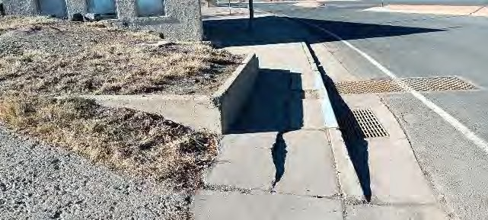
Sidewalks cracked, buckled, and narrower than 48 inches.
Suggested Solution: Replace and widen affected portion of sidewalk.
Projected cost: $5,000
Priority 5 due to lesser traffic area.

3.K. Second Street Right-Of-Way 300 block N. 2nd Street Including adjacent railroad underpass and east side of underpass
Special Conditions: The north railroad underpass is the only pedestrian crossing of the railroad in the north half of Raton. The railroad tracks cut roughly through the middle of town. The only other pedestrian crossing is nearly a mile away.
General Conditions: Sidewalks in fair to good condition.
- Underpass sidewalks – Vertical offsets at concrete joints measuring around 1 inch high.
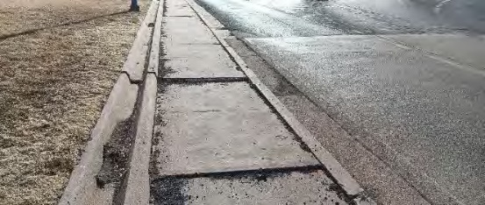
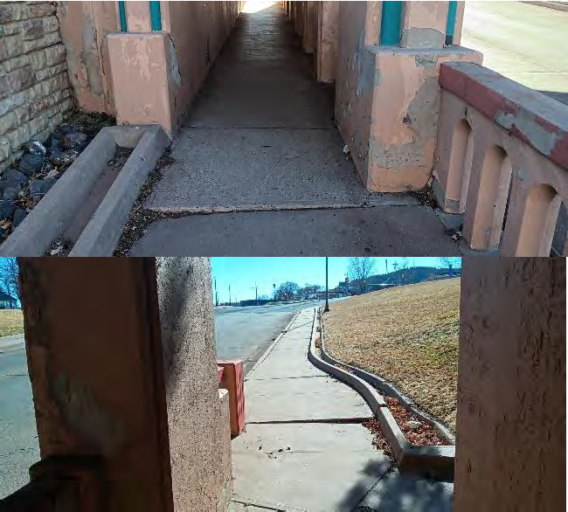
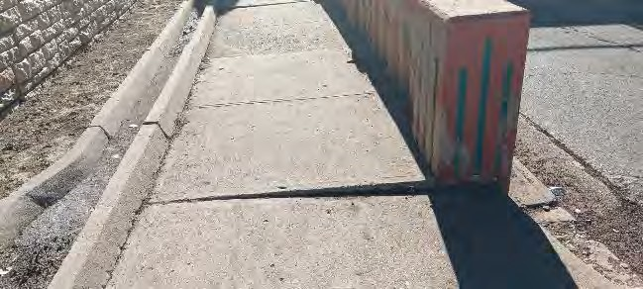
Underpass sidewalks: vertical offsets +/- 1” at concrete joints.
Suggested solution: Replace sidewalk at offsets or grind concrete to meet ADA allowances.
Projected cost of corrections: $10,000
Priority 4 due to non-compliance being minor.
ADA required maximum offsets

- North Underpass northeast side
  - Lack of curb cuts and crosswalks. See also the top landing and detectable warning descriptions in the Second Street general notes.
  - The only curb ramp is at the northeast corner of intersection.
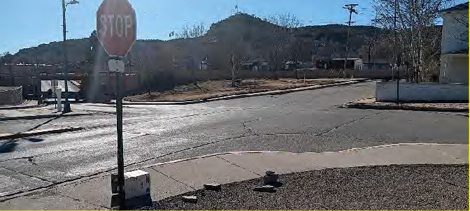
Lack of curb cuts and crosswalks; non-conforming landing and detectable warning.
Suggested solution: Replace curbs with curb ramps at this intersection.
Projected cost of corrections: $25,000.
Priority 4 per NCHRP guide.

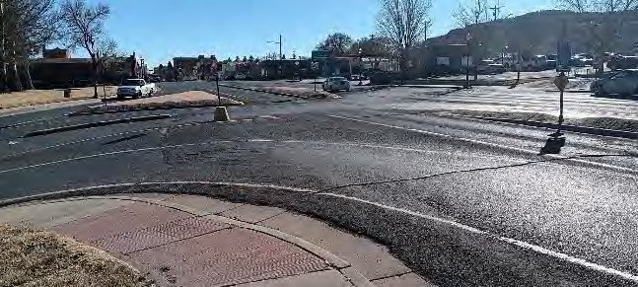
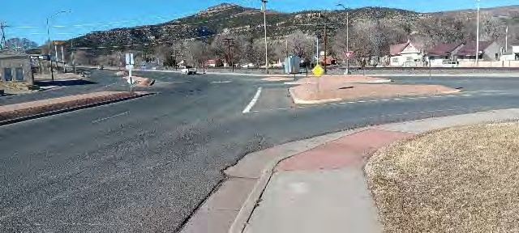
- N. Second Street northwest of North Underpass
Lone curb ramps with no accessible routes to the opposite sides of the streets.
Two curb ramps on the east side of North Second Street with no corresponding curb ramps across the street, and with raised islands blocking street crossings. See also the top landing and detectable warning descriptions in the Second Street general notes.
Suggested Solution: Construct missing curb ramps to correspond with the lone curb ramps. Alter islands to allow for pedestrian crossings.
If it is determined that crosswalks are not desired at these noted locations for safety or other reasons then the curb ramp might be eliminated and another accessible route provided without crossing the streets at these intersections. PROWAG R203.6.1.1 indicates “Where pedestrian crossing is prohibited, curb ramps or blended transitions shall not be provided, and the pedestrian circulation path shall be either (a) separated from the roadway with landscaping or other non-prepared surface or (b) separated from the roadway by a detectable vertical edge treatment with a bottom edge 15 inches maximum above the pedestrian circulation path.” Lone curb ramps with no accessible routes to the opposite sides of the streets.
Projected cost of corrections: $15,000
Priority 4 per NCHRP guide.
- N Second Street east side
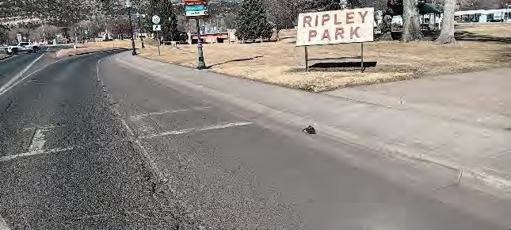
No curb ramp at end of crosswalk.
Suggested solution: Reconstruct sidewalk to include curb ramp.
Projected cost of correction: $8,000
Priority 4 per NCHRP guide.

- N Second Street east side
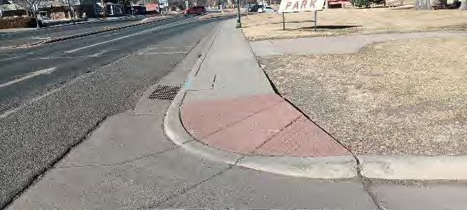
Curb ramp too steep, too narrow, and not op landing.
Suggested solution: Reconstruct the curb ramp to provide the required landings and slopes.
Projected cost of corrections: $8,000.
Priority 5 per NCHRP guide.

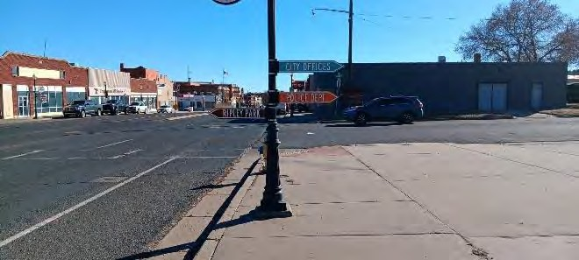
- N. Second Street west side
Directional sign less than 5 feet above the sidewalk.
Suggested solution: Remount sign to 6’ to 8’ above the sidewalk.
Projected cost of correction: $100.
Priority 1 because readily achievable.
Signs less than 6’-8” above the sidewalk

3.K. Second Street Right-Of-Way

3.K.1 200 block N. 2nd Street
General Conditions: Sidewalks in good condition with isolated exceptions. See the top landing and detectable warning descriptions in the Second Street general notes.
- A short portion of the east sidewalk has a running slope of 23% and could be sloped around 5% between nearby building entries. PROWAG R302.4.1 and R302.4.2 require a maximum running slope at pedestrian paths (sidewalks) of 5% when feasible.
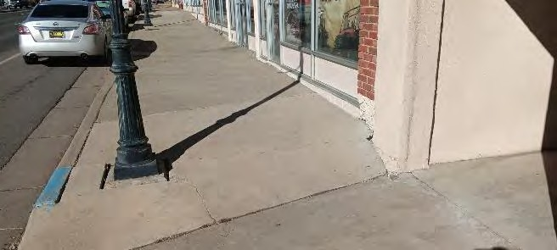
Steep portion of east sidewalk with 23% running slope.
Suggested solution: Remove portion of sidewalk
Projected cost of solution: $15,000.
Priority 4, as sidewalk is steep, but still passable.

3.K.2. Second Street Right-Of-Way 100 block N. 2nd Street
General Conditions: Sidewalks in good condition with isolated exceptions. See the top landing and detectable warning descriptions in the Second Street general notes.

3.K.3. Second Street Right-Of-Way 100 block S. 2nd Street
General Conditions: Sidewalks in good condition with isolated exceptions.
See Second Street general notes for posts located at ramp landings and for detectable warning surfaces.
- Curb ramp at southwest corner of N. Second and Park Avenue – The concrete has deteriorated and settled causing vertical offsets at the curb and at the underground electrical box covers.
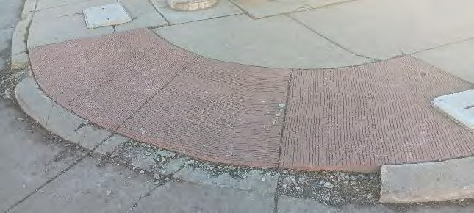
Deteriorated concrete causing vertical offsets at curb and underground electrical box covers.
Suggested solution: reconstruct curb ramp and sidewalks to eliminate vertical offsets.
Projected cost of solution: $5,000.
Priority 5 per NCHRP guide.

- Curb ramp at northeast corner of N. Second and Cook Avenue – The concrete has deteriorated and settled causing vertical offsets at the curb and at the underground electrical box covers.
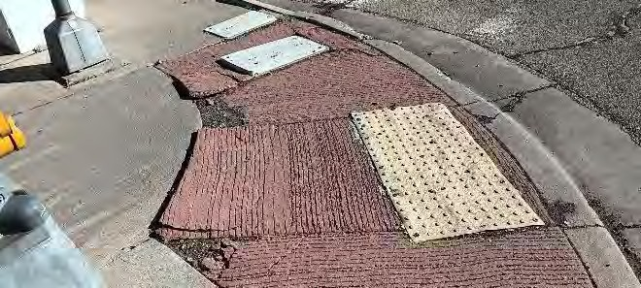
Deteriorated concrete causing vertical offsets at curb and underground electrical box covers.
Suggested solution: reconstruct curb ramp and sidewalks to eliminate vertical offsets.
Projected cost of solution: $5,000.
Priority 5 per NCHRP guide.

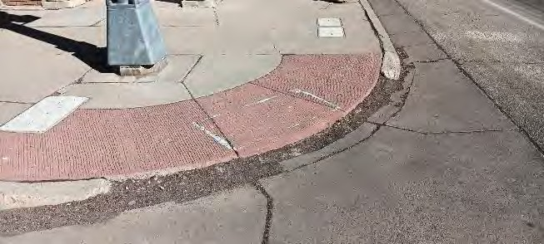
- Curb ramp at northwest corner of N. Second and Cook Avenue – The concrete has been damaged and removed causing a step at the bottom of the curb ramp. A light post is located in the top landing of the curb ramp.
Concrete damaged causing step at bottom of curb ramp; post located in top landing of ramp.
Suggested solution: reconstruct ramp and sidewalk to eliminate offsets; reconfigure ramp to avoid post in ramp top landing.
Proposed cost of solution: $25,000.
Priority 5 per NCHRP guide.

3.K.4. Second Street Right-Of-Way 200 block S. 2nd Street
General Conditions: Sidewalks in good condition with isolated exceptions. See Second Street general notes for posts located at ramp landings and for detectable warning surfaces.
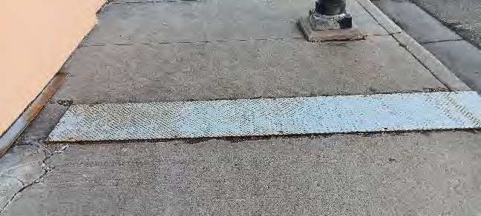
Trench cover rests on sidewalk instead of being recessed flush.
Suggested solution: Fit trench cover flush with adjacent concrete.
Proposed cost of solution: $500
Priority 3 due to sidewalk still usable.

3.K.5 Second Street Right-Of-Way 300 block S. 2nd Street
General Conditions: Sidewalks in good condition with isolated exceptions. See the top landing and detectable warning descriptions in the Second Street general notes.
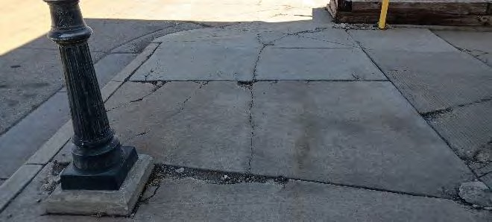
- Sidewalk at southeast corner of S. Second and Rio Grande Avenue – Concrete is deteriorated causing gaps and offsets.
Concrete deteriorated causing gaps and offsets.
Suggested solution: Replace deteriorated concrete.
Proposed cost of solution: $20,000.
Priority 5 due to sidewalk being still usable.

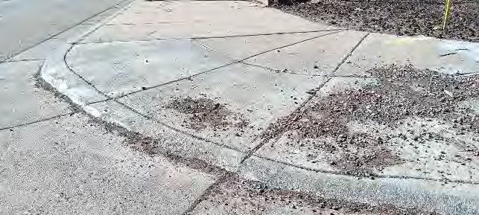
- Curb ramp at southwest corner of S. Second and Rio Grande Avenue – Abrupt transition at bottom of curb ramp rising around 1 inch.
Steep transition at bottom of ramp exceeds ADA allowances.
Proposed solution: Reconstruct or grind ramp for smooth transition.
Proposed cost of solution: $8,000
Priority 5 per NCHRP guide.

- East side of S. Second Street – Obsolete curb cuts causing running slopes of greater than 5% and cross slopes greater than 2.1%. PROWAG R302.4.1, R302.4.2, and R302.5 require a maximum running slope of 5% and maximum cross slope of 2.1% when feasible.
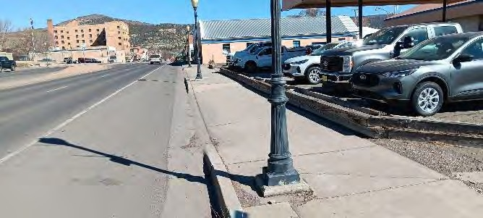
Obsolete curb cuts causing running slope greater than 5% and steep cross slopes at obsolete curb cut.
Proposed solution: Reconstruct or grind ramp for smooth transition.
Proposed cost of solution: $20,000
Priority 5 due to minor non-compliance.

3.K.6. Second Street Right-Of-Way 400 block S. 2nd Street
General Conditions: Sidewalks in good condition with isolated exceptions See the top landing and detectable warning descriptions in the Second Street general notes.

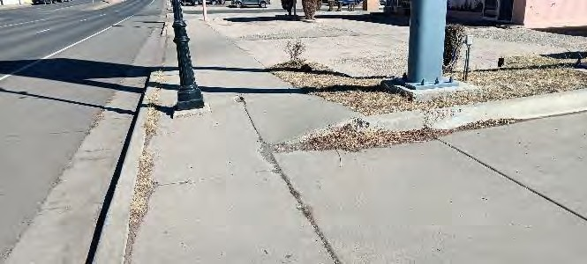
- East side of Second Street – Step causes tripping hazard and causes a cross slope greater than 5%. PROWAG R302.5 requires a maximum cross slope of 2.1% when feasible.
Step causes tripping hazard; cross slope greater than 5%.
Proposed solution: Reconstruct sidewalk to allowable cross slope and eliminate step.
Proposed cost of solution: $8,000
Priority 4 due to minor non-compliance

3.K.7. Second Street Right-Of-Way 500 block S. 2nd Street
General Conditions: Sidewalks in good condition with isolated exceptions. See the top landing and detectable warning descriptions in the Second Street general notes.

3.K.8. Second Street Right-Of-Way 600 block S. 2nd Street
General Conditions: Sidewalks in good condition with isolated exceptions. See the top landing and detectable warning descriptions in the Second Street general notes.
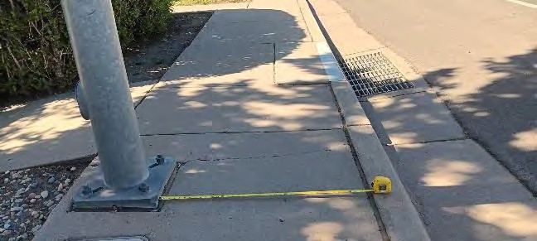
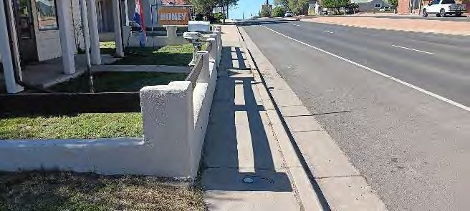
- East side of street – Sidewalk approximately 38 inches wide. Light poles in various areas and fence restricts sidewalk width. PROWAG R302.2 requires the pedestrian access route to be at least 48 inches.
Light pole and fence restrict sidewalk to 38”.
Proposed solution: Relocate light pole, remove fence and widen sidewalk. .
Proposed cost of solution: $30,000
Priority 5 due to narrow sidewalk still usable with effort.

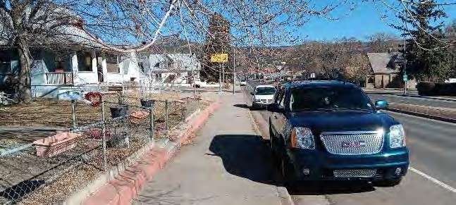
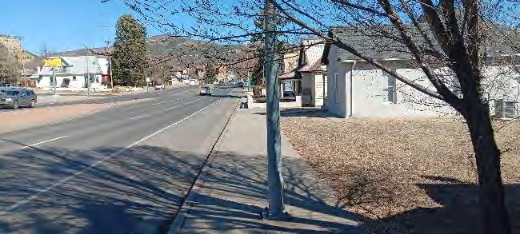
- Both sides of street - Tree branches within 6’-8” of the walking surface. PROWAG 402.2 requires no obstructions within 6’-8” above the walking surface.
Tree branches within 6”-8” of walking surface.
Proposed solution: Trim trees..
Proposed cost of solution: $100
Priority 1 due to corrections being readily achievable.
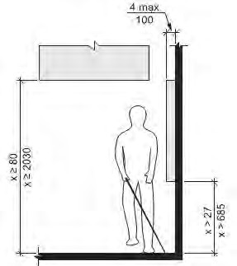
Restrictions for overhanging an accessible route

3.K.9. Second Street Right-Of-Way 700 block S. 2nd Street
General Conditions: Sidewalks in good condition with isolated exceptions. See the top landing and detectable warning descriptions in the Second Street general notes.
- Southwest corner of S. Second Street and Mora Avenue - Curb ramp slopes at 13% when not necessary. PROWAG R304.2.1 and R304.2.2 require a maximum running slope of 8.3% and a maximum cross slope of 2.1% at ramps when feasible.
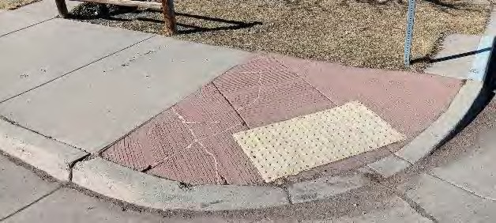
Steep curb ramp, slopes at 13%t.
Proposed solution: Reconstruct ramp to allowable slope and provide top ramp landing so landing edge is perpendicular to direction of travel.
Proposed cost of solution: $8,000
Priority 5 per NCHRP guide.

- West side of South Second Street - Obsolete curb cut causing running slope of greater than 5% at ends of curb cut and cross slopes greater than 2.1%. PROWAG R302.4.1, R302.4.2, and R302.5 require a maximum running slope of 5% and maximum cross slope of 2.1% when feasible.
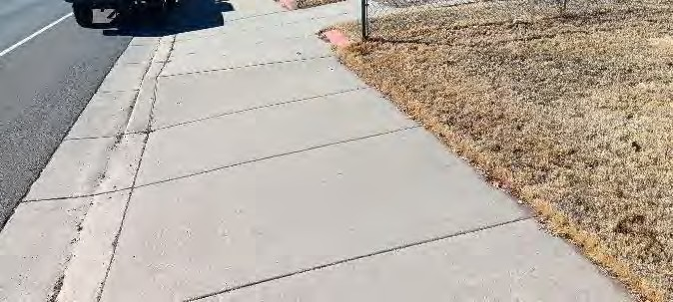
Obsolete curb cuts causing running slope greater than 5% and steep cross slopes.
Proposed solution: Replace affected sidewalk to eliminate obsolete curb cut.
Proposed cost of solution: $20,000
Priority 5 due to minor non-compliance

3.K.10. Second Street Right-Of-Way 800 block S. 2nd Street
General Conditions: Sidewalks in good condition with isolated exceptions. See the top landing and detectable warning descriptions in the Second Street general notes.

- Southwest corner of S. Second Street and Cimarron Avenue - Curb ramp has a running slope of 5% while the crosswalk has a running slope 13%. When added together the 5% + 13% totals 18%. PROWAG R304.5.2 allows for up to 13.3% when added together.
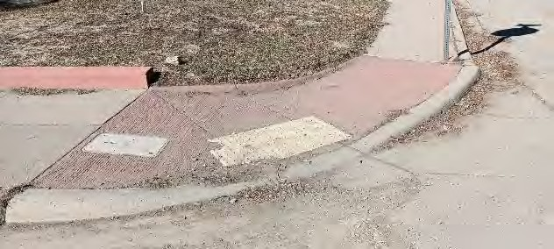
Curb ramp and running slope exceed required combined slopes. Curb and street are steep requiring level transition space at bottom of ramp.
Proposed solution: Reconstruct ramp to a 24” long level transition between 13% cross slope and new ramp slope of 8.3% or less. Provide landing at top of ramp rather than at flared sides. .
Proposed cost of solution: $10,000
Priority 5 per NCHRP guide.
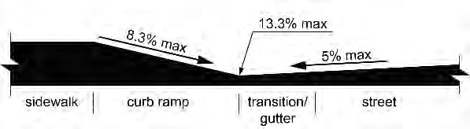
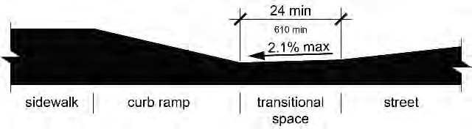

- West side of South Second Street - Obsolete curb cut causing running slopes of greater than 5% and cross slopes greater than 2.1%. PROWAG R302.4.1, R302.4.2, and R302.5 require a maximum running slope of 5% and maximum cross slope of 2.1% when feasible.
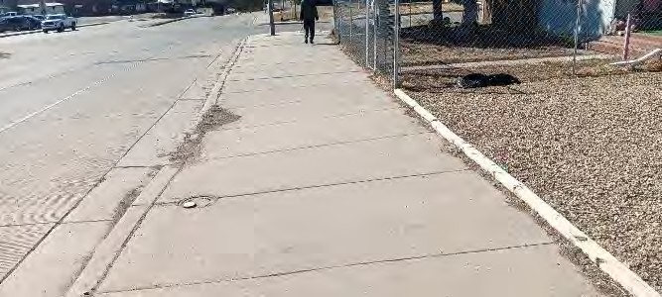
Obsolete curb cuts causing running slope greater than 5% and steep cross slopes greater than 2.1%..
Proposed solution: Replace affected sidewalk to eliminate obsolete curb cuts. .
Proposed cost of solution: $15,000
Priority 5 due to minor non-compliance

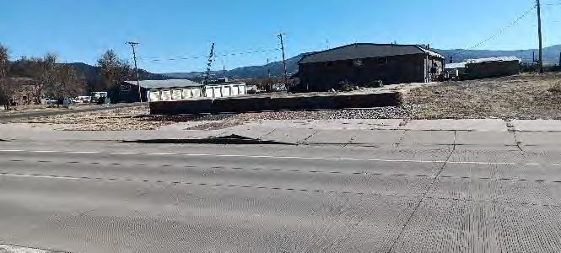
- West side of S. Second Street – Buckling sidewalk causing excessive slope and trip hazard. Obsolete curb cuts causing unnecessary steep running slopes at ends of curb cuts and steep cross slopes at obsolete curb cuts.
Buckling sidewalk and obsolete curb cuts causing steep running slopes.
Proposed solution: Replace curb cuts and buckling sidewalk.
Proposed cost of solution: $20,000
Priority 3 due to heaved concrete being a trip hazard.

- 3.K.11. Northwest corner of S. Second Street and Legion Avenue - Curb ramp has no top landing. PROWAG R304.2.5 requires a landing at the top of ramps. Flared sides of curb ramp slope at 28%. PROWAG 304.2.6 requires a maximum slope at flared sides of 10%.
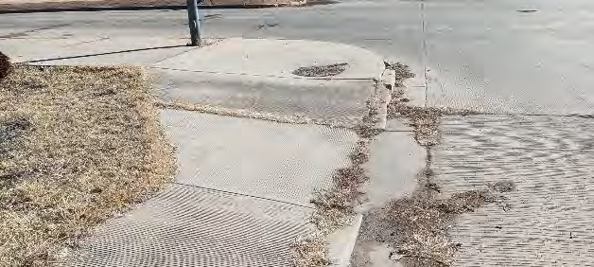
Curb ramp has no top landing; flared sides of curb ramp exceed required slope %.
Proposed solution: Reconstruct ramp so that it has a top ramp landing and acceptable slopes.
Proposed cost of solution: $10,000
Priority 5 per NCHRP guide.

3.K.11. Second Street Right-Of-Way 900 block S. 2nd Street
General Conditions: Sidewalks in good condition with isolated exceptions.
See the top landing and detectable warning descriptions in the Second Street general notes.
- Southwest corner of S. Second Street and Legion Avenue - Curb ramp has no top landing. PROWAG R304.2.5 requires a landing at the top of ramps. Reconstruct ramp so that it has a top landing. At this location the solution might include a level bottom landing at the location of the existing ramp, and a new ramp sloping up to the to the east and the Second Street sidewalk, and up to the west to the Legion Avenue sidewalk.

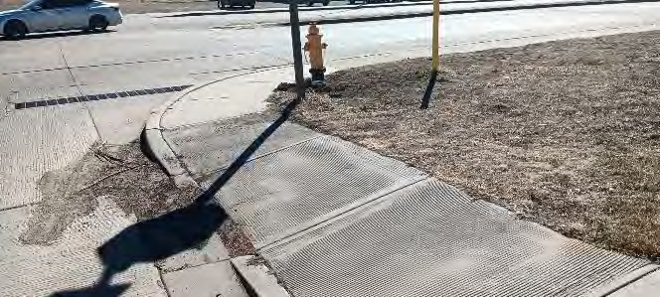
Curb ramp has no top landing.
Proposed solution: Reconstruct ramp so that it has a top landing; potentially include level bottom landing and new side ramps.
Proposed cost of solution: $15,000
Priority 5 per NCHRP guide.

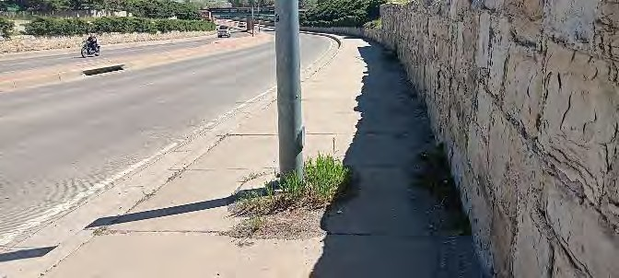
- West side of S. Second Street – Light pole in the middle of the sidewalk restricting the pedestrian access route to less approximately 36 inches each side of the pole base. PROWAG R302.2 requires the pedestrian access route to be at least 48 inches excluding the top of the street curb.
Light pole restricts sidewalk to less than 36”.
Proposed solution: Move light pole closer to retaining wall.
Proposed cost of solution: $50,000.
Priority 5 due to narrow sidewalk still being usable.
- West side of S. Second Street – Buckling sidewalk causing excessive slope and trip hazard.
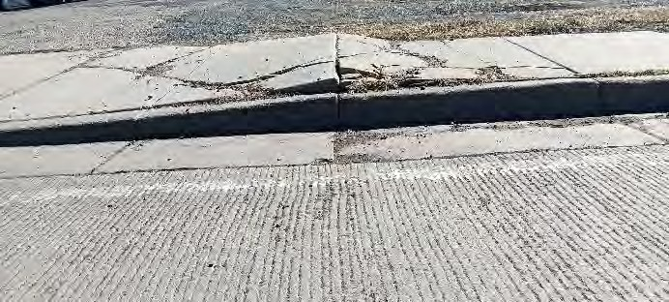
Buckling sidewalk causing excessive slope and trip hazard.
Proposed Solution: Replace portions of affected sidewalk.
Proposed cost of solution: $5,000.
Priority 5 due to non-compliance being minor.

3.K.12. Second Street South Right-Of-Way 900 block S. 2nd Street
General Conditions: Sidewalks in good condition with isolated exceptions. See the top landing and detectable warning descriptions in the Second Street general notes.
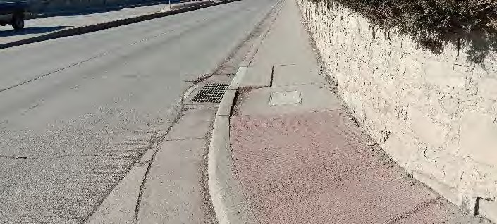
- Sidewalk east side has settled around a storm water drop inlet causing a vertical offset of approximately 1 inch.
Sidewalk has settled around stormwater drop inlet causing 1” vertical offset.
Proposed solution: Replace affected portion of sidewalk.
Proposed cost of solution: $5,000.
Priority 5 due to non-compliance being minor.

- Northeast corner of S. Second Street and Grant Avenue, curb ramp is deteriorated and missing.
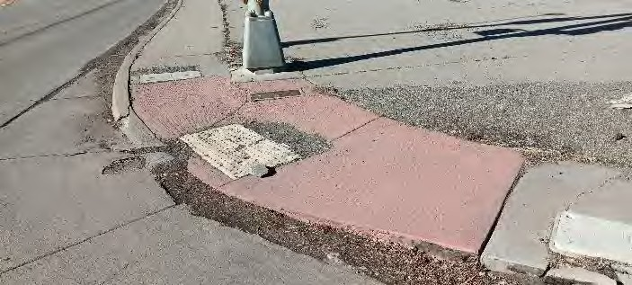
Curb ramp is deteriorated and missing.
Proposed solution: Reconstruct curb at edge of ramp.
Proposed cost of solution: $10,000.
Priority 5 per NCHRP guide.

3.K.13. Second Street Right-Of-Way 1000 block S. 2nd Street
General Conditions: Sidewalks in good condition with isolated exceptions.
- Southeast corner of S. Second Street and Grant Avenue – Deteriorated curb ramp concrete causing offsets, gaps, and uneven slopes.

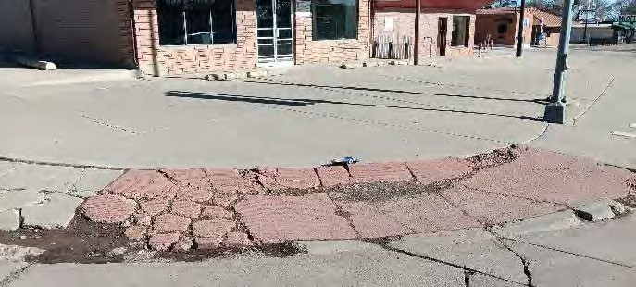
Deteriorated curb ramp concrete causing offsets, gaps, and uneven slopes.
Proposed solution: Reconstruct deteriorated ramp and adjacent deteriorated sidewalk.
Proposed cost of solution: $5,000.
Priority 5 per NCHRP guide.

- West side, buckling sidewalk – Sidewalk is buckling causing vertical offsets.
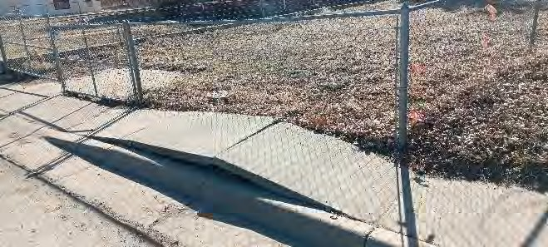
Sidewalk is buckling causing vertical offsets .
Proposed solution: place affected sidewalk.
Proposed cost of solution: $5,000.
Priority 4 due to relatively minor but trip hazard.

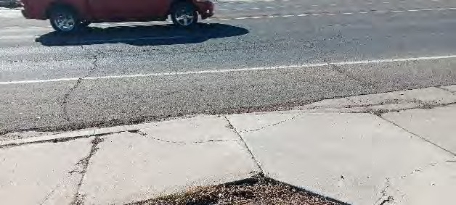
- East side, buckling sidewalk – Sidewalk is buckling causing vertical offsets.
Sidewalk is buckling causing vertical offsets .
Proposed solution: place affected sidewalk.
Proposed cost of solution: $5,000.
Priority 4 due to noncompliance being minor.

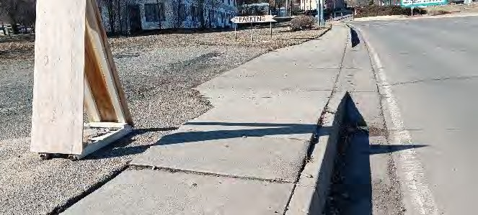
- West side – Sidewalk is buckling causing vertical offsets.
Sidewalk is buckling causing vertical offsets.
Proposed solution: Replace affected sidewalk.
Proposed cost of solution: $5,000.
Priority 5 due to noncompliance being minor.

- West side– Light pole in the middle of the sidewalk restricting the pedestrian access route to less approximately 36 inches each side of the pole base. PROWAG R302.2 requires the pedestrian access route to be at least 48 inches excluding the top of the street curb.
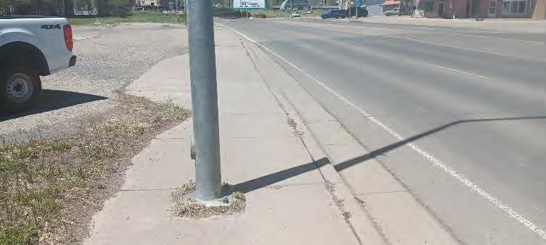
Light pole restricts sidewalk to less than 36” each side of pole.
Proposed solution: Move light pole to outside edge of sidewalk.
Proposed cost of solution: $50,000.
Priority 5 n due to high cost and sidewalk is still usable.

- West side– Sidewalk measures 39 inches wide from the back of the curb to the face of the retaining wall, and is further restricted to 34 inches at the concrete pier under the fence post. PROWAG R302.2 requires the pedestrian access route to be at least 48 inches excluding the top of the street curb.
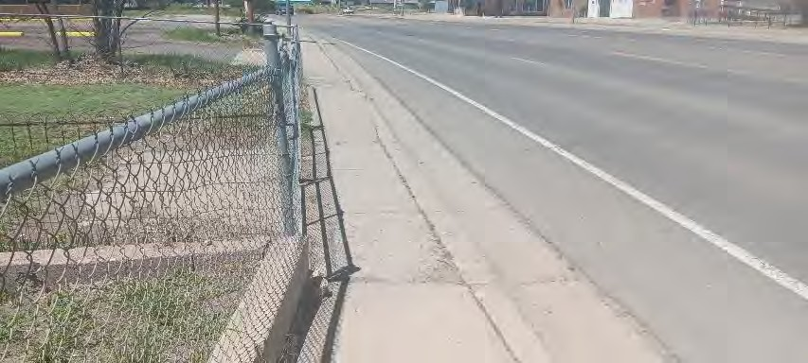
Sidewalk measures 39 inches wide from the back of the curb to the face of the retaining wall, and is further restricted to 34 inches at the concrete pier under the fence post.
Proposed solution: Widen sidewalk by removing fence and retaining wall.
Proposed cost of solution: $20,000, based on ownership of adjacent property.
Priority 5 due to cost and sidewalk is usable.

- East side – deteriorating concrete.
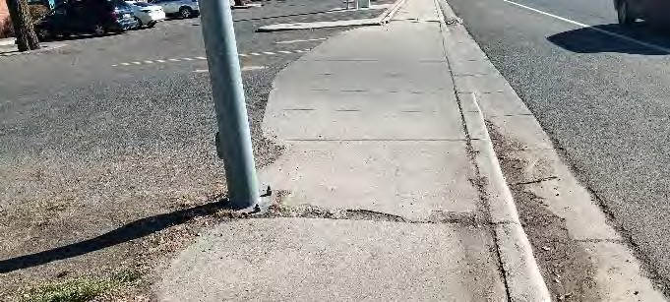
Deteriorated Concrete.
Proposed solution: Replace affected sidewalk.
Proposed cost of solution: $5,000.
Priority 5 due to non-compliance being relatively minor.

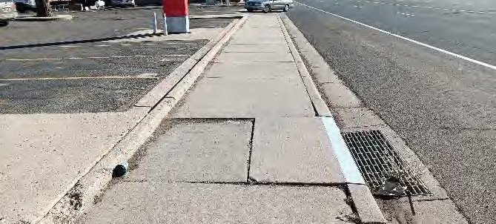
- East side – Settled concrete near storm water drop inlet causing vertical offsets.
Settled concrete near storm water inlet.
Proposed solution: Reconstruct settled sidewalk.
Proposed cost of solution: $5,000.
Priority 5 due to non-compliance being relatively minor.

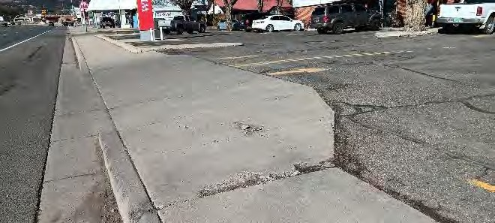
- East side – Deteriorated concrete causing vertical offsets.
Deteriorated concrete causing vertical offsets.
Proposed solution: Reconstruct crumbled area of sidewalk.
Proposed cost of solution: $5,000.
Priority 5 due to non-compliance being relatively minor.

- East side – Shrubs reducing the usable width of the sidewalk to less than 24 inches. Public Right-Of-Way Accessibility Guidelines (PROWAG) R302.2 requires the clear width of pedestrian access routes (sidewalks) to be at least 48 inches.
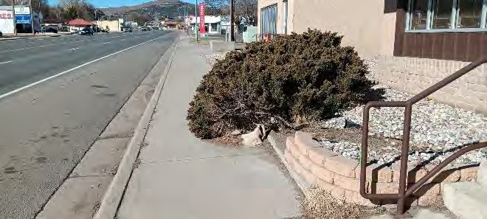
Bushes reduce sidewalk to less than 48”.
Proposed solution: Trim bushes.
Proposed cost of solution: $100.
Priority 1 due to solution being achievable.

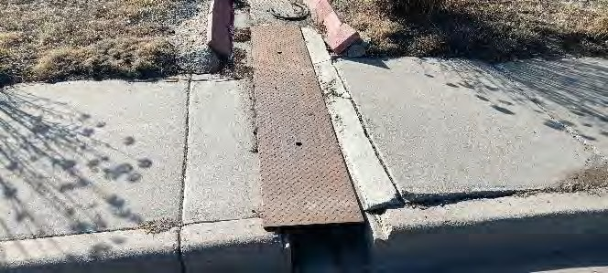
- West side – Steel cover at trench doesn’t fit trench causing vertical offsets.
Steel cover at trench doesn’t fit causing vertical offsets. .
Proposed solution: Alter steel or concrete cover to eliminate offsets.
Proposed cost of solution: $500.
Priority 3 due to non-compliance being relatively minor but solution being readily achievable.

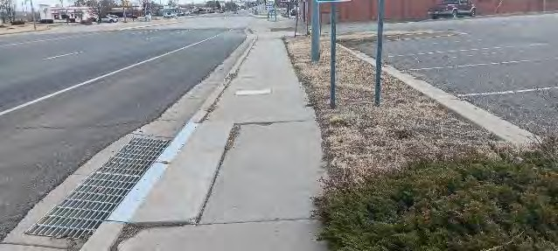
- East side – Settled concrete near storm water drop inlet causing vertical offsets.
Settled concrete near stormwater drop inlet causing vertical offsets..
Proposed solution: reconstruct settled sidewalk.
Proposed cost of solution: $5,000.
Priority 5 due to non-compliance being relatively minor.

- East side – Buckled sidewalk causing offsets and trip hazard
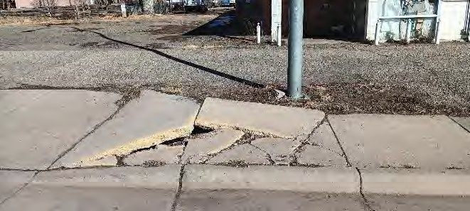
Buckled sidewalks causing offsets and trip hazard..
Proposed solution: Replace buckled sidewalk.
Proposed cost of solution: $5,000.
Priority 2 due to non-compliance and trip hazard.

3.K.14. Second Street Right-Of-Way 1100 block S. 2nd Street

General Conditions: Sidewalks in good condition with isolated exceptions. See the top landing and detectable warning descriptions in the Second Street general notes.
- West side – Settled concrete causing vertical offset.
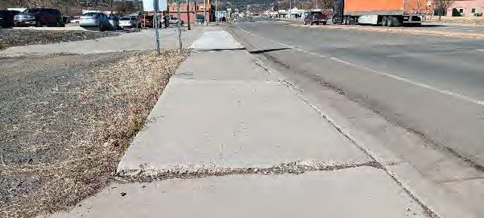
Settled Concrete causing vertical offset.
Proposed solution: Reconstruct settled sidewalk.
Proposed cost of solution: $5,000.
Priority 5 due to non-compliance being relatively minor.

- East side – Steel cover at trench doesn’t fit trench causing vertical offsets.
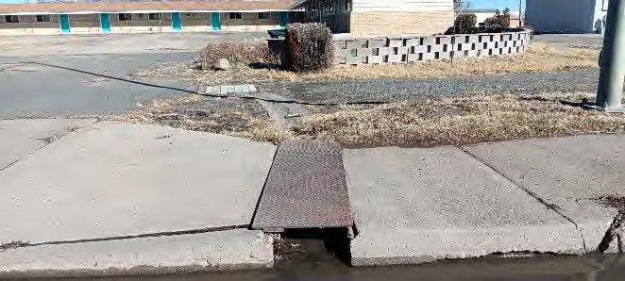
Steel trench at cover doesn’t fit causing vertical offsets.
Proposed solution: alter concrete or steel cover to fit snugly.
Proposed cost of solution: $500.
Priority 4 due to non-compliance being relatively minor and low cost of correction.

- West side – Deteriorated and broken concrete at isolated location.
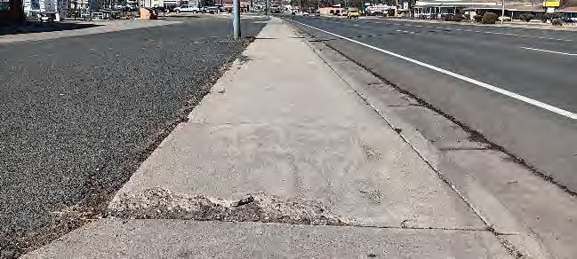
Deteriorated concrete at curb ramp.
Proposed solution: Replace deteriorated concrete.
Proposed cost of solution: $5,000.
Priority 5 due to non-compliance being relatively minor.

3.K.15. Second Street Right-Of-Way 1200 block S. 2nd Street
General Conditions: Sidewalks in good condition with isolated exceptions. See Second Street general notes for posts located at ramp landings and for detectable warning surfaces.

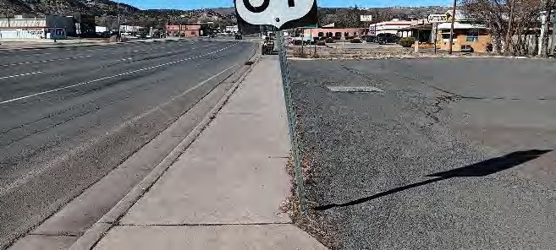
- East sidewalk – Sign 5 feet above sidewalk. 2024 Public Right-Of-Way Accessibility Guidelines (PROWAG) R402.2 requires no obstructions within 6’-8” above the walking surface.
Sign 5 feet above sidewalk.
Proposed solution: repair or replace leaning sign post. Raise sign.
Proposed cost of solution: $500.
Priority 2 due to low cost of correction.

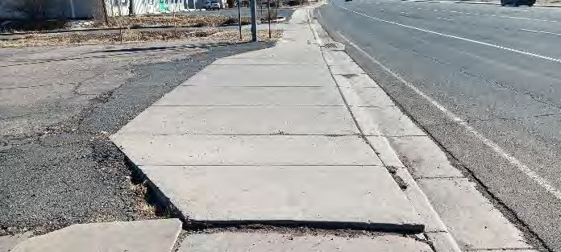
- East sidewalk – Heaved sidewalk causing 2 inch vertical step.
Heaved sidewalk causing 2” vertical step.
Proposed solution: replace heaved sidewalk, fill holes against edge of asphalt driveway.
Proposed cost of solution: $5,000.
Priority 5 due to non-compliance being relatively minor.

- East side – Deteriorated and broken concrete at isolated location.
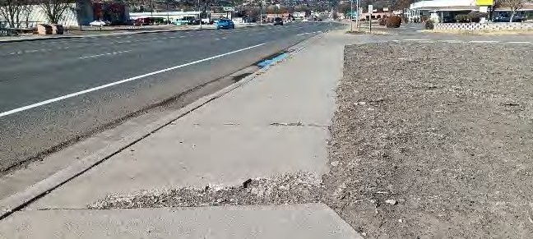
.
Deteriorated and broken concrete at isolated location. .
Proposed solution: replace deteriorated concrete.
Proposed cost of solution: $5,000.
Priority 5 due to non-compliance being relatively minor.

- West side – Deteriorated and broken concrete at isolated location causing gaps and vertical offsets in the sidewalk surface. Settled concrete at storm sewer drop inlet causing vertical offsets.
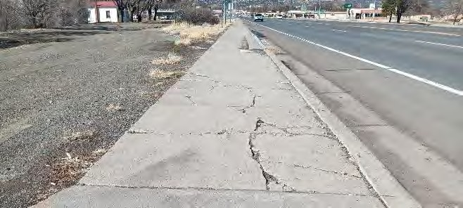
Deteriorated and broken concrete causing gaps and vertical offsets in sidewalk surface; settled concrete at storm sewer drop causing vertical offsets.
Proposed solution: replace deteriorated concrete.
Proposed cost of solution: $5,000.
Priority 5 due to non-compliance being relatively minor.

- East side – Concrete sidewalk maintains a constant width of around 4 feet without a passing space measuring at least 5 feet x 5 feet. 2024 Public Right-Of-Way Accessibility Guidelines (PROWAG) R302.3 requires a passing space measuring at least 5 feet x 5 feet spaced every 200 feet or less.

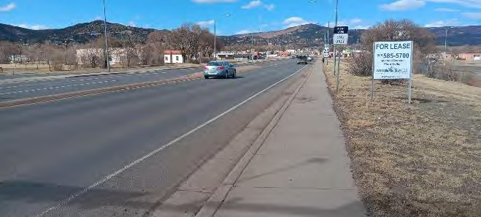
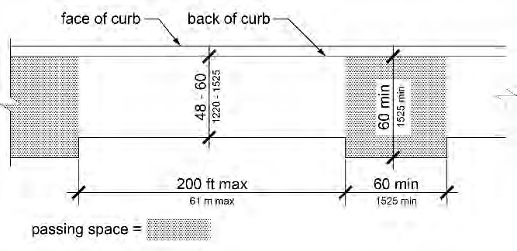
Concrete sidewalk maintains a constant width of around 4 feet without a passing space measuring at least 5 feet x 5 feet.
Proposed solution: Widen the sidewalk to at least 5 feet x 5 feet at least one place where needed to comply with the 200 feet spacing requirement .
Proposed cost of solution: $5,000.
Priority 5 due to low usage of the sidewalk at this location and low frequency of users needing a widened sidewalk to pass each other.
.

- East side – Sidewalk concrete settled or underground electrical box cover heaved, causing a 1 inch step at the edge of the box cover.

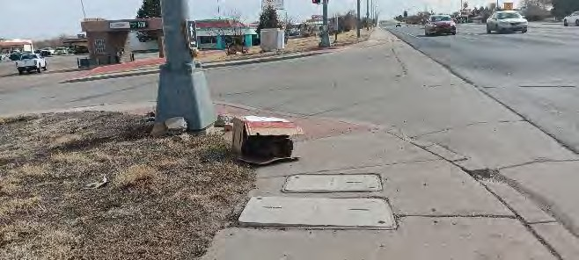
Concrete and electrical box causing 1” vertical step at edge of box cover.
Proposed solution: replace concrete around the electrical box to eliminate step.
Proposed cost of solution: $5,000.
Priority 5 due to non-compliance being relatively minor.

3.K.16. Second Street Right-Of-Way 1300 block S. 2nd Street
General Conditions: Sidewalks in good condition with isolated exceptions. See the top landing and detectable warning descriptions in the Second Street general notes.

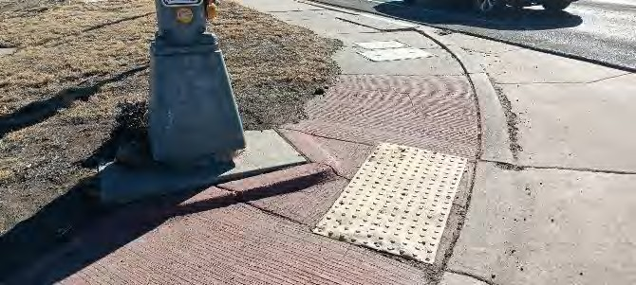
- Southeast corner of South Second Street and Hart Avenue - Base of signal post extends into ramp space.
Base of signal post extends into ramp space.
Suggested solution: reconstruct ramp to allow for clearance to signal post and provide required top landing.
Proposed cost of solution: $10,000.
Priority 5 due due to non-compliance being relatively minor.

- East side – Concrete sidewalk maintains a constant width of around 4 feet without a passing space measuring at least 5 feet x 5 feet. 2024 Public Right-Of-Way Accessibility Guidelines (PROWAG) R302.3 requires a passing space measuring at least 5 feet x 5 feet spaced every 200 feet or less.
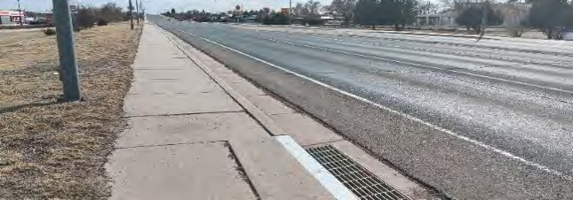
Sidewalk maintains width of around 48” without a passing space measuring 5 feet by 5 feet.
Proposed solution: Widen sidewalk to 5X5 feet in at least one place to comply with 200 feet spacing requirement.
Proposed cost of solution: $5,0000.
Priority 5 due to low usage of the sidewalk at this location and low frequency of users needing a widened sidewalk to pass each other.

- East side – Sloped edge of driveway curb cut is broken and heaved causing a vertical step of around an inch and an uneven surface.
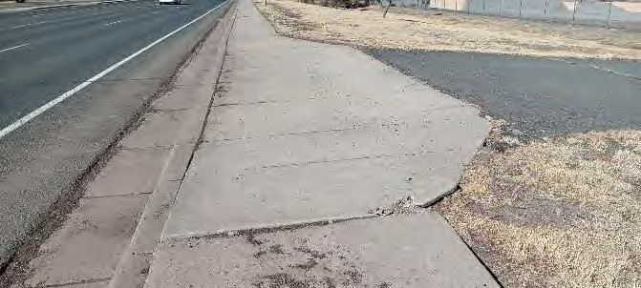
Sloped edge of driveway curb cut is broken and heaved, causing a 1” vertical step and an uneven surface.
Proposed solution: replace heaved and broken slab.
Proposed cost of solution: $5,000.
Priority 5 due to noncompliance being relatively minor.

- East side crosswalk – Asphalt connection to slab has settled causing about a 1 inch step.
Asphalt connection to slab has settled causing a 1” step.
Proposed solution: patch asphalt to provide a level transition.
Proposed cost of solution: $500.
Priority 5 due to noncompliance being relatively minor, low pedestrian usage. Correction is achievable.

3.L. Third Street Right-Of-Way

3.L.1. Third Street Right-Of-Way300 block N. 3rd Including adjacent Savage Ave.
General Conditions:
- Savage Avenue north side in front of city hall in generally good condition.
- Savage Avenue north side (across Savage Ave. north of County building) connecting to senior public housing, sidewalk in poor condition.
- Savage Avenue south side (across Savage Ave. south of City Hall) in poor condition.
- Savage Avenue south side (north of County offices, to County Clerk’s office) in fair to good condition.
Special Comments: North of Savage Avenue was not reviewed except for in front of City Hall and the adjacent street intersection. North of this location is a residential area.

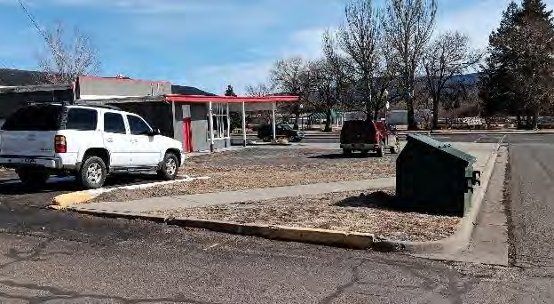
- Savage Ave. 200 block north side (in front of City Hall) – no curb ramp at southeast driveway to City Hall.
No curb ramp at southeast driveway to City Hall.
Proposed solution: replace stepped curb with a level transition from driveway to sidewalk.
Proposed cost of solution: $5,000.
Priority 1 per NCHRP guide.

3.L.2. Third Street Right-Of-Way 200 block N. 3rd Including adjacent Clark Ave.
General Conditions:
- North Third Street west side in fair to poor condition.
- North Third Street east side in a mix of fair and poor condition. Clark Avenue north side in fair condition.
- Clark Avenue south side in fair to poor condition.

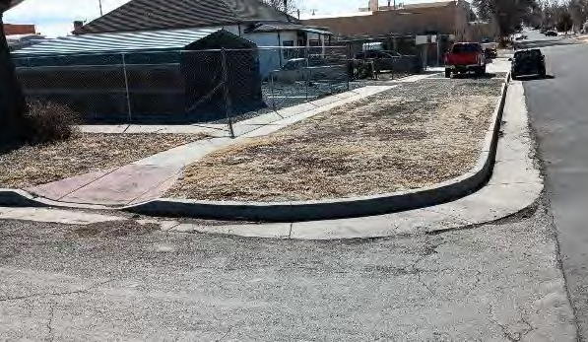
- North Third Street 200 block east side – No sidewalk or curb ramp at southeast corner of Savage for crossing 3rd Street.
No sidewalk or curb ramp at southeast corner of Savage for crossing 3rd Street.
Proposed solution: extend sidewalk and construct curb ramp.
Proposed cost of solution: $8,000.
Priority 4 per NCHRP guide.

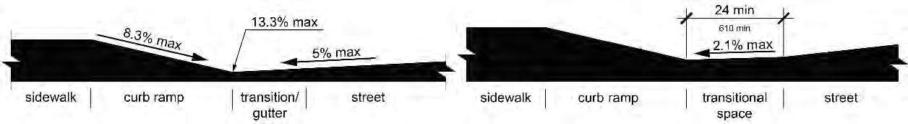
- Northwest corner of 3rd and Clark Ave. – Bottom of curb ramp at 3rd Street abruptly transitions to a steep slope from 3rd Street. PROWAG R304.5.2 requires a level (up to 2.1% slope) transitional space when the ramp slope and the street slope added together exceed 13.3%. Note that this condition is found at some other curb ramps where constructing a level landing at the bottom of the curb ramp isn’t feasible. At this 3rd and Clark location there is space to sufficiently reconstruct the curb ramp with a new transitional space at least 24 inches at the bottom of the curb ramp as shown on the diagrams below.
Maximum slope difference allowed Required for NW corner of N. 3rd & Clark Ave.
Without a 24” nearly level transition landing
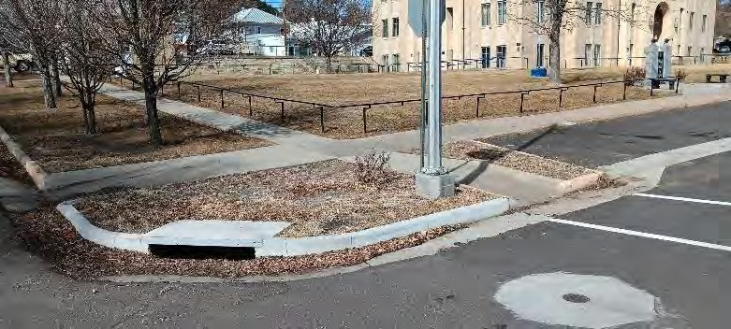
Combined slopes exceed 13.3% at one steep curb ramp.
Proposed solution: reconstruct curb ramp to 3rd Street with the required transitional space.
Proposed cost of solution: $10,000.
Priority 1 per NCHRP guide.

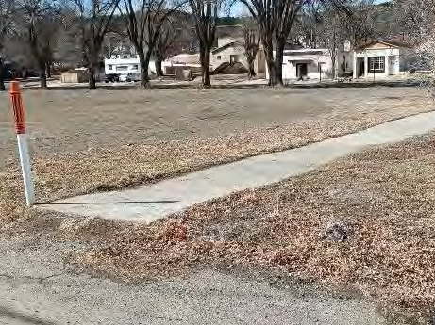
- Clark Avenue south side – No ramp at end of sidewalk connecting alley to sidewalk
No ramp at end of sidewalk.
Proposed solution: replace step from sidewalk to alley with a curb ramp.
Proposed cost of solution: $5,000.
Priority 2 per NCHRP guide.

3.L.3. Third Street Right-Of-Way 100 block N. 3rd Including adjacent Park Ave.
General Conditions:
- North Third Street west side in fair to poor condition.
- North Third Street east side has no sidewalk between curb ramps at street intersections. Park Avenue north side (west of alley) in poor condition.
- Park Avenue north side (east of alley) in fair condition. Park Avenue south side in fair condition.

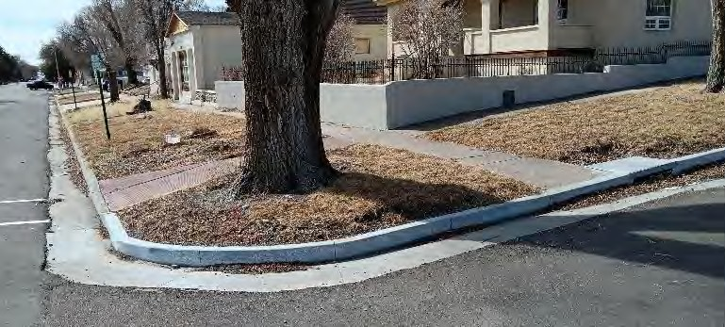
- North Third Street 200 block west side (southwest corner of 3rd and Clark) – No curb ramp at southwest corner of Clark Avenue for crossing Clark Avenue.
No curb ramp at southwest corner of 3rd and Clark.
Proposed solution: replace curb with curb ramp.
Proposed cost of solution: $8,000.
Priority 2 per NCHRP guide.

3.L.4. Third Street Right-Of-Way 100 block S. 3rd Including adjacent Cook Ave.
General Conditions:
- North Third Street west side in fair to poor condition.
- North Third Street east side in good to fair condition.
- Cook Avenue north side in good to fair condition.
- Cook Avenue south side in good to fair condition.

- Southeast corner of North Third Street and Cook Ave. – Trench under sidewalk is heaving.
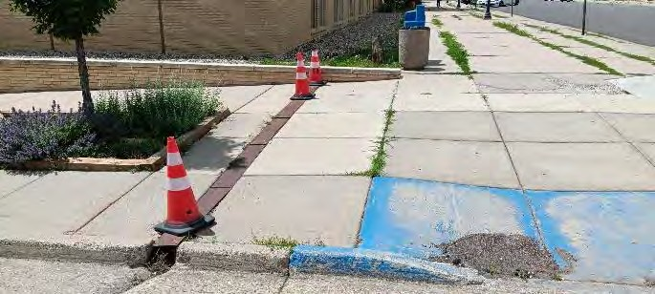
Trench under sidewalk is heaving.
Proposed solution: replace trench and adjoining concrete.
Proposed cost of solution: $10,000.
Priority 1 due to location next to a public building and high use.

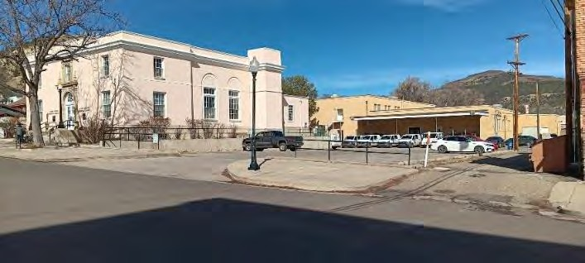
- North side Cook Ave. – Steps occur from the sidewalk to the alley and to the post office driveway.
Step from sidewalk to alley and to post office driveway.
Proposed solution: replace ends of sidewalk with smooth transition to alley surface and driveway surface.
Proposed cost of solution: $20,000.
Priority 1 per NCHRP guide.

3.L.5. Third Street Right-Of-Way 200 block S. 3rd Including adjacent Rio Grande Ave.
General Conditions:
- South Third Street west side mix of fair to poor condition.
- South Third Street east side mix of fair to poor condition.
- Rio Grande Avenue north side in fair condition.
- Rio Grande Avenue south side in fair condition.

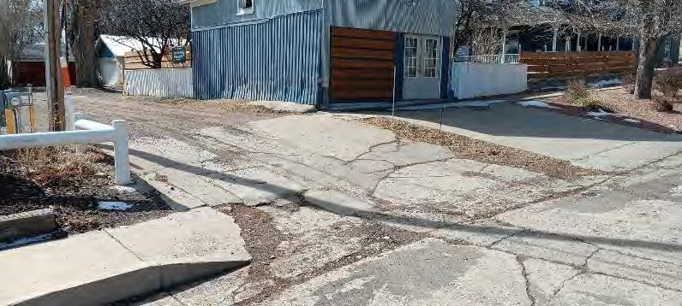
- South side of Rio Grande Avenue – Steep cross slope when crossing alley. Maximum slope when feasible is 2% per PROWAG R304.2.2.
Steep cross slope when crossing alley; slope exceeds 2%.
Proposed solution: replace and regrade alley driveway and adjacent sidewalks. Complete compliance not feasible without regrading re-routing most of the block.
Proposed cost of solution: $20,000.
Priority 3 due to cost of correction and moderate pedestrian use.

3.L.6. Third Street Right-Of-Way 300 block S. 3rd Including adjacent Apache Ave.
General Conditions:
- South Third Street west side mix of fair to poor condition.
- South Third Street east side mix of fair to poor condition.
- Rio Grande Avenue north side in fair condition.
- Rio Grande Avenue south side in fair condition.

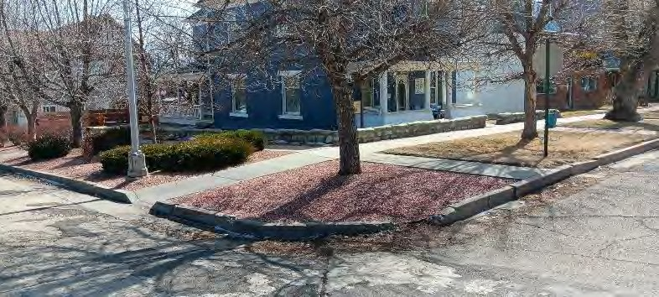
- Southeast corner of S. 3rd and Rio Grande – No curb ramp to S. 3rd Street.
No curb ramp to 3rd Street.
Proposed solution: replace stepped curb with curb ramp.
Proposed cost of solution: $8,000.
Priority 2 per NCHRP guide.

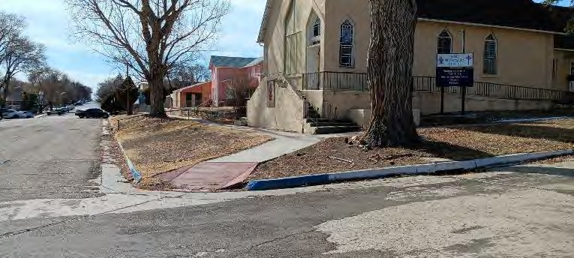
- Southwest corner of S. 3rd and Rio Grande – Curb ramp slope measures 12.5% slope. Maximum 8.3% required by PROWAG R304.3.1.
Curb ramp at 12.5% slope. Maximum allowed is 8.3%.
Proposed solution: 8.3% ramp not feasible; suggested to ramp from near church steps to the street in order to reduce slope.
Proposed cost of solution: $20,000.
Priority 5 per NCHRP guide.

- West side of S. 3rd Street – 10.5% slope at ramp to public senior housing. Maximum 8.3% required by PROWAG R304.3.1. Accessible parking not designated.
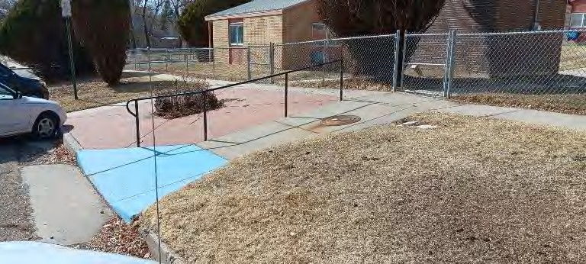
10.5% slope to public senior housing; maximum allowed is 8.3%. Accessible parking not designated.
Proposed solution: Supplement ramp with new U shaped ramp with intermediate landings. Install pavement markings to designate accessible parking and aisle; install required parking sign.
Proposed cost of solution: $40,000.
Priority 5 per NCHRP guide.

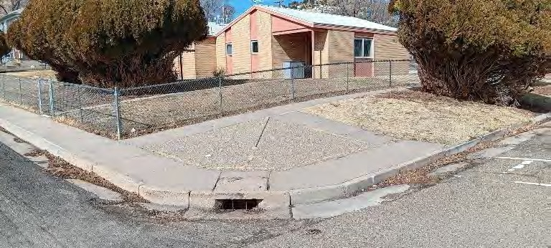
- Northwest corner of S. 3rd and Apache Avenue – No curb ramps next to public senior housing.
No curb ramps next to public senior housing.
Proposed solution: replace stepped curbs with curb ramps and handrails.
Proposed cost of solution: $20,000.
Priority 2 per NCHRP guide.

Part Four: Parks

4.A Climax Canyon
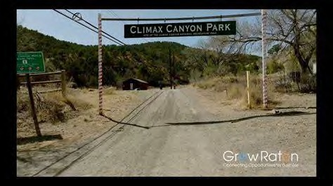
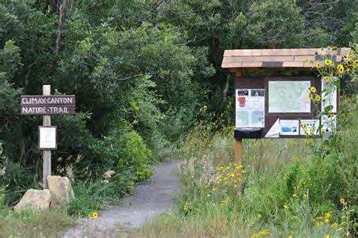
West end of Apache Avenue
Nature Trails; approximately160 acres.
Activities and Offerings: Bicycling and hiking trails
Special Conditions:
- No improvements other than a dirt road, small storage buildings for seasonal displays by a local non-profit, and maintained hiking and bicycling trails over relatively rugged terrain.
- No organized recreation or events are currently held by the City at Climax Canyon Park.

ADA doesn’t require accessible features and services when doing so would significantly change the fundamental nature of the location or activities such as requiring accessible rugged nature trails or accessible endurance competitions on the trails at the park.

4.B. Legion Park
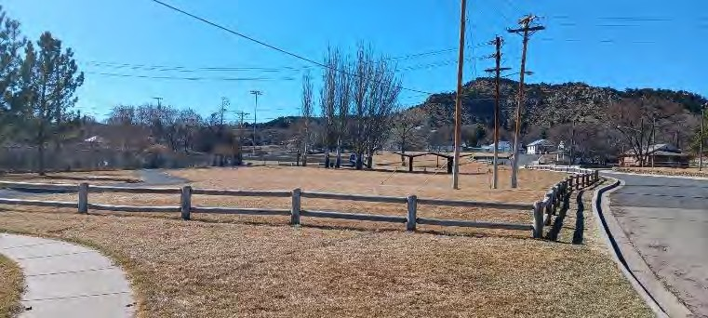
Legion Dr., South Third St.
With ball and soccer fields, ball fields and public park; approximately 16 acres.
Activities and Offerings:
- Baseball Fields
- Batting Cages
- Playground
- Off-street Parking

- Accessible Parking North
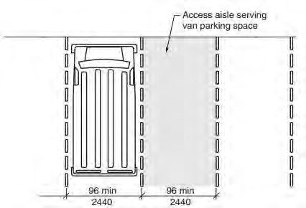
There is no designated accessible parking at the playground / picnic area.
Suggested Solution: Designate a ‘van accessible” parking space and access aisle at the east end of the Legion Drive parking where the surface is relatively level and closest to the top of the ramped sidewalk. Additional requirements apply
Projected cost of correction: $500
Priority 2 due to low cost, but lack of van accessible space doesn’t prohibit its access

Van Accessible parking option

- Accessible Parking at Gabrielle Field
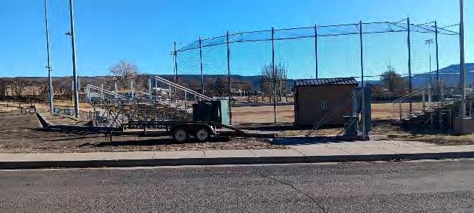
Accessible Parking at Gabrielle Field – there is no designated accessible parking
Proposed solution: Designate a ‘van accessible” parking space and access aisle near the bleachers to allow for an accessible route between the access aisle and the bleachers. Additional requirements apply related to signs and markings.
Proposed cost of solution: $500
Priority 2 per NCHRP guide. due to low cost, but lack of van accessible space doesn’t prohibit its access.

- Accessible Parking at Soccer and Little League fields – There is no designated accessible parking
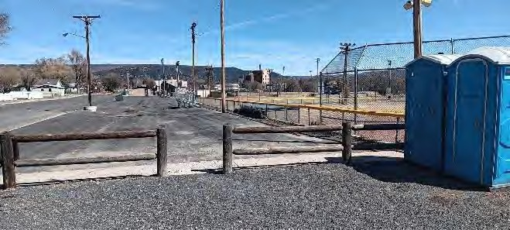
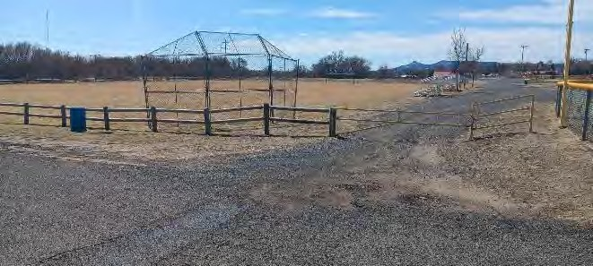
No accessible parking little league fields No accessible parking at soccer field
There is no designated accessible parking
Suggested Solution: Designate a ‘van accessible” parking space and access aisle at locations to allow for an accessible route between the access aisle and bleachers at each of the three fields. Additional requirements apply related to signs and markings.
Projected cost of correction: $500
Priority 2 due to low cost, but lack of van accessible space doesn’t prohibit its access

- North ramp railing
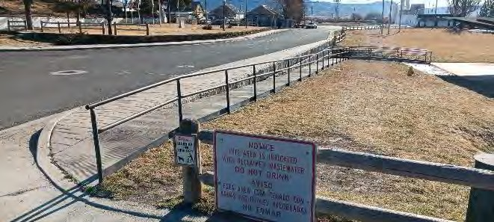
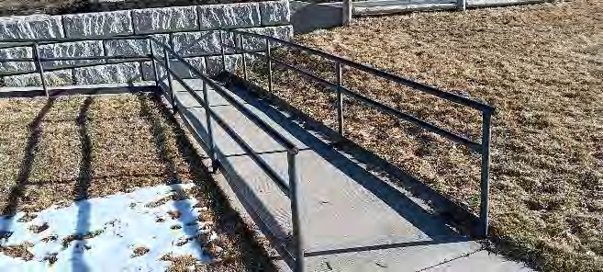
Top end of north ramp, only one handrail. Bottom end of ramp, no handrail extensions
Most of the ramp has a handrail at only one side. Americans with Disabilities Act Standards for Accessible Design (ADASAD) 505.2 requires a handrail each side of ramps. Handrails at the top and bottom of the ramp do not extend past the top and bottom of the ramp. ADASAD 505.10.1 requires railing extensions at the top and bottom of the ramp. Other requirements apply including diameter, height, and terminating the ends of the handrails. Note that the post at the top of the handrail will need to be relocated approximately 18 inches eastward in order to allow for the added handrail extension to avoid overhanging the driveway curb and walking surface at the parking slab.
Suggested solution: Add the missing handrail and rail extensions.
Projected cost of correction: $5000
Priority 5 due to some handrails already present and lack of remaining handrails doesn’t prohibit access.

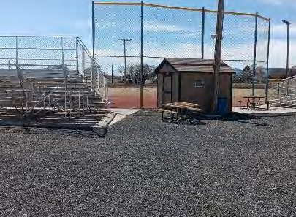
- Accessible Path of Travel Soccer and Little League fields
There is no accessible parking or accessible path of travel to the batting cages. An accessible path of travel is required to each park feature.
Suggested Solution: Provide accessible sidewalk between an entry point to the batting cages and new access aisle pavement markings beside a new accessible parking space in the nearby parking lot. Designate a ‘van accessible’ parking space in the northwest corner of the parking lot.
Projected cost of correction: $6000
Priority 4 due to seasonal use
Loose gravel surfaces (non-complying for Accessible path of travel) at little league fields

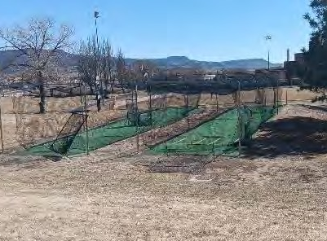
- Batting Cages Parking and Accessible Path of Travel
There is no accessible path of travel between parking, bleachers, concessions, and field. Surfaces are loose gravel and other non-complying surfaces. Some surfaces are steep.
Suggested Solution: Provide accessible routes of travel consisting of concrete sidewalks and ramps or other approved surfaces and slopes.
Projected cost of correction: $7000
Priority 4 due to mid range cost and only seasonal public use. Existing surfaces do not prohibit access.

No accessible route to the batting cages No accessible parking at nearby parking lot

- Play Area Surfaces –
US Access Board Guide to the ADA Accessibility Standards recognizes the need for soft surfaces in Playground Use Zones (the area under and adjacent to playground equipment) for safety of those playing so the accessible route within the Playground Use Zones according to the US Access Board can be
- poured in place rubber
- rubber tiles
- engineered wood fiber, or
- a hybrid or combination of the other three

Note that each of the four surfaces recognized as complying with ADA requirements at Playground Use Zones have safety and insurance industry standards independent of ADA requirements and the materials considered safe are usually certified for Playground Use Zone surfaces. For instance just any wood fiber or bark product doesn’t automatically comply with recognized playground industry standards for safety and insurance requirements.
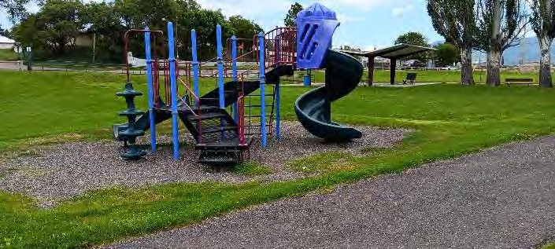
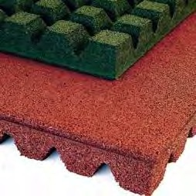
Gravel surface under the playset assembly. Sample of rubber tile surface
Grass, gravel, and sand are not recognized as acceptable playground surfaces for ADA or for safety purposes
Suggested Solution: Replace gravel at the Playground Use Zone to at least the depth and distance recommended by the equipment manufacturer and industry standards for each piece of playground equipment. Extend new surface to edge of asphalt sidewalk to eliminate the turf surface between the play surface and the accessible route. Replace with one of the acceptable surface materials. Include felt liner mats, manufactured border, and border ramp.
Projected cost of correction: $19,000 for certified wood fiber surface and accessories
Priority 5 due to high cost and how existing surface is close to compliance.

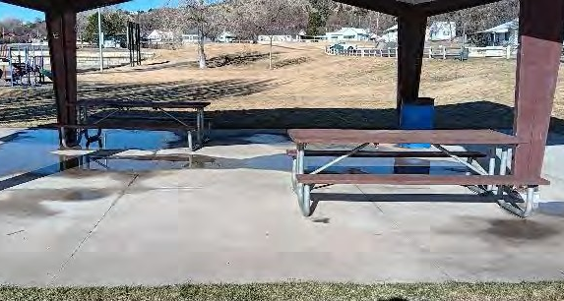
- Tables
One table is required to be accessible with required knee space. Other requirements apply such as table height and knee space dimensions.
Suggested Solution: Provide at least one accessible table with the other tables
Projected cost of correction: $2500
Priority 4 due to moderate cost and how lack of complying tables does not prohibit use.
Tables have no knee space.

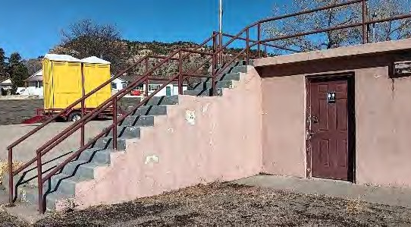
- Restrooms
Restrooms are not accessible per ADA standards
Park restrooms are not accessible by ADA standards due many dimensional requirements and other factors. Since restrooms are provided then accessible restrooms of similar quality and ease of access are required to be provided as well.
Suggested Solution: Construct new accessible restrooms
Projected cost of correction: $220,000
Priority 2 due to high need but seasonal use and high cost

Total Cost of Corrections at Park: $261,000 plus tax

4.C. Optimist Park
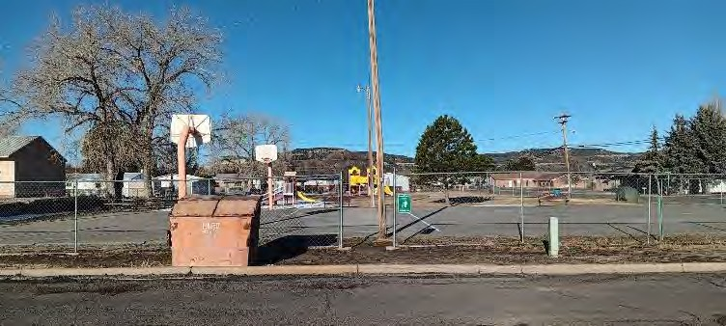
Kearney Avenue
Use: Public park
Approximate area: 1 acre
Activities and Offerings: Playground and Basketball

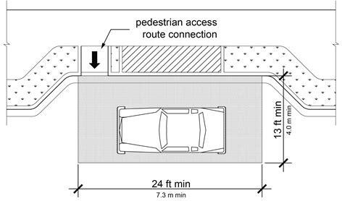
- Accessible Parking
No accessible parking is designated and no accessible route from the on-street parking to the openings in the chain link fence surrounding the park.
Suggested Solution: Since there is no sidewalk beside the streets surrounding Optimist Park the solution could be to indent the street curb to provide the required access aisle on the passenger side of the vehicle. Provide a curb ramp from the access aisle to a new accessible path of travel (sidewalk) from the top of the new curb ramp to the park. Additional requirements apply to the surfaces, slopes, markings, signs, sidewalks, and more as found in 2010 Americans With Disabilities Act Standards for Accessible Design (ADASAD)
Projected cost of correction: $20,000
Priority 4 due to cost and park is smaller and less used than other parks.
Accessible on-street parking option

- Accessible Path of Travel
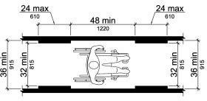
Minimum 36 inch accessible route (sidewalk) width inside the park boundaries.
An accessible path of travel is required between each park feature including each piece of play equipment. Exceptions are to items such as benches, tables, or grilles when those items are duplicate to accessible benches, tables, and grilles so that at least one accessible item is provided with an accessible path of travel to the accessible item. Playground equipment is not included in the exception and requires an accessible path of travel to each.
2010 Americans With Disabilities Act Standards for Accessible Design (ADASAD) 302.1 requires accessible paths of travel to be stable, firm, and slip resistant. While ADASAD and the US Access Board Guide to the ADA Accessibility Standards don’t specifically exclude turf and gravel as acceptable surfaces from accessible paths of travel they prohibit carpet more than ½ inch thick and recommend avoiding gravel surfaces unless the gravel is packed firmly or used with a binder to avoid loose gravel. It therefore can be interpreted that turf, loose gravel, and wood chips are not normally acceptable surfaces for an accessible path of travel
Projected cost of correction: $15,000
Priority 5 due to cost and park is smaller and less used than other parks.

- Play Area Surfaces - US Access Board Guide to the ADA Accessibility Standards recognizes the need for soft surfaces in Playground Use Zones (the area under and adjacent to playground equipment) for safety of those playing so the accessible route within the Playground Use Zones according to the US Access Board can be
- poured in place rubber
- rubber tiles
- loose engineered wood fiber, or
- a hybrid or combination of the other three

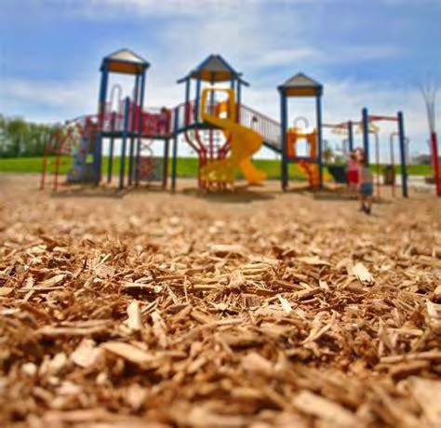
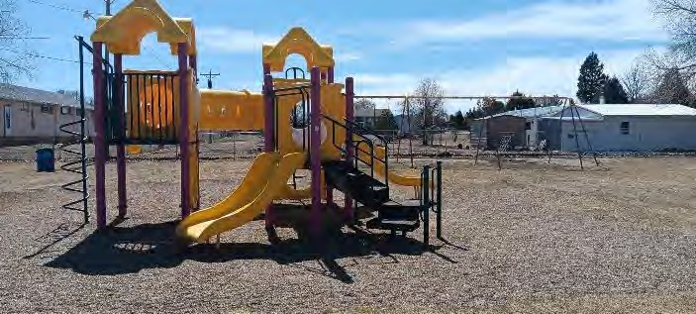
Note that each of the four surfaces recognized as complying with ADA requirements at Playground Use Zones have safety and insurance industry standards independent of ADA requirements and the materials considered safe are usually certified for Playground Use Zone surfaces. For instance just any wood fiber or bark product doesn’t automatically comply with recognized playground industry standards for safety and insurance requirements.
Grass, loose gravel, and sand are not recognized as acceptable playground surfaces for ADA or safety purposes.
Suggested Solution: Replace gravel at the Playground Use Zone to at least the depth and distance recommended by the equipment manufacturer and industry standards for each piece of playground equipment. Replace with one of the acceptable surface materials. Include felt liner mats, manufactured border, and border ramp.
Projected cost of correction: $26,000 for certified wood fiber surface and accessories
Priority 5 due to cost.

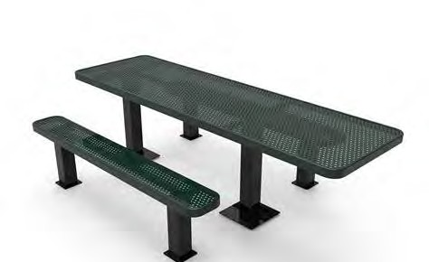
- Tables
Since tables are provided then at least one is required to be accessible with required knee space
Suggested Solution: Provide at least one accessible table on an accessible route
Projected cost of correction: $2500
Priority 4 due to currently no accessible route present to tables and existing tables to no prohibit use

Sample of accessible table with knee space
Total Cost of Corrections at Park: $63,500 plus tax

4.D. Tennis and Pickle Ball Courts
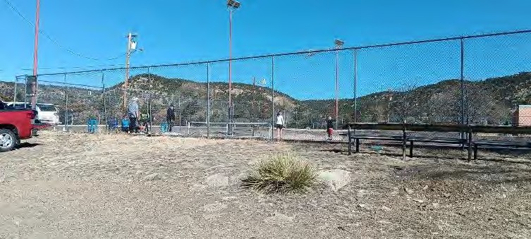
Tiger Drive
Use: Tennis and Pickleball Courts Approximate area:1 acre
Activities and Offerings: Tennis and Pickleball Courts for public use
Special Conditions: There are two individually fenced courts located close together at the north end of the school property. Ownership of the courts between the City of Raton and Raton Public Schools is cloudy following the last time there were major maintenance and improvements performed in the mid 1980s. The land under the courts is part of the High School campus. The ownership and maintenance responsibilities of the courts is not clearly defined.
The court surfaces, markings, and nets are scheduled to be upgraded by the City of Raton in 2025.
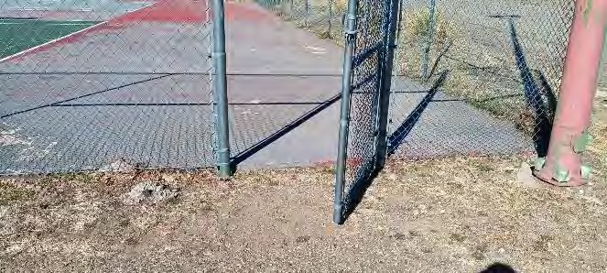
The schools will continue to have priority for use at times to be determined.
No accessible parking. No accessible routes. Two-inch step at gates.
There are parking areas located at or near each of the two fenced courts but no designated accessible parking and no accessible route to the court gates. The existing parking is gravel and degrading asphalt. There are benches outside of the court for spectator seating but no hard level surface for an accessible wheelchair space beside the seating and no accessible route to the seating.
Suggested Solution: Since the surface height of the courts is expected to be affected by the work planned for 2025 it is suggested that the accessible route to the courts be constructed during or after the scheduled court work
Projected Cost of Corrections: $30,000
Priority 4 due to cost.

4. E. Ripley Park
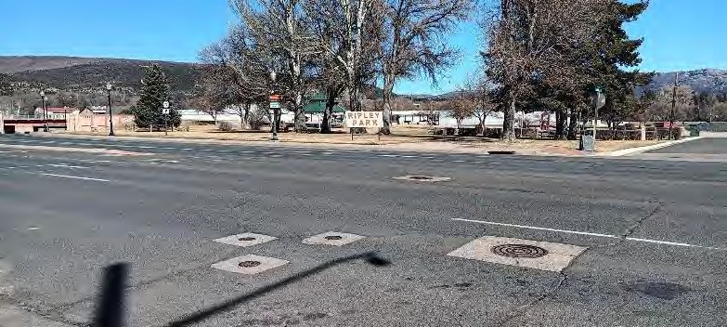
Second Street
Use: Public park
Approximate area: 2 acres
Activities and Offerings:
- Gazebo/bandstand
- Concerts
- Festivals
- Playground

- Accessible Parking
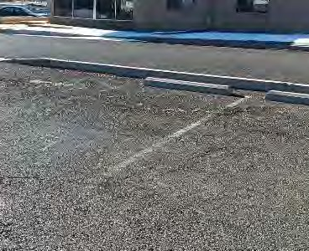
The only designated accessible park space at Ripley Park is in a small off-street parking lot. The designated space is located on the opposite end of the parking lot from the curb ramp to access the park. It lacks an 8 foot wide access aisle to make the accessible parking space qualify as van accessible which is required, and lacks a pole sign. Pavement markings are faded.

Suggested Solution: Either a) Relocate the accessible parking space with markings, access aisle, and signs to the space closest to the curb ramp, or b) Upgrade the existing accessible space with the required markings, access aisle, and new sign, then add a curb ramp to allow access from the parking space to the playground equipment. See the Accessible Path of Travel description if option b is to be considered
Projected cost of correction: $4000
Priority 1 due to frequent use

Existing accessible parking location and markings

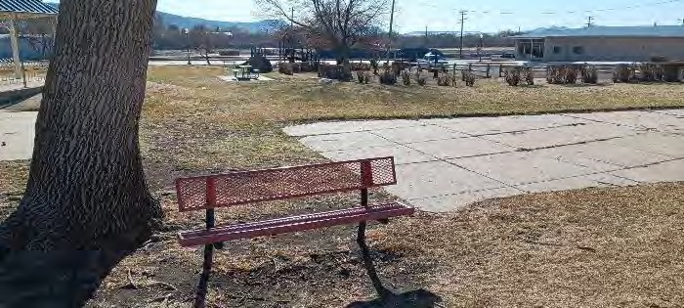
- Accessible Path of Travel
No accessible path surface between park features
An accessible path of travel is required between each park feature including each piece of play equipment. Exceptions are to items such as benches, tables, or grilles when those items are duplicate to accessible benches, tables, and grilles so that at least one accessible item is provided with an accessible path of travel to the accessible item. Playground equipment is not included in the exception and requires an accessible path of travel to each. See the Play Area Surfaces description.
2010 Americans With Disabilities Act Standards for Accessible Design (ADASAD) 302.1 requires accessible paths of travel to be stable, firm, and slip resistant. While ADASAD and the US Access Board Guide to the ADA Accessibility Standards don’t specifically exclude turf and gravel as acceptable surfaces from accessible paths of travel they prohibit carpet more than ½ inch thick and recommend avoiding gravel surfaces unless the gravel is packed firmly or used with a binder to avoid loose gravel. It therefore can be interpreted that turf, loose gravel, and wood chips are not normally acceptable surfaces for an accessible path of travel.
Suggested Solution: Provide concrete sidewalks connecting the accessible parking, at least some benches, accessible table, gazebo, and playground equipment.
Projected cost of correction: $20,000
Priority 5 due to cost and how features are already partially served by accessible paths.

- Play Area Surfaces - US Access Board Guide to the ADA Accessibility Standards recognizes the need for soft surfaces in Playground Use Zones (the area under and adjacent to playground equipment) for safety of those playing so the accessible route within the Playground Use Zones according to the US Access Board can be
  - poured in place rubber
  - rubber tiles
  - engineered wood fiber, or
  - a hybrid or combination of the other three

Note that each of the four surfaces recognized as complying with ADA requirements at Playground Use Zones have safety and insurance industry standards independent of ADA requirements and the materials considered safe are usually certified for Playground Use Zone surfaces. For instance, just any wood fiber or bark product doesn’t automatically comply with recognized playground industry standards for safety and insurance requirements.
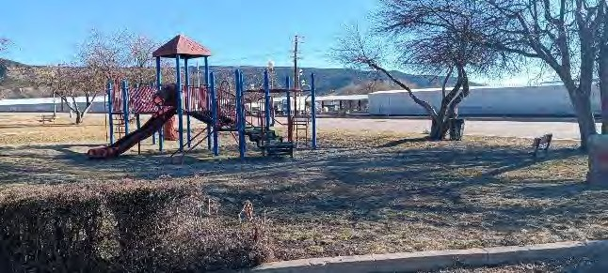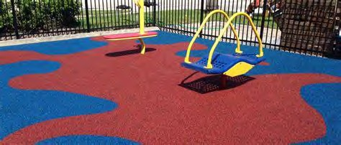
Gravel under playground equipment Sample of poured in place rubber surface
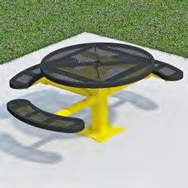
- Tables
Since tables are provided then at least one is required to be accessible with required knee space
Suggested Solution: Provide at least one accessible table on an accessible route.
Projected cost: $2500
Priority 4 due to how existing tables do not prohibit use.

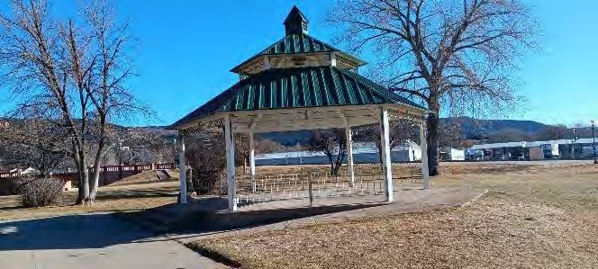
- Gazebo
The ramp and steps lack handrails each side. Americans with Disabilities Act Standards for Accessible Design (ADASAD) 505.2 requires a handrail each side of ramps and steps. Additional requirements apply to the handrail design and construction.

Suggested Solution: Add handrails each side of the gazebo steps and ramp.
Projected cost: $8000
Priority 5 due to lack of handrails do not prohibit access.

Total Cost of Corrections at Park: $54,500 plus tax

4.F. Romero Park
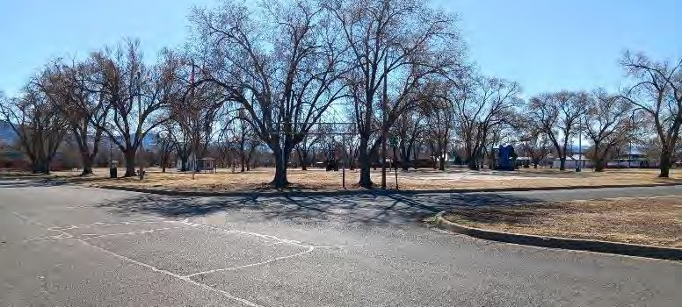
Sugarite Avenue
Use: Public park
Approximate area: 3 acres
- Activities and Offerings: Playground
- Basketball
- Picnic
Special Conditions: Upgrades are planned and funded for the Park including a new skate park and bicycle pump track. Details are not resolved yet.
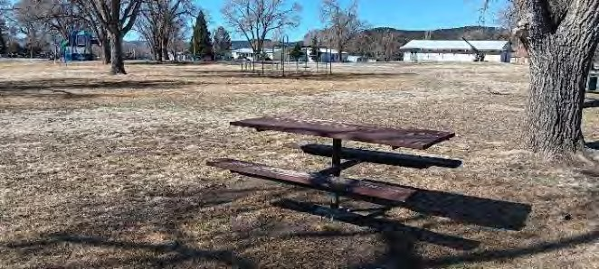
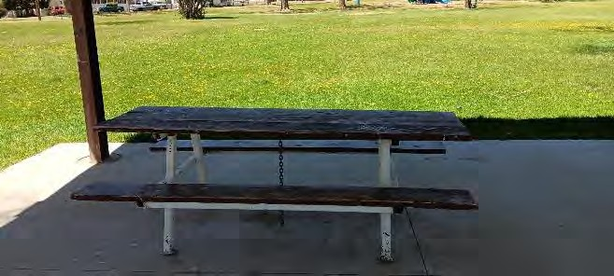
The park currently has two picnic tables that space at the ends of each table that qualify as the required knee spaces. Only one has the required hard smooth ground surface. If only two tables are provided then only one is required to be accessible.
Table at Romero Park and surface below. Provide the required knee space and ground under the table isn’t hard or level. hard level surface.

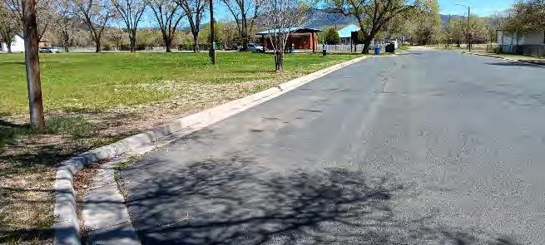
- Accessible Parking
Accessible on-street parking option Existing curb offset w/o ‘van accessible’ dimensions.
A dirt and gravel surface at the Sugarite Avenue right-of-way at the north end of the park is used for parallel parking. On-street asphalt parking is available on E. Eight and E. Seventh Streets long the east and west edges of the park. The south edge of the park includes a curb line that indents from E. Clark Avenue northward around 10 feet x 150 feet so the indentation is too shallow to allow for angled parking without the backs of the parked vehicles extending into the road.
Parking on all four sides of the park, not including parallel parking across the street from the park, totals approximately 50 unmarked spaces. 2010 Americans with Disabilities Act Standards for Accessible Design (ADASAD) requires two accessible parking spaces when the total number of parking spaces is between 26 and 50.
Suggested Solution: Provide at least two accessible parking spaces. Locations to be determined after the park revisions are better known. At least one space is required to be ‘van accessible’. See the Accessible Path of Travel description related to connecting the accessible parking with sidewalks to park features. Depending on how the rest of the park will be redeveloped the least costly locations for accessible parking
A similar configuration might be appropriate for E. Clark Avenue for a non van accessible space.
Projected cost of correction: $30,000
Priority 4 due to low traffic volume on adjacent streets making access low hazard might be at the existing parking off of Sugarite Avenue or off of E. Clark Avenue.

- Accessible Path of Travel
Minimum 36 inch accessible route (sidewalk) width inside the park boundaries.
An accessible path of travel is required between each park feature including each piece of play equipment. Exceptions are to items such as benches, tables, or grilles when those items are duplicate to accessible benches, tables, and grilles so that at least one accessible item is provided with an accessible path of travel to the accessible item. Playground equipment is not included in the exception and requires an accessible path of travel to each. See the Play Area Surfaces description.
2010 Americans With Disabilities Act Standards for Accessible Design (ADASAD) 302.1 requires accessible paths of travel to be stable, firm, and slip resistant. While ADASAD and the US Access Board Guide to the ADA Accessibility Standards don’t specifically exclude turf and gravel as acceptable surfaces from accessible paths of travel they prohibit carpet more than ½ inch thick and recommend avoiding gravel surfaces unless the gravel is packed firmly or used with a binder to avoid loose gravel. It therefore can be interpreted that turf, loose gravel, and wood chips are not normally acceptable surfaces for an accessible path of travel.
Suggested Solution: Provide concrete sidewalks connecting the accessible parking, at least some benches, accessible table, gazebo, and playground equipment. No accessible path surface between park features
Projected cost of correction: $20,000
Priority 5 due to cost and how features are already partially served by accessible paths.

- Play Area Surfaces - US Access Board Guide to the ADA Accessibility Standards recognizes the need for soft surfaces in Playground Use Zones (the area under and adjacent to playground equipment) for safety of those playing so the accessible route within the Playground Use Zones according to the US Access Board can be
- poured in place rubber
- rubber tiles
- loose engineered wood fiber, or
- a hybrid or combination of the other three

Note that each of the four surfaces recognized as complying with ADA requirements at Playground Use Zones have safety and insurance industry standards independent of ADA requirements and the materials considered safe are usually certified for Playground Use Zone surfaces. For instance just any wood fiber or bark product doesn’t automatically comply with safety industry standards.

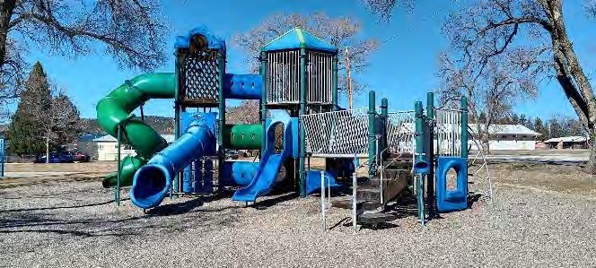
Gravel surface at play structure at Romero Park. Sample of engineered Wood Fiber Grass C
packed soil at swings not pictured.
Grass, gravel, and sand are not recognized as acceptable playground surfaces for ADA or safety purposes.
Suggested Solution: Replace gravel at the Playground Use Zone to at least the depth and distance recommended by the equipment manufacturer and industry standards for each piece of playground equipment. Replace with one of the acceptable surface materials. Include felt liner mats, manufactured border, and border ramp.
Provide an accessible route (sidewalk) to the edge of the playground surface.
Projected cost of correction: $20,000 for certified wood fiber surface and accessories
Priority 5 due to cost and how existing gravel surface comes close to compliance.

Total Projected Cost of Corrections at Romero Park: $100,000 plus tax

4.G. Roundhouse Memorial Park
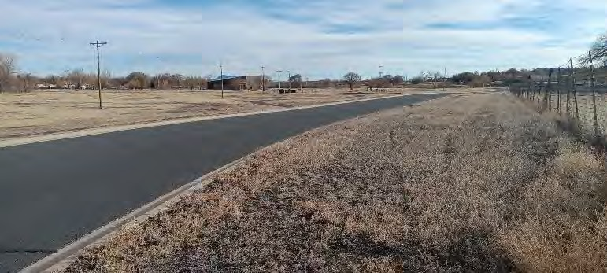
Memorial Lane
Use: Public park
Approximate area:70 acres
Activities and Offerings:
- Maintained asphalt walking trails Disc Golf
- Horseshoe Dog park Picnic shelters
- Open space
Special Conditions: The Raton Aquatic Center is located in the Roundhouse Memorial Park. The Aquatic Center for this ADA Transition Plan is reviewed separately from the Park. The only designated parking area in Roundhouse Park is at the Aquatic Center. Parking at the Aquatic Center for this ADA Transition Plan is reviewed with the Aquatic Center and not in this review of Roundhouse Park.
The maintained walking trails are all on level terrain, are nearly all constructed of asphalt, and are all in relatively fair to good condition with few items in need of correction for accessibility.

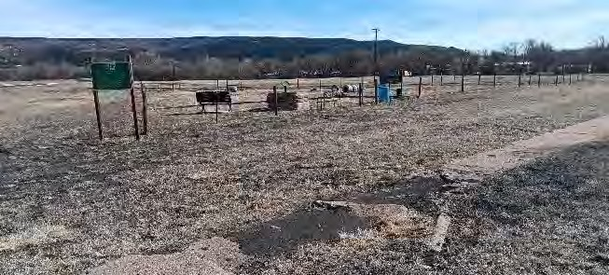
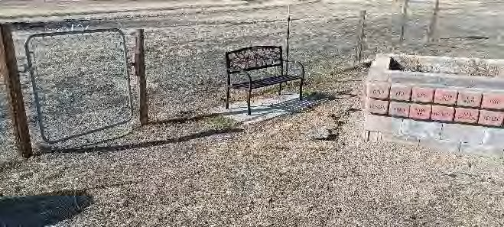
- Dog Park Accessible Route
No accessible path surface to or within the dog park.
The fenced dog park is sized approximately one half acre within Roundhouse Park. There is no accessible route to the fenced dog park and no accessible route from the gates to anywhere within the enclosure such as a nearby bench. 2010 Americans With Disabilities Act Standards for Accessible Design (ADASAD) 302.1 requires accessible paths of travel to be stable, firm, and slip resistant. While ADASAD and the US Access Board Guide to the ADA Accessibility Standards don’t specifically exclude turf and gravel as acceptable surfaces from accessible paths of travel they prohibit carpet more than ½ inch thick and recommend avoiding gravel surfaces unless the gravel is packed firmly or used with a binder to avoid loose gravel. It therefore can be interpreted that turf, loose gravel, and wood chips are not normally acceptable surfaces for an accessible path of travel. PARKS – ROUNDHOUSE MEMORIAL PARK page 2
Suggested Solution: Provide asphalt or concrete walking surfaces that connect the dog park gate to an existing asphalt walking trail which already connects to the existing accessible parking at the Aquatic Center, or provide a new accessible walking surface to a new closer accessible parking area constructed at the same time as the new accessible route. Also construct a new asphalt or concrete route from the inside of a gate to a bench inside the fenced enclosure.
Projected cost of correction: $ 40,000 sidewalk and new nearby accessible parking.
Priority 5 due to cost.

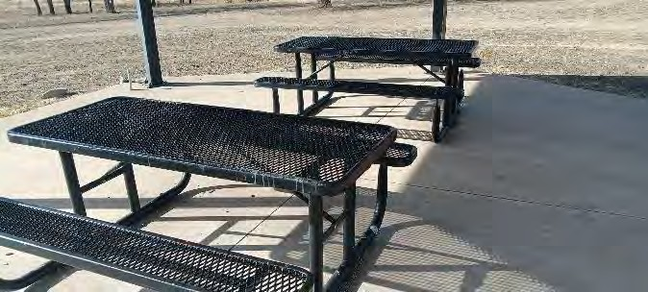
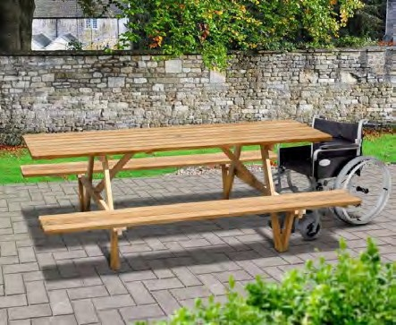
- Tables
Picnic tables are not accessible Sample of accessible table with knee space
Two picnic / shade shelters have picnic tables. Since tables are provided at least one table at each shelter is required to be accessible with required knee space. Since the shelters are in different parts of the park each shelter should have an accessible table. Additional requirements apply to a new table such as the height of the table surface and the dimensions of the knee space.
Suggested Solution: Provide at least one accessible table at each of the two shelters
Projected cost of correction: $4000
Priority 4 due to how existing tables to not prohibit use.

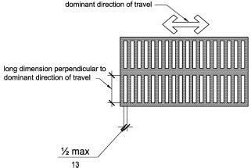
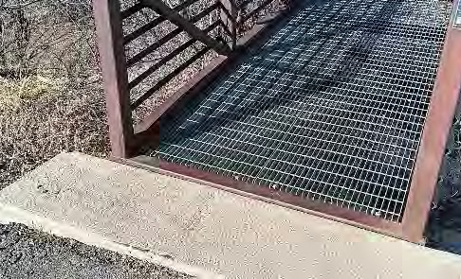
- Footbridge Surface
Bridge surface has openings that do not comply.
The footbridge surface is made of steel grates that have openings approximately five inches long in the direction of travel by 1 inch wide. ADASAD 302.3 requires openings in the walking surface to be a maximum of ½ inch long in the direction of travel.
Suggested Solution: Evaluate with the bridge manufacturer or with a structural engineer to determine if the bridge deck can be decked over with the added weight of the new deck material and of anticipated snow that will accumulate if the open grates are decked over. If structurally allowed from the additional weight then install plank decking above the existing steel grates. Adjust the tops of the concrete abutments and adjacent asphalt for the new higher deck surface.
Projected cost of correction: $30,000
Priority 5 due to cost and bridge being in an isolated leg of the walking trail system.

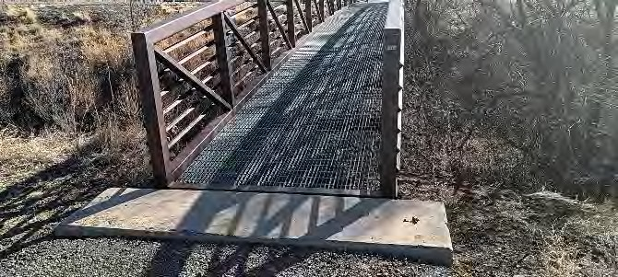
- Footbridge Abutment Surface
Step from asphalt to bridge abutments, both ends of bridge
The top of the concrete abutment at each end of the footbridge serves as part of the walking surface. The asphalt surface beside the concrete has settled causing a step of approximately one inch.
Suggested Solution: Build up asphalt against the edge of the concrete to provide a level transition.
Projected cost of correction: $300
Priority 2 due to being readily achievable.

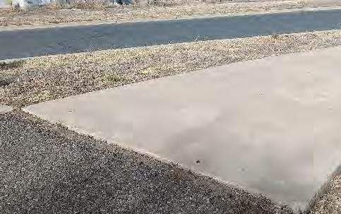
- Asphalt to Concrete
The asphalt and concrete have settled differently causing a one inch step in the walking path near the north end of the park.
Suggested Solution: Build up asphalt against the edge of the concrete to provide a level transition. Step from asphalt to concrete sidewalk.
Projected cost of correction: $200
Priority 2 due to being readily achievable
Step from asphalt to concrete sidewalk.

Total Cost of Corrections at Park: $74,500 plus tax

4.H. Veteran’s Park
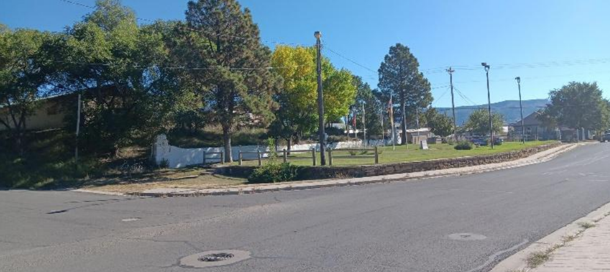
Legion Dr., South Third St.

Use: Monument
Approximate area: 0.2 acres
Activities and Offerings: Landscaped monument with flagpoles, engraved stone, and memorial bricks.
Special Conditions: The engraved stone monument is legible while driving slow or parked on Legion Drive so the stone monument doesn’t necessarily lack accessibility.
The retaining walls on site are registered by the New Mexico Historic Preservation Division (HPD) as a contributing property in the Raton Original Townsite Historic District so the walls cannot be altered without approval by HPD.
As an alternative to constructing costly new alterations the features of Veteran’s Park that are required to be reached by an accessible route (benches and memorial bricks) could be relocated to a more accessible location such as nearby Legion Park or eliminated if acceptable to the City and public. The engraved stone monument and flagpoles could be left in place so that Veteran’s Park has no features requiring user access.

- Accessible Parking
Parking for Veteran’s Park is located cadi-corner from Veteran’s Park at Legion Park. See the Legion Park description regarding the lack of designated accessible parking at the north end of Legion Park.
Projected cost of correction: included in Legion Park projected costs

- No curbs ramps
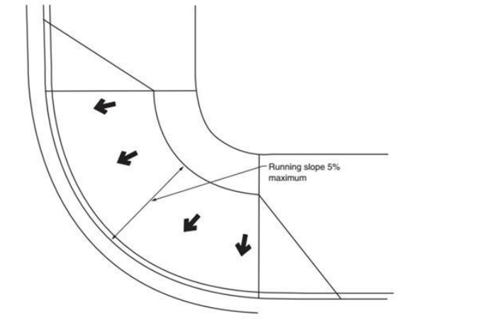
There are no curb ramps or marked crosswalks connecting the parking area at Legion Park to Veteran’s Park.
Suggested Solution: Add crosswalks and curb ramps. Each of the possible configurations requires at least one crosswalk and at least two curb ramps.
Projected cost of correction: $4000
Priority 5 due to low use by pedestrians.
No curb ramps
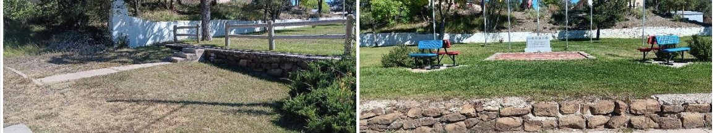
- Accessible Route within Veteran’s Park
Currently if pedestrians wish to reach the memorial the most obvious route includes climbing steps that don’t comply with Americans with Disabilities Act Standards for Accessible Design (ADASAD) requirements and without connecting sidewalks. Other routes require stepping over a low retaining wall or similar obstacles. The path of travel for all routes include gravel and turf surfaces.
Suggested Solution: Construct sidewalks and ramps connecting the curb ramp noted earlier with the memorial brick pavers and with at least one bench if benches are to remain present. Since the memorial bricks are surrounded by an uneven stone border the new sidewalk at the memorial bricks will need to be constructed so that the bricks themselves and the stone borders aren’t part of the accessible route surface. If the new sidewalks are placed right the text on the bricks can be read without the reader being on the bricks. Furthermore the bricks are currently installed with gaps between the bricks that don’t provide a suitable surface for an accessible route that complies with Americans with Disabilities Act Standards for Accessible Design (ADASAD) 302.3. Removing the part or all of the stone border and reconfiguring the bricks to avoid gaps between the bricks is also an option that could allow the engraved memorial bricks to be part of the accessible route surface.
ADASAD 903.2 requires accessible benches to have an accessible wheelchair space of a minimum size beside the bench such as an extension from the sidewalk surface allowing a wheelchair to be placed beside the bench. Additional requirements in ADASAD 903 apply to the accessible bench dimensions
Depending on the new sidewalk and ramp configuration the ramp will likely need to include handrails each side and possibly switchbacks
Projected cost of correction: $10,000
Priority 5 due to low use by pedestrians.

Part Five: City Facilities

5.A. Raton Animal Shelter
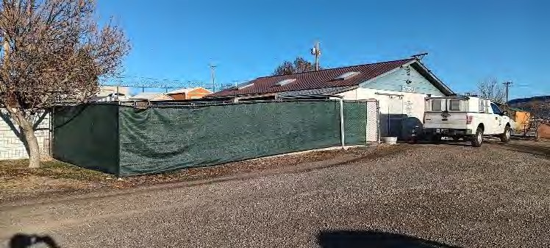
448 Hereford Avenue
Use: City Animal Shelter Approximate construction date:
1985 with small detached indoor and outdoor kennels added various times later.
Activities and Offerings: Temporary dog and cat sheltering. Pet adoption.
Special Conditions: The facility is owned by the City of Raton. The facility is staffed by the City of Raton and by volunteers from the Raton Humane Society.
The City of Raton is actively pursuing State funding to either replace the shelter facility or add to it and will comply with ADA requirements. Since the new or altered facility is planned to comply with ADA requirements the existing facility is not reviewed for this ADA Transition Plan.

5.B. Aquatic Center
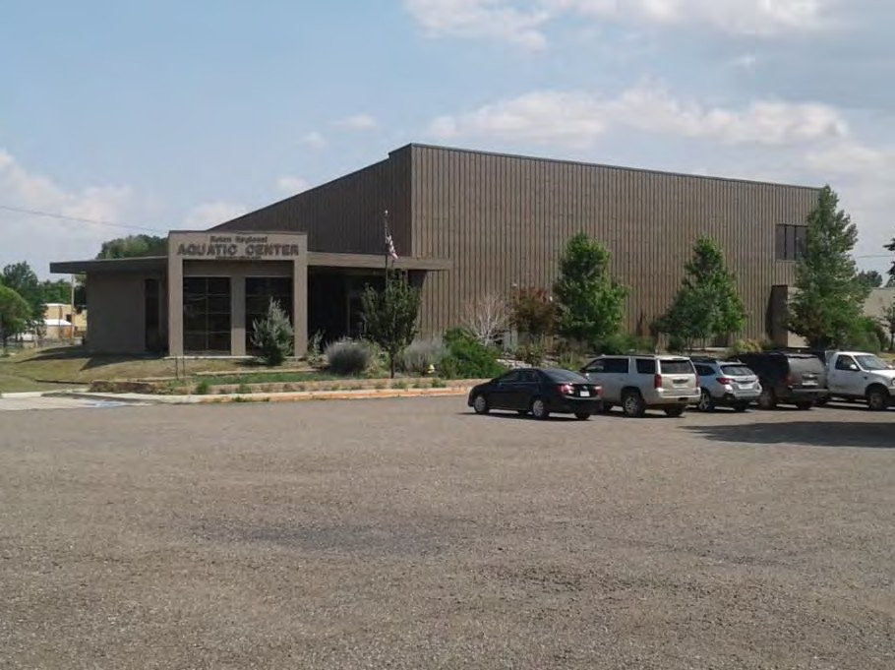
100 Memorial Lane

Use: Indoor pool
Approximate construction date: 2011 Activities and Offerings:
Indoor recreation and exercise centered around the indoor pool. Party room and pool rented to public for special events. Swimming lessons offered.
Special requirements related to Swimming Pools: Dimensional and similar requirements specifically applying to swimming pools and recreation elements were not included in ADA requirements prior to 2012. Since this Raton facility was constructed prior to 2012 the “safe harbor” provisions of the current ADA requirements exempt the swimming pool area from being required to be altered to comply with the current 2010 ADA Standards for Accessibility which took effect in 2012.

When the swimming pool area is altered in the future, for instance if reconstructing a wading pool, then the area altered will be required to comply with current standards.
Readily achievable alterations are required to be made to comply with current requirements for new construction, even though those requirements weren’t in place when originally constructed. One example might be to adjust a sign height that is too high by current ADA standards for new construction.

- Parking Signs
Parking signs are mounted 4’-3” and 4’-9” above the sidewalk. ADA Standards for Accessible Design (ADASAD) 502.6 requires a minimum height of 5’ to the bottom of the sign.
Suggested solution: Mount same signs higher. Post replacement or extension will be required due to the increased height.
Projected Cost of Correction: $ 400
Priority 2 due to being readily achievable.
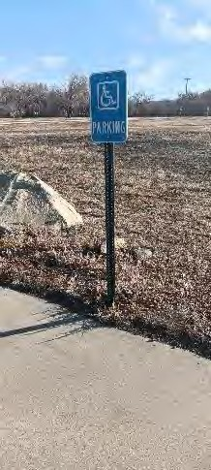
Sign too low.

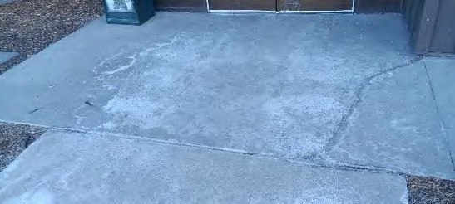
- Entry Sidewalk Joints:
Expansion joints in the sidewalks have deteriorated filler causing gaps in the sidewalk over ½” wide. ADASAD 302.3 requires gaps such as joints to be not more than ½” wide.
Suggested solution: Clean deteriorated joint material from top of concrete expansion joints and add sealant with the top of the sealant flush with the top of the adjacent concrete surfaces. Gaps are found at the accessible parking area, near the public entry, and between.
Projected Cost of Correction: $ 400
Priority 2 due to being readily achievable
Gaps at sidewalk joints.

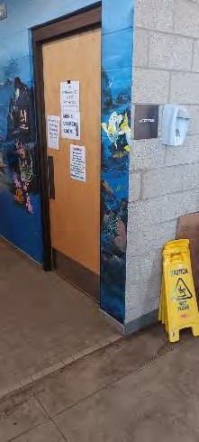
- Hand Sanitizer Dispenser
Wall mounted sanitizer dispenser located in the lobby is mounted at 5’-2” above the floor and next to the ‘natatorium’ sign. ADASAD 308 requires a maximum height of 4’ to the operable portions of the dispenser when over clear floor space at least 2’-6” wide. ADASAD 703.4.2 requires 9” of clear space each side of the center of the sign.
Suggested solution: Remove or relocate the sanitizer dispenser to a lower height and at least 9” from the edge of the dispenser to the center of the sign. Clean and patch the wall after sanitizer is relocated.
Projected Cost of Correction: $ 100
Priority 2 due to being readily achievable
Hand sanitizer mounted too high.

- Bill Changer
The operable portion of the paper currency changer is 53 inches above the floor and located beside a crane/claw game machine. ADASAD 308 requires a maximum height of 48 inches to the operable portions of the bill changer.
Suggested solution: Remove or relocate the bill changer so that the parts of the bill changer that need to be reached to operate are not more than 48 inches above the floor.
Projected Cost of Correction: $ 0
Priority 1 due to being readily achievable
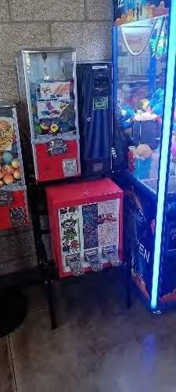
Bill changer mounted too high.

- Accessible Showers

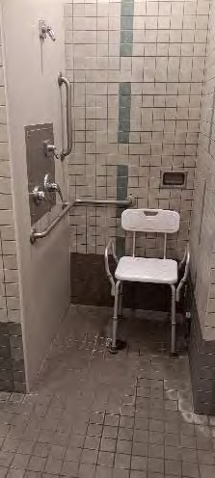
The required four accessible showers (women’s, men’s, and two family shower rooms) lack the required hand held shower head on a hose, and lack a permanent seat. ADASAD 607.6 requires a hand held ‘spray unit’ on a minimum 59” hose at accessible showers. ADASAD 608.4 requires mounted seats in ‘transfer type shower compartments’ like the size of those present.
Suggested Solution: Replace or supplement the shower heads at the four accessible showers to include the hand held shower head with hose, and install a fixed or fold-down shower seat. Both the new shower head and seat have additional requirements to follow which are described in the referenced portions of ADASAD.
Projected Cost of Correction: $ 5000
Priority 3 due to being moderate cost and how current installations are still usable without correction.
Note that the required horizontal grab bar is present. A vertical grab bar is present but not required.

- Toilet Partition Doors
Stall doors at the men’s and women’s accessible toilet stalls are not self-closing
ADASAD 604.8.1.2 requires accessible stall doors to be self closing.
Suggested Solution: Replace accessible stall door hinges with self-closing hinges at the two accessible toilet stalls.
Projected Cost of Correction: $ 300
Priority 5 due to how the current installations are still usable without correction.

Total projected costs of facility corrections: $6,200 plus tax

5.C. Raton City Hall
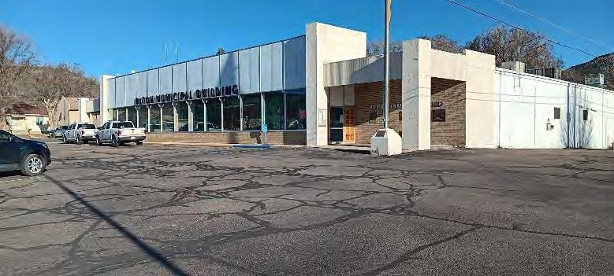
224 Savage Avenue
Use:
- City general administration
- City Police Department administration
- City Water Department administration
- Municipal Court

Approximate construction date: 1965 with a major remodel in 1979
Activities and Offerings:
- General City general administration
- City Commission and other public board meetings
- Receive payments for public utilities and other types of city payments
- Police and emergency dispatch
- Police general administration
- Water, sewer, and trash general administration

Special Conditions: The facility was constructed as a retail grocery store then remodeled in 1979 for City uses with no major remodels after that time. Since the Americans with Disabilities Act (ADA) became law in 1992 the facility has not been required to be brought into ADA compliance other than items which are readily achievable and do not create an undue burden to the City government.
Most of the building area is limited to access by City staff rather than open to the public. When items don’t comply with 2010 Americans with Disabilities Act Standards for Accessible Design (ADASAD) are identified in the staff-only areas of the facility then ADASAD allows for those non-complying items to be left out of compliance until the area is altered or until the non-compliance negatively affects a staff member with a disability.
The break room counter height measures over 36 inches above the floor. ADASAD 606.3 and 902.3 requires accessible sinks and countertops to be no more than 34 inches above the floor. Since the break room is in an area generally restricted from public access countertop at over 36 inches can remain until the area is altered, or until the high countertop affects an employee with a disability.
Countertop more than 34 inches above floor. Staff access only so suggested to leave as is until needed by a staff member or until part of a larger remodel.

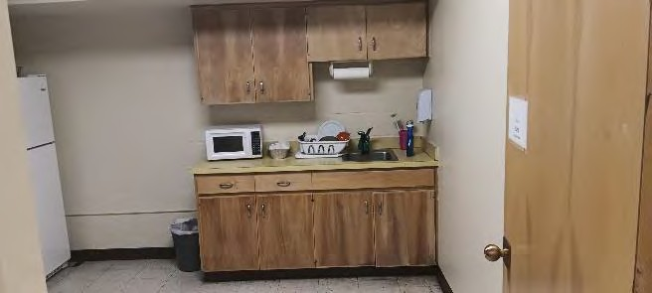
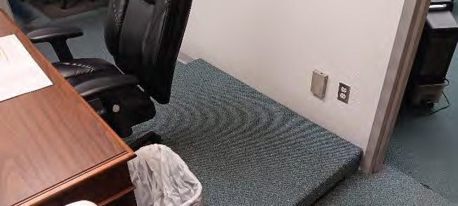
The municipal court judge dais (raised floor) behind the judge’s bench has a step and no accessible route to the top of the dais. Since the room is confined so that the addition of a ramp is not feasible, and since the judge is the only person that needs to reach the dais, it is suggested the court be prepared to either remove the raised dais under the judges bench or hold court at a more accessible location if a judge has a disability and is negatively affected by the steps at the dais.
The dais under the judge’s bench has steps on each side. Staff access only, so suggested to leave as is until needed by a staff member or until part of a larger remodel

The assisted listening system in the City Commission Chamber complies with ADASDAD, including two receivers for the room with a capacity of under 50, and both receivers are hearing-aid compatible.

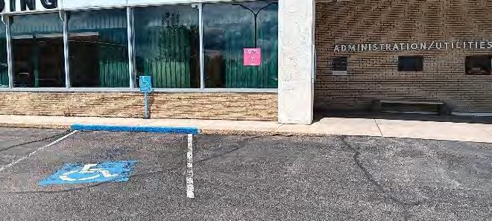
- Accessible Parking
Lone accessible parking space doesn’t comply. Additional accessible spaces required.
One accessible parking space is designated out of the approximately 90 parking spaces on site and adjacent city street parking serving City Hall and nearby electric utility office. ADASAD 208 requires at least four out of the 90 spaces to be designated as accessible and at least one of the four to be designated as ‘van accessible’ and include an access aisle. The bottom of the parking sign is approximately 30 inches above the driving surface. ADASAD requires the bottom to be at least five feet above the driving surface. The accessible route between the parking lot and the electric utility office was not reviewed.
Suggested Solution: Provide at least four accessible spaces in locations to serve the main entrances to the City Hall area, Police and Municipal Court area, and the nearby electric utility office. Since the three entrances are at different locations it is suggested that each have a van accessible parking space and access aisle so that at least three van accessible spaces will be at the City Hall parking lot. Mount pole or wall signs at a height of five feet above the driving surface. Additional requirements found in ADASAD apply to the dimensions, signs, markings, and more.
Note that while PROWAG applies to public street right-of-ways and prohibits the accessible route by an access aisle from crossing a roadway, ADASAD applies to parking lots and discourages but does not prohibit the accessible route by an access aisle from crossing a driving lane. The accessible parking spaces are required to be located so that the accessible route length between the parking and the building entry is minimized, but the accessible space can be located with the other spaces that are not designated as accessible. The designated accessible parking current location can be moved from its current location and the current space return to being used as a driveway or loading area.
Projected Cost of Correction: $ 2,000
Priority 1 due to frequent use.

- Public Entry Doors
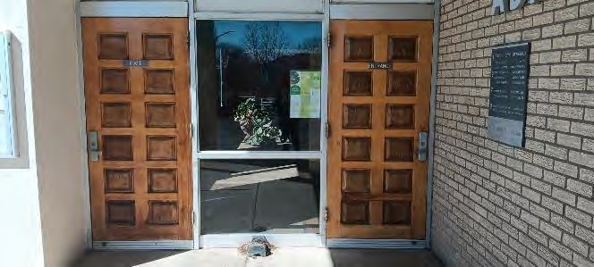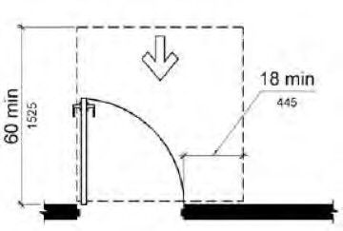
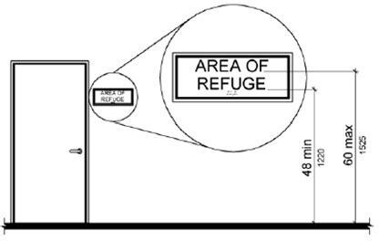
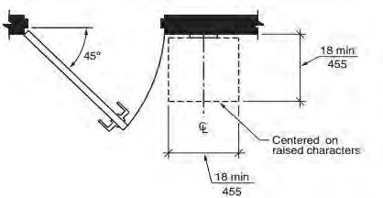
Walls next to the door latches. Required clearance beside door

Required sign height (if sign is present) Required sign location beside door
Public entry doors at both the City Hall side and the Police Department side have obstructions within 2 inches of the latch edge of the door. ADASAD 404.2.4 requires 18 inches beside the door latch on the pull side of the door.
Signs without braille are mounted to the face of the doors at approximately 5’-8” above the floor. If signs are present such as “entrance” and “exit” then the signs are required by ADASAD 703.4 to have raised characters and braille among other things and be located beside the door at a height between 4 feet and 5 feet above the floor. Additional sign requirements apply as found in ADASAD 703.
Suggested Solution: Alter the doors and frames so that they hinge on the obstructed (opposite of how they are currently mounted) side of the door. Remove the signs from the doors. If replaced then replace with signs that comply in allowable locations such as on the window glass after the door operation is altered. Patch doors and frames.
Projected Cost of Correction: $ 6,000
Priority 4 due to the doors being usable when non-compliant.
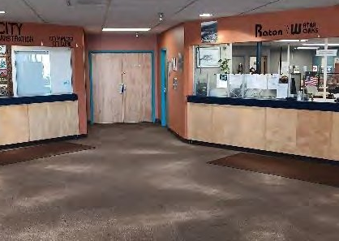
- Service Counters:
The two service counters in the City and utility administration areas have countertop heights of 42 inches above the floor. ADASAD 904.4.1 requires service counters to have at least a 36 inch wide portion of the service counter at a height of not more than 36 inches above the floor.
Suggested Solution: Alter or replace each of the two service counters to provide the required accessible portion of the counter. Additional requirement from ADASAD apply.
Projected Cost of Correction: $ 10,000
Priority 5 due to the current ability of staff to accommodate users through other means.
Service counters lack a lowered accessible portion

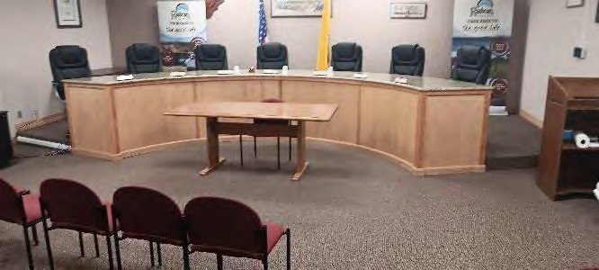
- City Commission Chamber
The dais (raised floor) has steps but no accessible route to reach the top of the dais such as a ramp.
Suggested Solution: Either a) construct a ramp to the dais when the room is next remodeled, b) construct a ramp when a member of a Commission or staff that uses the dais is negatively affected by the lack of a ramp or lift, or c) be prepared to hold meetings at a more accessible location if the need arises. ADASAD includes requirements for ramps including slopes, railing, landings, edge protections, and more
Projected Cost of Correction: $ 4000
Priority 5 due to no commissioners currently in need of correction.
Step required to reach the dais

- Restrooms:

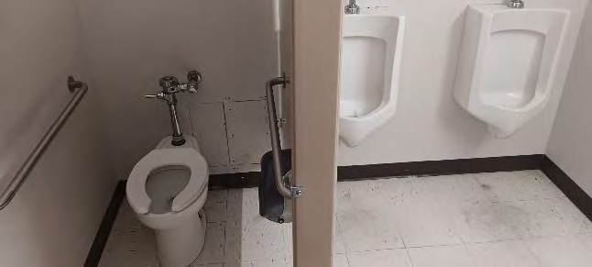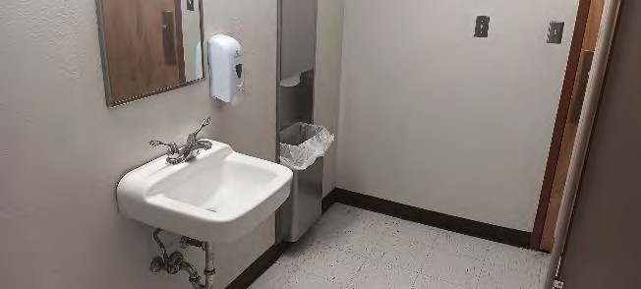
Restrooms have several issues that don’t comply with current ADA requirements.

All three pairs of restrooms do not comply with ADA requirements for many reasons common to restrooms constructed before ADA became law.
Suggested Solution: Reconfigure at the pair of public restrooms so that the facility has at least one pair of accessible restrooms available for both public and staff use. The public restrooms can be made accessible by reducing the number of fixtures to allow more space in the room and by altering the height of some of the fixture mountings. The number of toilets and urinals in the building can be reduced since there are currently more fixtures than required by the 2021 International Building Code for this facility. Fixture heights can be adjusted when needed without trenching the floor. Additional alterations easier to accomplish will be needed such as re-mounting the mirrors, insulating the pipes under the lavatories, and installing additional grab bars. Staff restrooms can remain non-complying until a larger facility remodel not yet planned.
Projected Cost of Correction: $ 15,000
Priority 5 due to non-compliance being relatively minor.

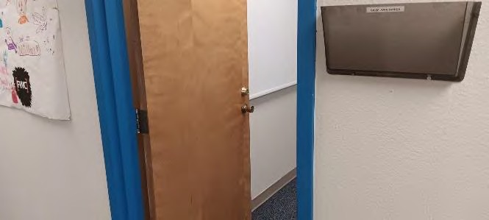
- Door Knobs
Most doors in the staff only areas have knobs instead of levers.
Suggested Solution: Replace knobs with lever hardware. Key as required for security needs.
Projected Cost of Correction: $ 10,000
Priority 3 because most door knobs are located in staff only areas.
Door knobs instead of levers at staff areas

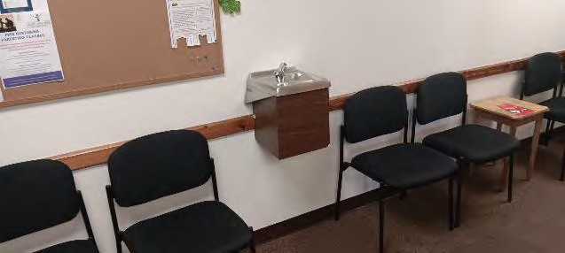
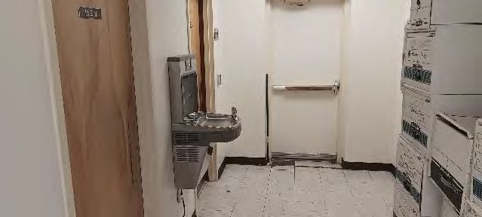
- Drinking fountains
Fountain in the City administration area and non-complying fountain by Municipal Court needs barriers each side needs replacing and needs barriers each side Suggested for leaving till future remodel. Suggested for replacement.
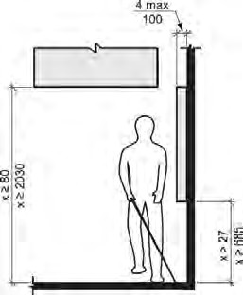
The fountain in the staff area of City Hall meets the height and other requirements for a standing user. The fountain outside of the Municipal Court doesn’t comply with the mounting height and manufactured dimensions for a seated use. ADASAD 602 requires one fountain height for a user that stands and another height for a user seated with knee space under the low fountain. Both fountains at the facility also lack barriers each side of the fountain to warn someone that is visually impaired and navigating with a cane that the fountains project over the walking surface (hallway).
Suggested Solution: Replace the fountain outside of the Municipal Court. Install barriers such as a post or low wall each side of both fountains. Additional requirements found in ADASAD apply regarding clearances to doors and regarding barrier distances from the centerline of the fountains. Patch walls as needed after new fountains installed. It is suggested to leave the fountain by the staff restrooms till the area is remodeled since it is only used by staff and will be supplemented by accessible fountains in the public area of the police department.
Projected Cost of Correction: $ 6,000
Priority 3 due to being located partly in staff only areas.

Diagram showing maximum 4 inch extension into walking surface. Barriers required each side of drinking fountains.

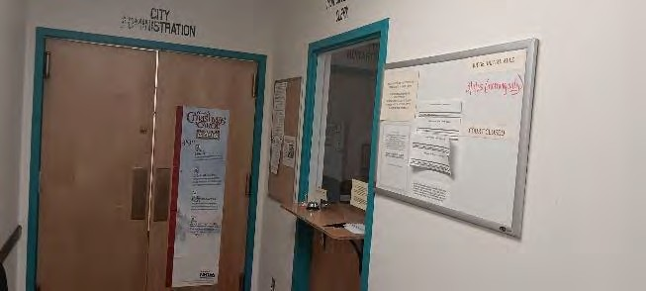
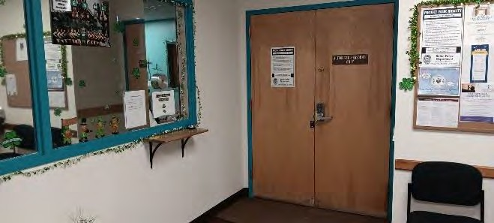
- Service Counters at Municipal Court window and at Police Dispatch
Municipal Court service counter too high Police Dispatch service counter is too high
The tops of the service counters are 44 inches above the floor. ADASAD 904.4.1 requires service counters to have at least a 36 inch wide portion of the service counter at a height of not more than 36 inches above the floor. Additional dimensional requirements are found in ADASAD.
Suggested Solution: Remove or reconstruct the two service counters to comply. Significant alterations to the nearby walls and openings will be required
Projected Cost of Correction: $ 10,000
Priority 2 due to confined space, windows, and other barriers that make it less efficient for the staff to accommodate the user in other ways.

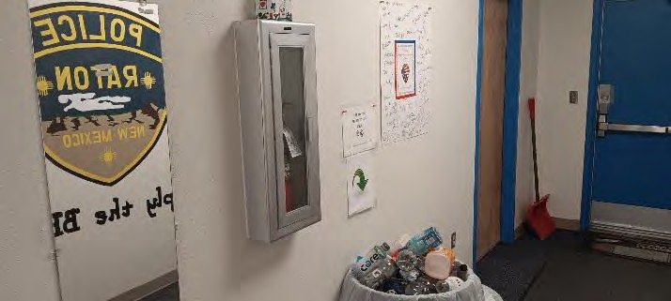
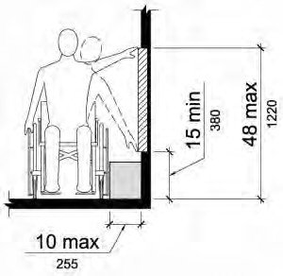
- Fire Extinguishers
Fire extinguishers too high Allowable reach range for side reach
The fire extinguishers and cabinets are mounted so that the reachable parts (cabinet handle and extinguisher handle) are mounted more at 54 inches and more above the floor. ADASAD 308.2 and 308.3 requires a maximum reach height of 48 inches when a user reaches forward or to the side.
Suggested Solution: Relocate the fire extinguishers with or without cabinets so that the portions that need to be reached are less than 4 feet above the floor. Repair walls at removed cabinets.
Projected Cost of Correction: $ 2,000
Priority 5 due to low usage and minimal access by the public.

- Room Required sign height (if any sign is present)
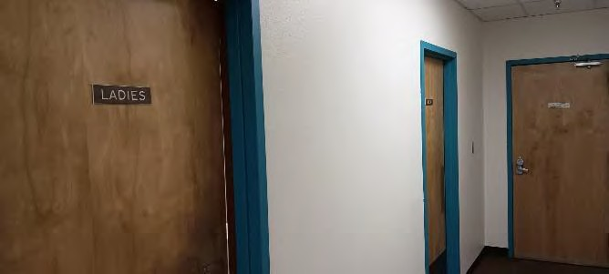
Room signs lack braille and other tactile requirements. Required sign location
Room signs mounted too high and in some cases are mounted in non-compliant locations.

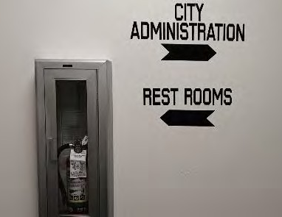
Directional signs at City Hall like those pictured below are not required to have braille or tactile lettering by ADASAD 216.3 and 703.5. Most of the directional signage at City Hall are of allowable height above the floor and allowable letter height and color contrast but don’t fully comply with the line spacing and letter stroke requirements. The next time the directional signs are updated they are required to follow ADASAD 216.3 and 703.5.
Projected Cost of Correction: $1,000
Priority 3 due to non-compliance being relatively minor.
Signs at doors that identify the rooms and uses such as “womens”, “municipal court”, “authorized personnel only”, and others are located on door faces or above doors. The signs have no braille and other tactile features that are required. The signs are required by ADASAD 703.4 to have raised characters and braille among other things and be located beside the door at a height of 4-5 feet above the floor. Additional requirements apply such as raised characters and symbols and character contrast are found in ADASAD 703.
Suggested Solution: Remove, replace, or supplement the room identification signs. If replaced or supplemented then replace or supplement with signs that comply in allowable locations. The existing signs can remain if supplemented with complying signage. Patch walls and doors where old signs are removed.
Total projected costs of facility corrections: $66,000 plus tax

5.D. City Administration Building
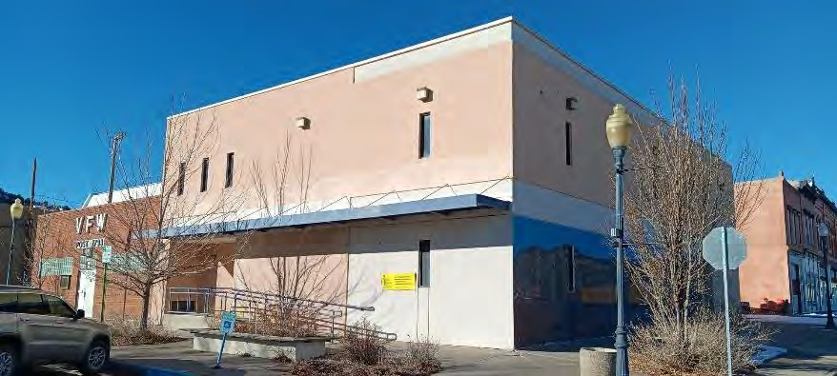
130 Park Avenue
Use: city staff offices and administration for non-profit community development
Approximate construction date: 1987 with exterior ramp constructed around 2018.
Activities and Offerings:
- Administration
- Occasional classroom or lecture type training
Low traffic. Minimal staff and public use except for periodic training.
Special Conditions: Because the facility was constructed before there were ADA requirements several of the non-complying items are not technically feasible to correct without a major remodel. It is suggested to alter the facility when compliance for those items is readily achievable as listed in this description, and to indefinitely postpone major alterations so that available resources can be spent on accessibility upgrades to other facilities that potentially offer more benefits to disabled users and the general public.
For this facility it is suggested that the staff be prepared to hold their usual public meetings and training at an alternative accessible location when needed. If the non-compliance affects a disabled staff member then the employer is required to either make reasonable alterations to the facility to accommodate the staff member’s needs or arrange for the staff member to perform the same job from a more accessible facility if doing so does not create an undue burden on the employer.
Public parking is on-street parking and is addressed in the Right Of Way review in this Raton ADA Transition Plan.
The exterior ramp at the primary entry facing Park Avenue is too steep at around 1:8 (12.5%) slope. 2010 ADA Standards for Accessible Design (ADASAD) 405.2 requires ramps to have a slope of not more than 1:12 (8.3%). The only other exterior door faces First Street and has an excessively steep landing sloping down to the public sidewalk, and lacks required clearances next to the door with no readily achievable alteration options. It is suggested that the non-compliance at both entrances be left out of compliance due to the cost of correction unless and until the services and employment provided at the facility can no longer be relocated to more accessible facilities when needed.
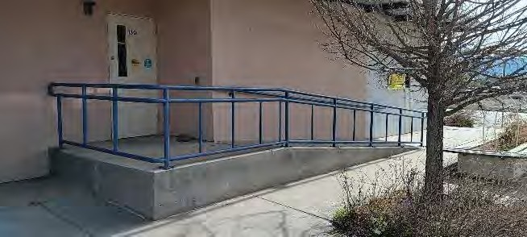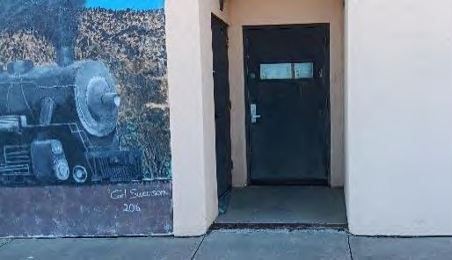
Main entry ramp too steep Back door has landing with steep slope

Suggested to leave both out of compliance due to cost of corrections and low usage.
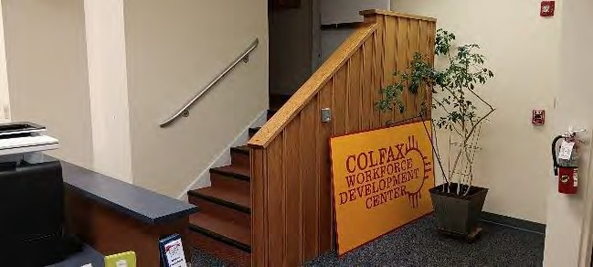
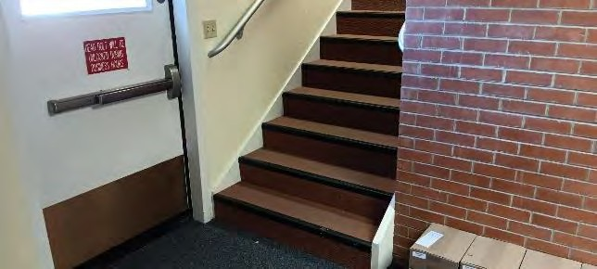
The interior stairs, both sets of interior stairs have 8” risers instead of the maximum 7” required. Stairs lack handrails or have incomplete handrails lacking extensions at the top and bottom. There is no elevator present. Replacing the stairs and in some cases extending or replacing the handrails for compliance is technically unfeasible without a major costly remodel. It is suggested to leave the stairs and handrails as they are. See the Special Conditions description.
Stairs are too steep and lack required handrail extensions.
Suggested to leave out of compliance due to technically unfeasible corrections.
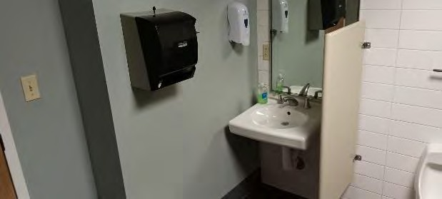
Upper and lower level restrooms lack most of the dimensional and clear floor space requirements. It’s technically unfeasible to alter the restrooms for compliance without a major costly remodel. It is suggested to leave the restrooms as they are unless limited alterations are needed in the future to accommodate a disabled staff member with specific needs.
Not reasonably feasible to alter restrooms for compliance.
Some of the office and meeting room doors are 32” wide instead of the required 36” wide. Because of the limited use of the affected rooms it is suggested to leave the 32” doors unless a wider door is later needed for a disabled staff member.
Fire extinguisher cabinets are mounted so that the portion of the cabinet handle and extinguisher required to be reached is around 60”. ADASAD 308.2.1 requires a maximum of 48” for a required reach height. It is suggested to leave the cabinets out of compliance because of the cost of relocating and the lack of accessibility elsewhere in the facility.
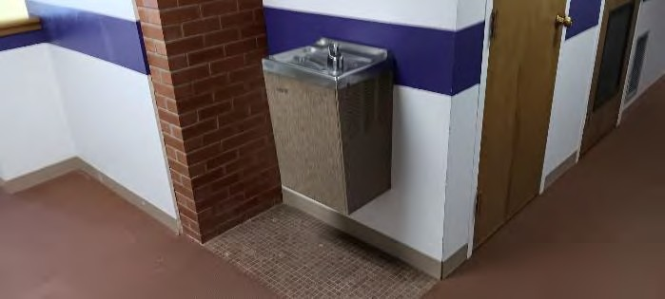
Drinking Fountains are single units without a knee space and lack the hi-low pair. ADASAD 602 requires one fountain height for a user that stands and another height for a user seated with knee space under the low fountain. Because the fountains are located in spaces where providing two fountains and associated clearances around the fountains aren’t technically feasible without significant re-plumbing to a new location is it suggested that the fountains remain out of compliance.
Not reasonable feasible to correct fountains.

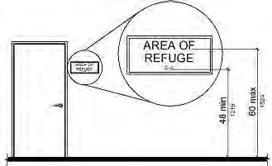
- Restroom Sign Heights:
ADASAD 704.5.1 requires mounting between 48” and 60” measured as shown on the diagram below.
Suggested Solution: Remount the restroom signs to a height complying with the diagram below. Clean, patch, and paint surfaces after old signs removed.
Projected Cost of Correction: $ 200
Priority 1 due to being readily achievable.
Restroom signs are mounted too high.

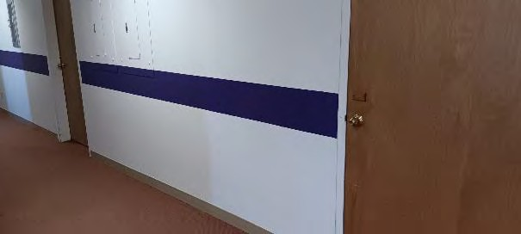
- Interior Door Knobs:
Some of the office and meeting room doors have knobs wide instead of the required lever hardware.
Suggested Solution: Replace interior door knobs with commercial grade lever hardware. Key each as needed for operational security.
Projected Cost of Correction: $4000
Priority 5 due to minimal use by the public.
Doors have knobs instead of levers.

Total projected costs of facility corrections excluding technically unfeasible corrections: $4,200 plus tax

5.E. Raton Convention Center
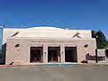
901 South 3rd Street

Use: public assembly, commercial kitchen
Approximate construction date: 1941 with significant remodel in 1991
Activities and Offerings:
- Public meetings, conventions, displays, banquets, dances, classes
- Available to rent for special events
- Kitchen is available to rent for events at the facility and for other commercial uses.

Special Conditions: The building’s last major remodel occurred before ADA was enacted.
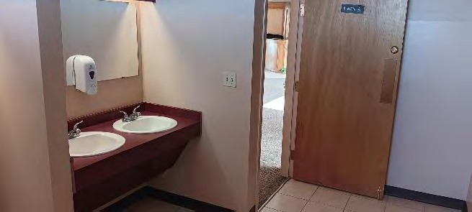
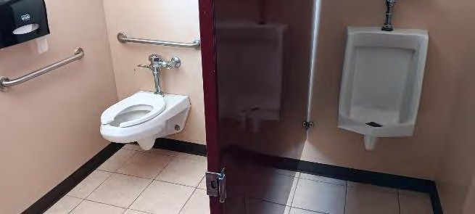
All three restrooms were constructed to accessibility requirements at the time of the last major remodel but have several items that are currently non-compliant for new construction including accessible stall width, toilet and urinal heights, grab bar lengths, mirror height, and similar items. Altering for full compliance would be costly for only minor improvements so it is suggested that most or all of the non-compliant items be left as is until a significant remodel occurs.
Restrooms are not fully compliant. Due to cost it is suggested to leave out of full compliance until the next time a major remodel occurs.
Old U-shaped stairs located west of the larger L-shaped stairs have a non-complying handrail and the handrail is found on only one flight of the stairs. ADASAD 505 requires handrails each side of the stairs and includes requirements about rail sizes, clearances, height, extensions, and additional details. In addition the riser heights are 8 inches instead of the maximum 7 inches required by ADASAD. It is suggested that because the U shaped stairs are supplemental to the nearby L shaped stairs and are seldom used it is suggested that the narrow U shaped stairs and handrails be left unaltered since the larger L shaped stairs are a more logical choice to alter for the required accessible stairs.

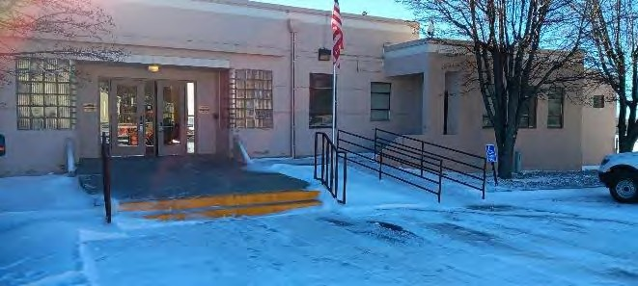
- Southwest Accessible Parking:
The southwest accessible parking space surface is too steep with a cross slope of over 2% among other non-compliant details.
Suggested Solution: See southwest exterior ramp description.
Projected Cost of Correction: See southwest exterior ramp description.
Priority: not applicable because correction is included in southwest exterior ramp
Southwest accessible parking is too steep.

- Southwest Exterior Ramp:
Photo of existing southwest exterior ramp seen in southwest parking description.
The ramp is too steep, lacks barriers near grade at the edge of the ramp surface, has a bottom landing with a cross slope of greater than 2%, handrails lack extensions at the top and bottom of the ramp, and other issues that don’t comply with 2010 Americans With Disabilities Act Standards for Accessible Design (ADASAD).
Suggested Solution: Construct a new ramp, railing, and landing so that the top of the new ramp is located approximately 20 feet north of the existing ramp, with the new ramp sloping down to the north to a new landing next to two new accessible parking spaces where the existing parking slopes less than 2% and is also near the auditorium entry. Eliminate the southwest accessible parking space noted in item 1, and eliminate the accessible parking space near the auditorium entry which is located in an area also used for loading. Photo of existing southwest exterior ramp seen in southwest parking description.
Projected Cost of Correction: $9000
Priority 5 due to existing parking and ramp already present but not fully complying.

- Entry Sidewalk Joints:
Expansion joints in the sidewalks have deteriorated filler causing gaps in the sidewalk over ½” wide. 2010 ADA Standards for Accessible Design (ADASAD) 302.3 requires gaps such as joints to be not more than ½” wide unless the gap is filled flush with he walking surface.
Suggested Solution: Clean deteriorated joint material from top of concrete expansion joints and add sealant with the top of the sealant flush with the top of the adjacent concrete surfaces. Gaps are found at the accessible parking area, near the public entry, and between.
Projected Cost of Correction: $ 300
Priority 1 due to being readily achievable.

- Restroom Sign Heights:
Restroom signs are mounted too high. ADASAD 704.5.1 requires mounting between 48” and 60” measured as shown on the diagram below.
Suggested Solution: Remount the restroom signs to a height complying with the diagram below. Patch and finish walls and doors where signs have been removed.
Projected Cost of Correction: $200
Priority 2 due to non-compliant signs already present but correction is readily achievable.
Diagram showing required height of room signs when present.

- Other Room Signs:
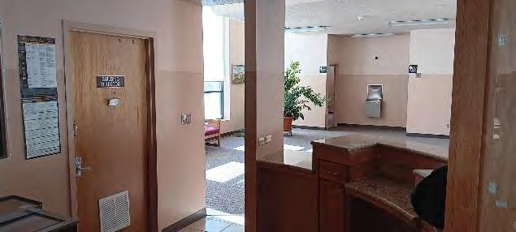
Old room signs do not comply New sign location requirements.
Most room signs designating the name of the meeting rooms and building manager’s office lack raised characters, contrasting background, and braille. ADASAD 703 has requirements for these and other sign features.
Suggested Solution: Remove, replace, or supplement the existing room signs with new signs complying with ADASAD 703. Patch doors and walls where old signs are removed. There are additional requirements for placement in relation to the door including as shown on the following diagram.
Projected Cost of Correction: $500
Priority 2 due to non-compliant signs already present but correction is readily achievable.

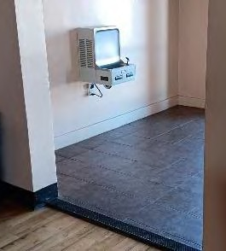
- Drinking Fountains:
Fountains lack the hi-low pair at all three locations. ADASAD 602 requires one fountain height for a user that stands and another height for a user seated with knee space under the low fountain. Both fountain heights are required to be provided.
Suggested Solution: Supplement the auditorium fountain and the lower level fountain with a second fountain so that both locations comply. The existing are too high for a seated user and too low for a standing user so the new installations will be required to have two newly mounted fountains at the correct heights.
Note that the fountain outside of the upper south restrooms is too close to the restroom doors to add another fountain without encroaching into the ADA required space outside each restroom door so it is suggested to leave that upper south fountain undisturbed until a significant remodel occurs.
Projected Cost of Correction: $8000
Priority 3 due to non-compliant fountains already present.
Fountains do not comply. Upper north fountain pictured.
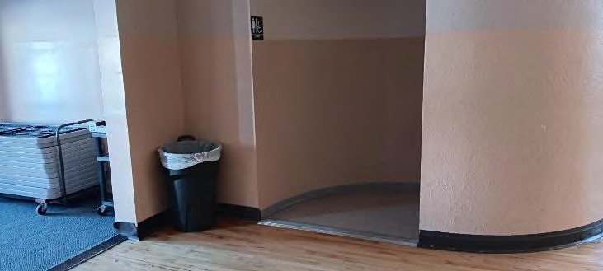
- Flooring Transitions, Auditorium:
Flooring transitions at vestibule and restroom too steep. Maximum flooring offsets
Flooring transitions at the entries to the auditorium restrooms and inside the auditorium entry vestibule offset more than ½”. ADASAD 303 limits vertical offsets in walking surfaces to ¼” or ½” depending on how the offset is beveled.
Suggested Solution: Replace the flooring transition strips with new transitions that have an offset that complies with the requirements.
Projected Cost of Correction: $500
Priority 2 due being readily achievable.

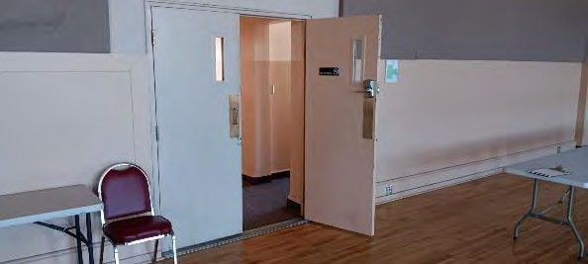
- Auditorium Door Lever
The door from the south hall to the auditorium is mounted too high. ADASAD 308 requires items that need to be reached such as door levers to be mounted at a maximum 48” above the floor.
Note that the bottom of the window glass is higher than currently allowed but was installed before ADA applied and doesn’t prohibit someone with a disability from using the door so it is suggested that the doors with non-complying glass remain.
Suggested Solution: Lower the door level so that the top is no higher than 48” above the floor. Patch and paint door after old hardware is removed.
Projected Cost of Correction: $1200
Priority 2 due to semi-frequent use
Door level too high

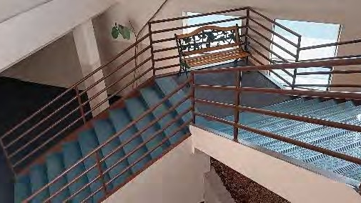
- L shaped Stairs
Stairs have guard railing but not handrails. ADASAD 505 requires handrails each side of the stairs and includes requirements about rail sizes, clearances, height, extensions, and additional details.
Suggested Solution: Install handrails that comply the requirements.
Projected Cost of Correction: $1200
Priority 2 due to semi-frequent use
Stairs have guard rails but no handrails.
- Assistive Listening System
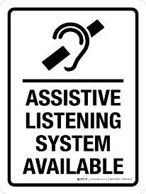
Assistive listening system equipment is not provided. ADASAD 219 and 706 requires assistive listening equipment be made available at all rooms that have voice amplification (amplified speakers) and requires signage identifying the equipment as being available for use by the public upon request. Additional requirements for the system apply.
The auditorium is the only room with an amplification system and measures approximately 5850 square feet. The 2021 International Building Code indicates occupancy calculation at 15 square feet per occupant for unconcentrated assembly areas of tables and chairs. 5850 s.f. @ 150 s.f. per occupant = 390 occupants at the auditorium. ADASAD 219 indicates for 390 occupants that 16 assisted listening receivers should be available. At least 4 of the 16 receivers are required to be hearing-aid compatible which is usually accomplished by the use of neck loops and related equipment.
Neck loops can be plugged into any sound source such as the receiver loaned to the user by the facility management. The neck loop wirelessly relays sound from the device to the user’s telecoil.
A telecoil also known as a t-coil is a small copper wire neatly coiled inside some hearing aids and cochlear implants. The t-coil receives electromagnetic audio signals when switched on and helps those with hearing loss hear the audio being amplified more clearly for better speech intelligibility. Not all hearing aids have t-coils, but most cochlear implants do.
Suggested Solution: Provide and maintain the required Assistive Listening System and required signage to notify the public of the system availability.
Projected Cost of Correction: $2200
Priority 3 due to sound system being infrequently used at this facility.

Total projected costs of facility corrections: $26,900 plus tax

5.F. Fire and Emergency Station #1
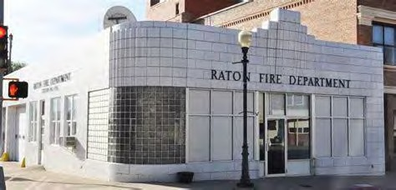
100 Clayton Road

Use: fire station with administration and sleeping
Approximate construction date: 1940 original with 1980 addition Activities and Offerings:
- Fire and Emergency Station
- Occasional public access to administrative area. Staff only elsewhere.

Special Conditions: Most of the facility does not comply with ADA requirements in both public and staff areas due to the building age, multi-level ground floor, limited space, State historic designation, and other factors.
Few if any items that don’t comply with standards for new construction are readily achievable.
Only public approach to the facility and facility entry related items are noted below because those items affect the public more than items in the rest of the facility and because those items might be considered achievable without an undue hardship to the owner.
Public parking is on-street parking and is addressed in the Right Of Way review in this Raton ADA Transition Plan.
The original glass entry door now forms the inside of the entry airlock. 2010 Americans With Disabilities Act Standards for Accessible Design (ADASAD) 404.2.6 requires the airlock length in the direction of travel to measure at least 48 inches from the edge of the fully open door to the face of the second door opening. The existing airlock provides only around 24 inches. Since altering the entry airlock would be cost prohibitive, would significantly alter the historically significant original glass entry, and the facility has little traffic from the public, it is suggested to leave the entry airlock out of compliance, or prop the interior door open.

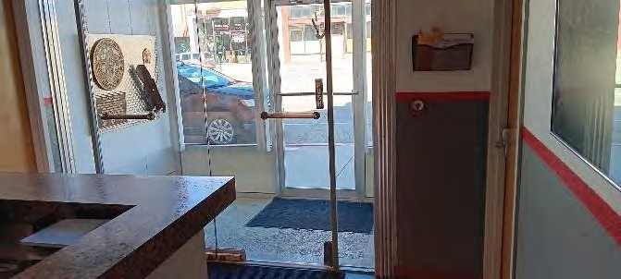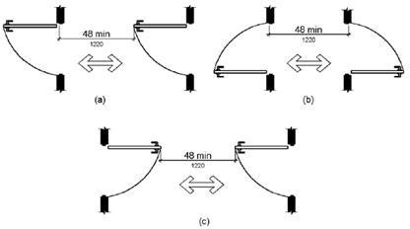
Airlock doors are too close together. Required distance between doors. Suggested to leave as is.

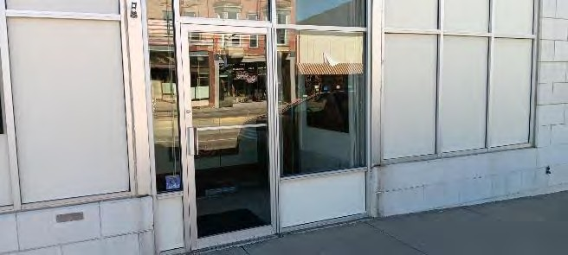
- Exterior Door 2nd Street:
Storefront glass and aluminum door has an uneven surface at the bottom 10” of the door since the aluminum frame is thicker than the glass like on most aluminum storefront doors. 2010 ADA Standards for Accessible Design (ADASAD 404.2.10) requires a smooth surface each side of the door within 10” of the walking surface so that the feet of a wheelchair user are less likely to get caught on the door when the user opens or closes the door.
Suggested Solution: Replace the aluminum storefront door with a door that has a smooth bottom rail at least 10” tall, or add a smooth aluminum plate at least 10 inches tall to each side of the bottom of the door.
Projected Cost of Correction: $ 5000 for door replacement.
Priority 5 due to non-compliant door remaining usable and low usage.

Total projected cost of facility Corrections excluding less feasible corrections:
$5000 plus tax

5.G.Fire and Emergency Station #2
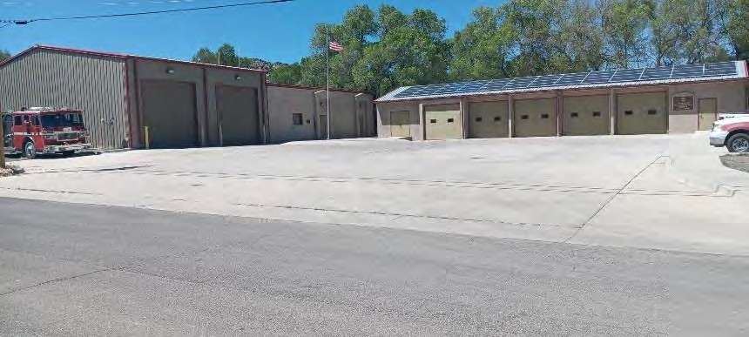
301 W. Troy Avenue

Use: fire station with sleeping
Approximate construction date: 1960 and 2017 Activities and Offerings:
Fire and Emergency Station, staff access only.

Special Conditions: The newer larger building constructed around 2017 is used for 24 hour occupancy by fire and emergency personnel, and for fire truck parking. The facility includes a residential type kitchen, exercise, laundry, and sleeping rooms.
The storage building located east of the station was constructed around the 1960s and is used only for smaller fire truck parking and storage. The storage rooms at the east and west ends of the building lack an accessible route to the parking area. The east storage room lacks an accessible entrance due to the ramp outside of the exterior door. Since the facility is used as storage and parking only with no public access it is suggested that the east building can remain unaltered until a disabled employee needs alterations or until the building is otherwise significantly altered.
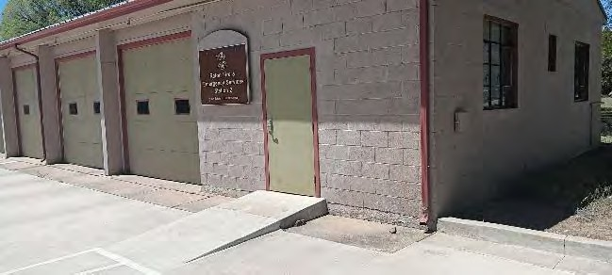
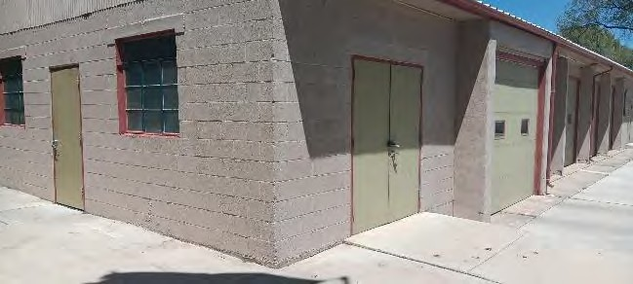
East building lacks accessible entrance and accessible route within the building.
It is suggested to leave without accessibility in the short term because of its use as only storage and parking without public access.
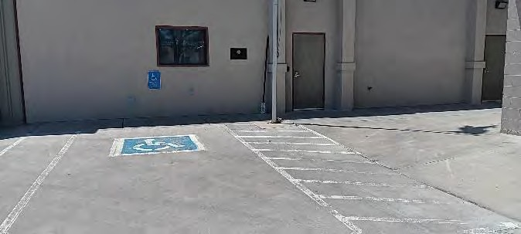
- Accessible Parking
Accessible space too narrow. Wall sign too low.
The accessible parking is marked for an accessible space 10 feet wide with an access aisle on the passenger side five feet wide. Americans with Disabilities Act Standards for Accessible Design (ADASAD) 502 requires that the accessible space and the access aisle to be 11 feet and five feet respectively, or eight feet and eight feet respectively. Either of those two solutions total 16 feet wide.
The bottom of the wall mounted sign is approximately two feet above grade and doesn’t indicate ‘van accessible”. ADASAD 502.6 requires the bottom of parking signs to be at least five feet above grade, and requires signs at van accessible spaces to be labeled “van accessible”
Suggested Solution: When replacing worn pavement markings widen the accessible space southward so that it is at least 10 feet wide. Relocate the parking sign so that the bottom is at least five feet above grade and includes the text “van accessible” either on the same new sign or on a new supplemental sign.
Projected Cost of Correction: $ 200
Priority 1 due to being readily achievable at low cost.

- Restroom Signs
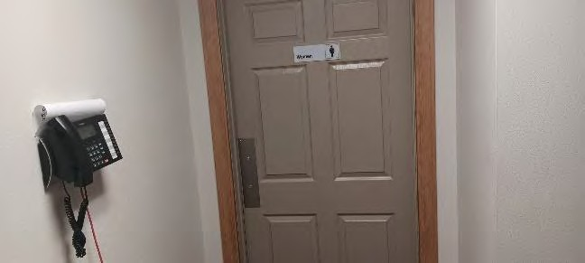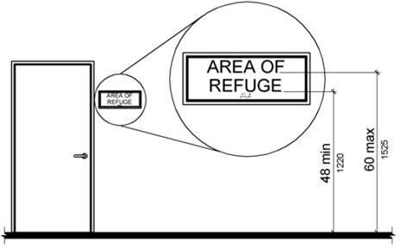 Non-complying room signs and heights. Sign height
Room signs have no braille or raised characters and are mounted at a height of over five feet above the floor. ADASAD 703 has many requirements for signs, including that room signs include raised characters with braille, and a mounting height range as pictured below. In most situations the required signs cannot be mounted to the face of the door but there is an exception for cases like this where the door swings away from the hall and the door has a closer.
Suggested Solution: Replace or supplement room signs with new complying signs at an acceptable height and located either on the door or beside the opening edge of the door. Note that many other requirements apply including character size, open space in front of the signs, font, and visual contrast. Clean and patch door if old signs are removed and damage the door finish.
Projected Cost of Correction: $ 100
Priority 1 due to being readily achievable at low cost.
- Restroom dispensers:
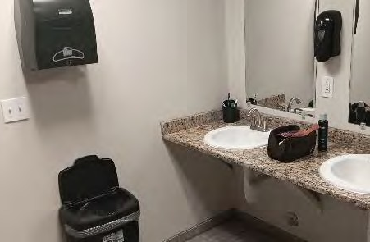
Soap and towel dispensers are mounted with reachable parts at around 52 and 56 inches above the floor. ADASAD 308 requires reachable components of dispensers to be not more than 48 inches above the floor, and not more than 44 inches above the floor when the user reaches over a countertop more than 20 inches deep.
Suggested Solution: Re-mount dispensers so that the parts of the dispenser that require reaching are not more than 48 inches above the floor, and not more than 44 inches above the floor when above a countertop. Patch wall surfaces if needed.
Projected Cost of Correction: $ 100
Priority 1 due to being readily achievable at low cost.

Dispensers installed too high.

Total projected cost of facility corrections: $400 plus tax

5.H. Fire and Emergency Station #4
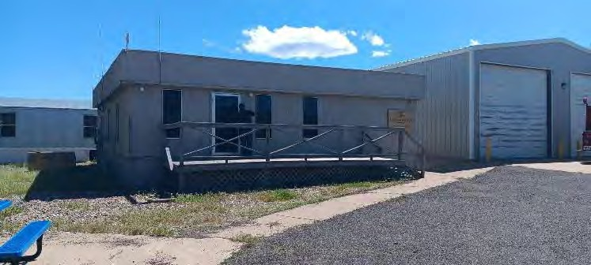
Roundhouse Road

Use: fire and emergency training
Approximate construction date: 1980 then moved to current location around 1996
Activities and Offerings: Classroom training for regional fire and emergency personnel.
Special Conditions: Other buildings on site are used only for parking and storage. Only the classroom building was reviewed for this Self Evaluation report.
The classroom building was constructed before ADA requirements applied and was used for other purposes before it was moved to the current site.
Since classroom training inside the building is sometimes combined with hands-on outdoor training at other on-site installations it is often less feasible to relocate the classroom training to another facility with better accessibility. Due to the facility condition and non-complying issues noted it is suggested that replacing the facility could be more beneficial in the long term than correcting the individual non-complying items.

- Accessible Parking:
No accessible parking is marked.
Suggested Solution: Designate accessible parking with a sign and pavement markings. Requirements for the signs, markings, dimensions, slopes, surfaces, and accessible between the parking and the building are identified in the 2010 Americans With Disabilities Act Standards for Accessible Design (ADASAD).
Projected cost of correction: $500
Priority 2 due to being readily achievable but moderate use by the public.

- Accessible Route to Entrance:
Entering the building requires the user to walk up steps with non-complying handrails and across a wood deck with non-complying gaps between the deck planks. There is a step of around two inches from the deck to the door threshold.
Suggested Solution: Replace the wood deck. Provide a ramp. Additional requirements about ramps, slopes, landings, surfaces, stairs, and handrails are identified in ADASAD.
Projected Cost of Correction: $ 10,000
Priority 3 due to cost and moderate use.
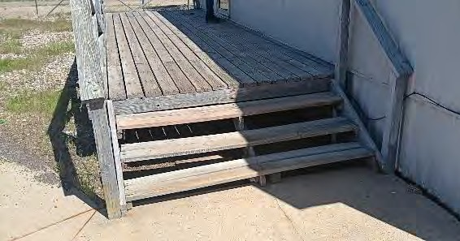
Entry has steps with no ramp. Handrails don’t
comply. Deck has non-complying gaps.

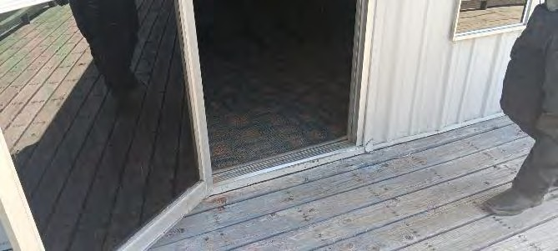
- Front Door
Storefront glass and aluminum door has an uneven surface at the bottom 10” of the door since the aluminum frame is thicker than the glass like on most aluminum storefront doors. 2010 ADA Standards for Accessible Design (ADASAD 404.2.10) requires a smooth surface each side of the door within 10” of the walking surface so that the feet of a wheelchair user are less likely to get caught on the door when the user opens or closes the door.
Suggested Solution: Replace the aluminum storefront door with a door that has a smooth bottom rail at least 10” tall, or add a smooth aluminum plate at least 10 inches tall to each side of the bottom of the door.
Projected Cost of Correction: $ 5000
Priority 4 because non-compliance doesn’t prohibit use, moderate use by the public.
Uneven surface at bottom 10 inches of the door.

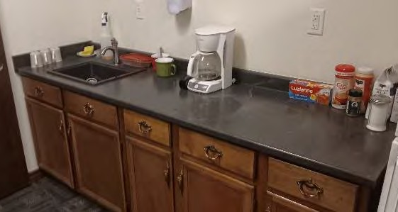
- Coffee Bar:
The coffee bar has a countertop 36 inches above the floor. ADASAD requires at least 36 inches of the countertop length to be no more than 34 inches above the floor. If the coffee bar was used by only City staff then the countertop could be left as-is until a disabled employee needed alterations, but in this case the coffee bar is used by the public and emergency personnel that aren’t employed by the City.
Suggested Solution: Replace at least part of the countertop and cabinets to provide the required lowered countertop height. Patch adjacent surfaces that are damaged and exposed during the replacement.
Projected Cost of Correction: $4000
Priority 5 due to cost and minimal use by the public.
Countertop too high.

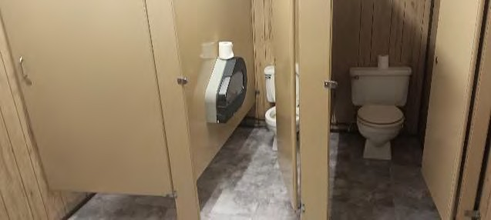
- Restrooms:
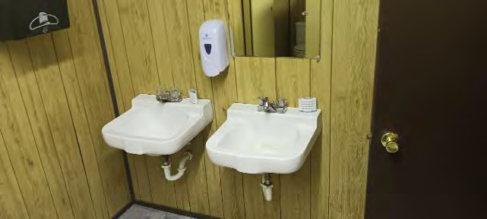
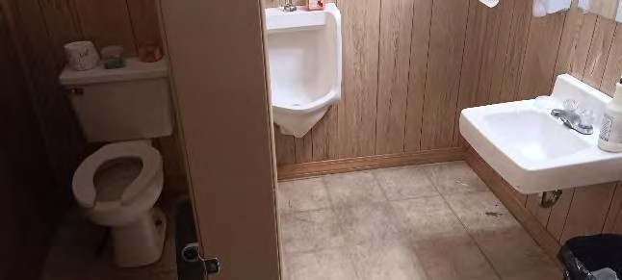
Restrooms small and far out of compliance.
The pair of restrooms do not comply for many reasons including floor space.
Suggested Solution: Since making the restrooms comply for the number of fixtures required it is not feasible to correct without a major remodel.
Projected Cost of Correction: $48,000
Priority 3 due to cost and moderate use

Total projected cost of facility corrections: $67,500 plus tax

5.I. Kearney School/El Raton Media Works
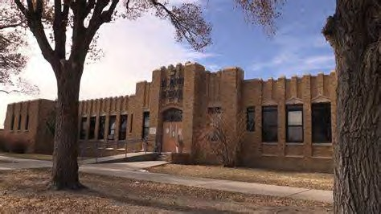
800 South Third Street

Use: Post-secondary education (planned future use) Approximate construction date:1939
Activities and Offerings: Workforce training in the video production industry (future)
Special Conditions: The facility was a public grade school till around 2015 and has been unused since. The facility is currently owned by the City of Raton and is expected to begin the first phase of a major renovation 2025. After renovated the facility is planned for use as a workforce training facility for the film and video media industry. It is planned to be operated by the non-profit El Raton Media Works.
The facility in its current condition was not reviewed for ADA compliance because the scheduled renovations are planned to comply with ADA requirements and address any items that are currently not in compliance. Likewise the services and activities offered at the facility are expected to comply.

5.J. Arthur Johnson Memorial Library
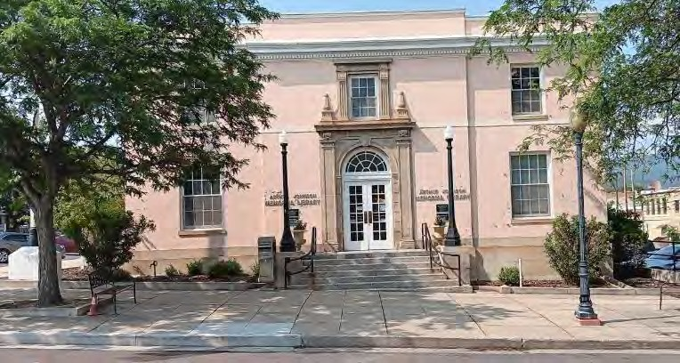
224 Cook Avenue

Use: Public Library Approximate construction date:
1920 with a major remodels around 1966 and 1994
Activities and Offerings: Library of books, videos, periodicals, and other media
- Public access computers
- Art display
- Children’s story time public meetings
Special Conditions: The library is a registered historic property by the State of New Mexico and is exempt from ADA compliance when that compliance detracts from the historic appearance and affects significant historic features. When the facility was remodeled around 1994 the main public entry which faces south to Cook Avenue was left unaltered with steps and no ramp, narrow doors, and a small narrow entry vestibule because altering the Cook Avenue entry would significantly alter the historic appearance and function of the entry and the vestibule.
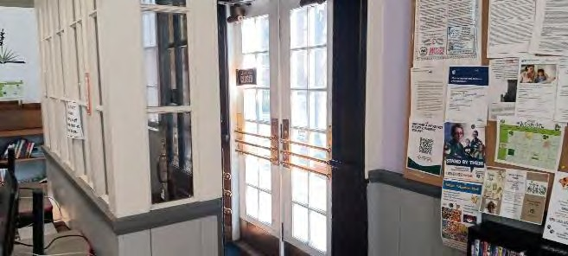
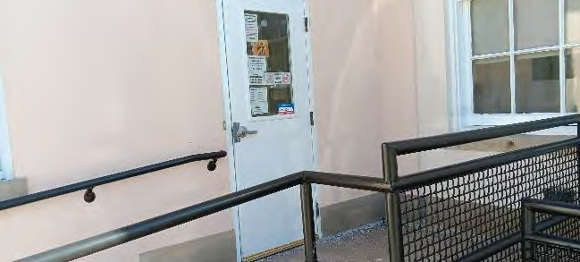
The northwest entry had an accessible ramp and landing added probably around the 1966 remodel without widening the northwest door. During the 1994 remodel accessible off- street parking was added by the 1966 ramp and a handrail was added to the ramp. It was apparently agreed at that time by New Mexico Historic Preservation Division and New Mexico Construction Industries Division that the northwest door would be left at 32 inches wide instead of widening to 36 inches wide because doing so would negatively alter the historic appearance of the facility exterior.
Non-complying entries can be left unaltered due to historic exemption.

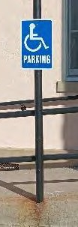
- Accessible Parking
Existing accessible off-street parking has a sign has a parking sign on a post. The bottom of the sign is mounted approximately 4 feet above the parking surface. 2010 Americans With Disabilities Act Standards for Accessible Design (ADASAD) 502.6 requires the bottom of the sign to be at least 5 feet above the ground. The wide access aisle for a ‘van accessible’ space is provided but the sign does not indicate ‘van accessible’. ADASAD 208.2.4 requires that the space be van accessible. ADASAD 506.6 requires that the sign at van accessible spaces be labeled as ‘van accessible’.
Suggested Solution: Raise the parking sign so that the bottom of the sign is at least 5 feet above the parking surface and add a ‘van accessible’ sign to it so that both signs are mounted at least 5 feet above the ground, or replace the sign to the required height with a new sign reading ‘van accessible’ with the required blue accessibility symbol.
Projected Cost of Correction: $ 200
Priority 3 due to non-compliance being relatively minor
Parking sign too low and lacks ‘van accessible’

- Ramp edge
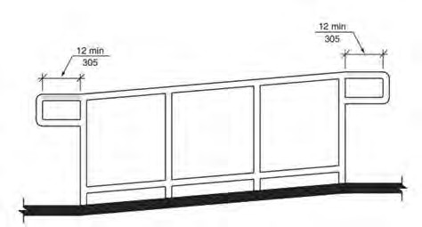
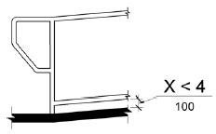
Required ramp edge barrier Required handrail extension at bottom of ramp
The accessible entry ramp lacks a curb or low barrier at the edge of the ramp. ADASAD 405.9.2 requires a curb or barrier within 4 inches of the ramp surface. The existing bottom rail is too high to serve as the required barrier.
The outside handrail lacks a horizontal extension to the bottom of the handrail. ADASAD 505.10.1 requires the handrail extend level for at least 1 foot beyond the top and bottom of the ramp then curve back to the adjacent wall or post. The handrail at the top of the ramp can be left as-is since adding the extension to the handrail at the top of the ramp would conflict with the top landing space requirements and is technically not feasible.
Suggested Solution: Add the required barrier at the outside edge of the ramp and add the handrail extension to the outside rail at the bottom of the ramp.
Projected Cost of Correction: $ 2000
Priority 5 due to non-compliance being relatively minor and due to cost.
- Room Signs

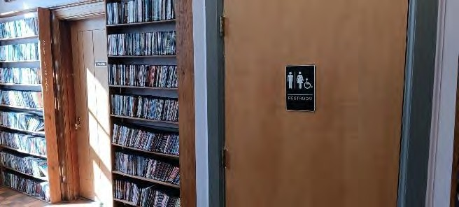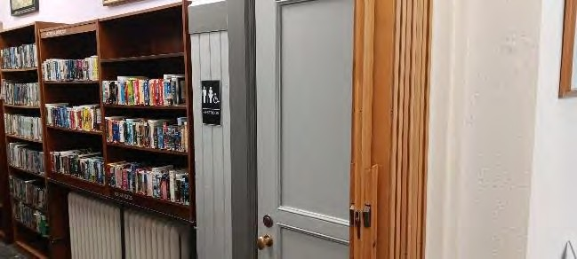
Non-complying door signs and sign placement
Required sign height (if any sign is present) Required sign location beside door
Signs at doors that identify the rooms and uses such as “restroom” and “private” and others are located on door faces. ADASAD 703.4.2 prohibits signs on the face of doors with few exceptions. Some of the existing signs lack raised characters and braille. ADASAD 703 requires when room identification signs are present that they include raised characters, braille, and other specifications. The lower level restroom signs include the wheelchair shaped accessibility indication but the lower level restrooms do not meet accessibility requirements for several reasons. The lower level restroom signs shouldn’t imply that they are accessible. Other sign requirements apply as found in ADASAD 703

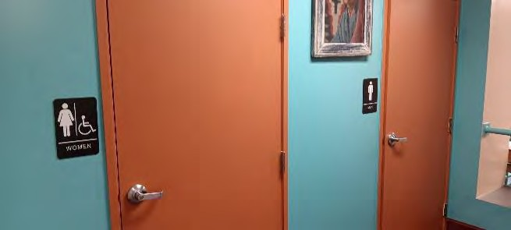 Upper level restroom signs comply
except no accessible symbol at men’s
Suggested Solution: Remove or replace the room designation signs with signs that comply. Note that signs in the photos are required to be placed beside the door with clear floor space under the sign extending at least 18 inches from the edge of the door as shown on the diagrams and will require altering the adjacent shelving if signs are present. These requirements apply to other doors in the facility such as those labeled “private” unless the door sign is removed from a door and not replaced.
Provide signs outside of the non-accessible restrooms directing users to accessible restrooms. As an alternative solution instead of altering the adjacent shelving beside the doors, ADAASAD 703.4.2 includes an exemption that allows for door signs to be placed on the face of the door when the door swings into the room and has an automatic closer. The door could be altered to swing into the restroom and installed with a door closer in order to avoid altering the adjacent shelving to make room for the restroom sign. Clean and patch damaged door and wall finishes where signs and shelves have been removed.
Projected Cost of Correction: $ 800
Priority 2 due to being readily achievable.

- Upper Women’s Room Lavatory

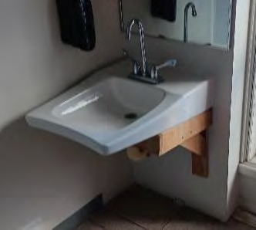
The lavatory is supported by a site constructed wood frame that reduces the knee space to 24 inches high above the floor level. ADASAD 306.3 requires the knee space to be at least 27 inches high.
Suggested Solution: Either alter the lavatory support or replace the lavatory and mounting to provide a knee space at least 27 inches tall. Other requirements in ADASAD for lavatories, faucets, and knee spaces apply. Note that the existing lavatory is especially deep measured front to back and is not required to be a model as deep. Patch wall surface as needed after wall is opened for the placement of brackets to support the new lavatory. Texture and paint the affected wall surface to match the adjacent wall.
Projected Cost of Correction: $ 1800
Priority 4 due to non-compliance being relatively minor.
Wood support under lavatory makes the knee space too low.

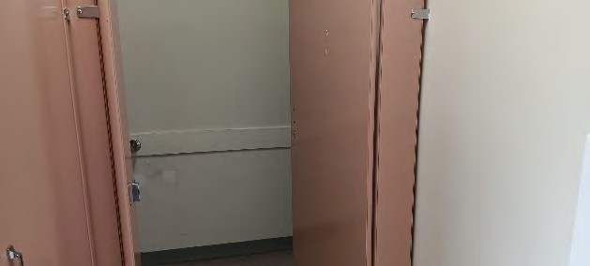
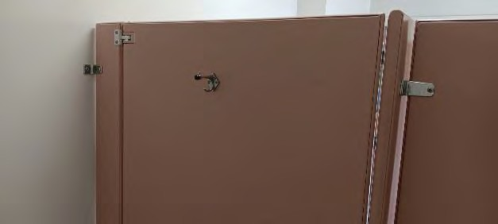
- Upper Women’s Room Toilet Partition
No pull mounted to push side of partition door. Coat hanger installed too high
The accessible partition door has no pull handle on the outside of the door. ADASAD 604.8.2.2 requires a pull located near the latch on both the push and pull sides of the door. The partition has a coat hook located approximately 5 feet above the floor level. ADASAD 604.8.3 requires if a coat hook is present that it be mounted at an allowable range between 40 inches and 48 inches above the floor.
Suggested Solution: Install pull on the push side of the door. Remove or lower the coat hanger to the acceptable range. Patch or place dummy bolts in old openings to minimize the unattractive appearance of the old screw holes
Projected Cost of Correction: $ 200
Priority 4 due to non-compliance being relatively minor.

- Upper Level Men’s Toilet
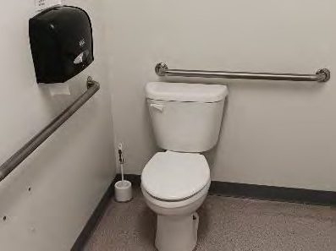
The toilet flush lever is on the restricted side of the toilet. ADASAD 604.6 requires accessible toilets to have their flush valve lever on the open side of the toilet.
Suggested Solution: Replace the upper level men’s room toilet with an accessible height toilet that has the flush lever on the right side of the toilet.
Projected Cost of Correction: $ 2000
Priority 5 due to non-compliance being relatively minor.
Flush lever on restricted side of the toilet
Total projected cost of facility corrections: $7,000 plus tax

5.K. Parish Hall
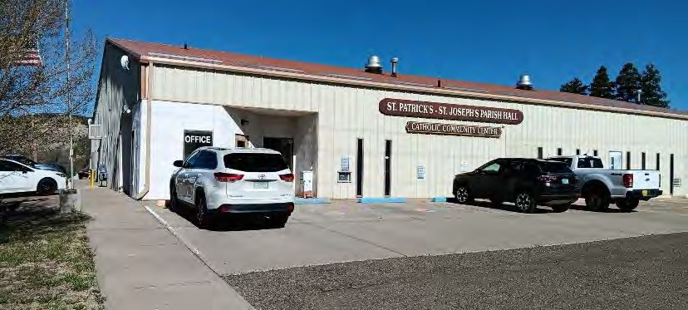
104 Buena Vista Street
Use: Church hall
Approximate construction date: 1990
Activities and Offerings:
- Church events
- Church dinners
- Church administration
- Public voting

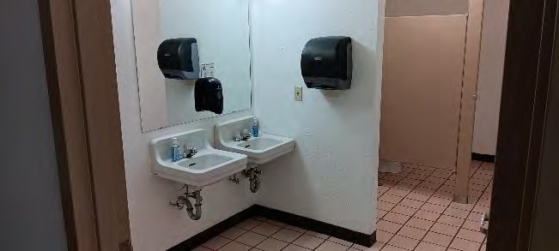
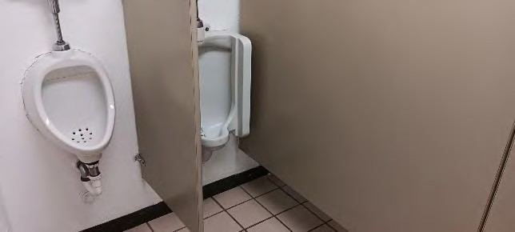
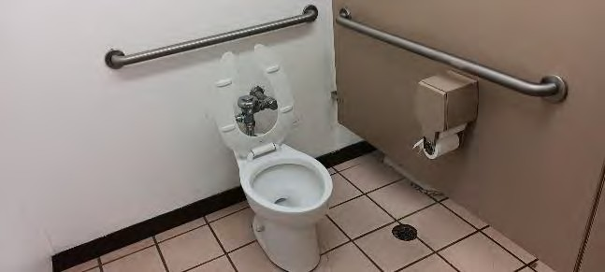
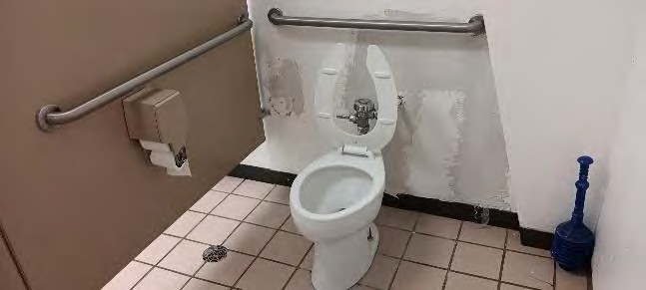
Special Conditions: The Parish Hall is owned and operated by the St. Patrick – St. Joseph Catholic Church. It is included in this City of Raton ADA Transition Plan because it is one of the two polling locations used for City, County, and State elections. The other polling location is the Raton Convention Center. Polling generally takes place one day between zero and two times each year depending mostly on election cycles.

Public restrooms do not comply for a long list of reasons mostly related to clearances around fixtures, mounting heights, stall hardware, and other minor compliance issues. Accessible toilets and stalls are provided. Since the non-compliance is relatively minor, most are not easy to fix, accessible toilets and stalls are provided, and the facility is not publicly owned, it is suggested to leave the restrooms as-is.
Since the reviewed areas of the facility were found to be mostly in compliance other than the restrooms, and most other facilities would have similar or more non-compliance than the Parish Hall, and the Parish Hall is ideally located to serve the eastern areas of Raton, and there are few other facilities in the neighborhood that can easily serve as a polling place for the east side of Raton, it is suggested to continue to use the Parish Hall as a polling location.
Only the parking area, entry, auditorium, and public restrooms were reviewed for this Transition Plan because those are the areas accessed by the public for voting.

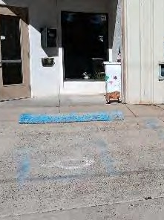
- Accessible Parking
The concrete driving surface at the accessible parking spaces slope around 4% (1:25). 2010 Americans With Disabilities Act Standards for Accessible Design (ADASAD) 502.4 and 302 require accessible parking to slope not more than 2% (1:48). Since the existing slope is not severe and since relocating the accessible parking to a more level surface would locate the accessible parking approximately 50 feet from the primary building entry it is suggested to leave the accessible parking at its current location. The accessible parking spaces have parking signs at only some accessible spaces. The signs are mounted at 2 feet and 3 feet above the parking surface. No ‘van accessible’ space is designated. No access aisles are marked.
Suggested Solution: Remark and re-sign the accessible parking spaces to provide at least three accessible spaces, each with an access aisle on at least one side, and an eight feet wide access aisle to the passenger side of the van accessible space. Provide wall or pole mounted signs for each accessible space with the bottoms of the signs at five feet above the driving surface. Re-paint faded and worn pavement markings at the accessible spaces. Additional requirements found in ADASAD apply including dimensions, sign display, colors, and more.
Projected cost of correction: not prepared due to the facility being non-government owned
Priority 2 due to non-compliance being relatively minor but readily achievable to correct.
Accessible parking spaces do not comply for several reasons.

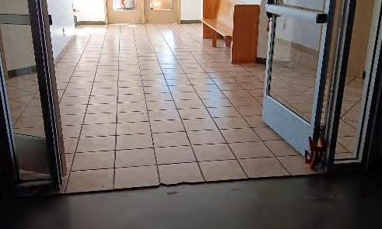
- Flooring Transition
Vertical step at edge of floor tile
There is an abrupt step of approximately one half inch in height at the edge of the ceramic floor tile. ADASAD limits the height of offsets in the walking surface as shown in the diagram below.
Suggested Solution: Install a beveled transition strip that complies with ADASAD to reduce or eliminate the abrupt step.
Projected cost of correction: not prepared due to the facility being non-government owned
Priority 2 due to non-compliance being relatively minor but readily achievable to correct

5.L. Raton Senior Center
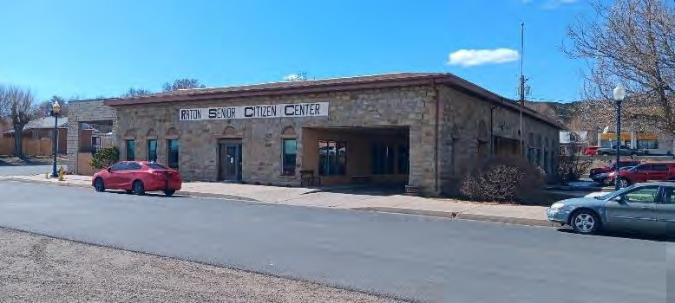
440 Savage Avenue
Use: Senior Citizens Center
Approximate construction date: 1910 with a major remodel in 1988 and addition in 1998
Activities and Offerings:
- Senior recreation
- social gatherings
- Kitchen and dining
- Billiards
- Administration

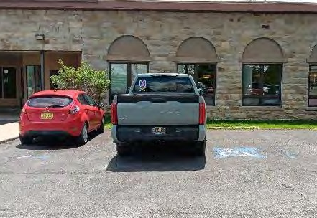
- Accessible Parking
Existing accessible parking markings that used to be present are mostly missing. No pole signs marking the accessible parking are present.
Suggested Solution: Add missing pavement markings including required access aisles. Add missing signs. At least one space is required to be marked and dimensioned as ‘van accessible’. Required markings and dimensions are found in 2010 Americans With Disabilities Act Standards for Accessible Design (ADASAD) 502.
Projected Cost of Correction: $ 700
Priority 1, Readily achievable and high use
Noncompliant markings, missing signs.

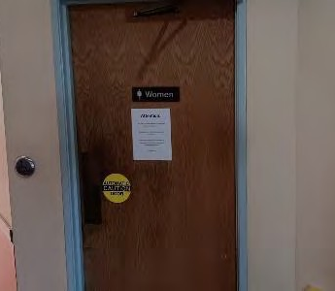
- Restroom Signs
Signs lack braille and raised characters. The location on the face of the door is allowed by ADASAD on these restroom doors because the doors swing away from the hall side. ADASAD 207 and 703 require among other things that when room signs are present they have raised characters, symbols, and braille.
Suggested Solution: Replace restroom signs with compliant signs at the same locations as the existing. Other requirements found in ADASAD apply to the sign, symbols, font, mounting height, and other details.
Projected Cost of Correction: $ 200
Priority 1 due to being readily achievable and high use
Signs without raised characters or braille

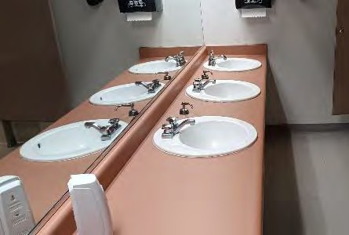
- Women’s Room Accessible Lavatory
The accessible lavatory with the lever handles has a towel dispenser projected into the required floor area. ADASAD requires a clear floor space of 30 inches wide centered on the lavatory with no obstructions.
Suggested Solution: Either move the towel dispenser to an acceptable location or make one of the other lavatories accessible by replacing the lavatory knobs with levers.
Projected Cost of Correction: $200
Priority 1 due to being readily achievable and high use by senior citizens
Accessible lavatory has towel dispenser
projected over the required lavatory space

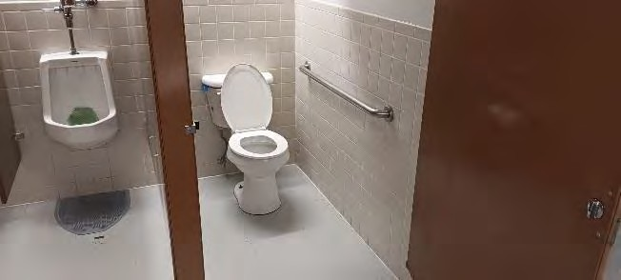
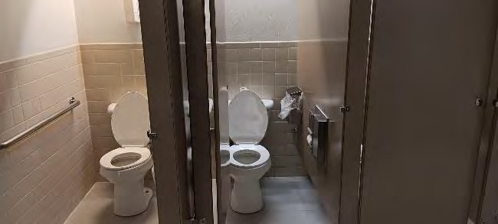
- Women’s and Men’s accessible toilet
Women’s accessible toilet stall to narrow Men’s accessible toilet stall too narrow
The accessible toilets stalls are too narrow. ADASAD 604.8 requires accessible stalls to be at least 5 feet wide depending on the type of partition. Additional requirements apply such as grab bars. The 2021 International Building Code (IBC) requires two toilets in each of the two restrooms for this building size, use, and configuration. Removing one of the three toilets from the women’s room and removing one of the urinals from the men’s room in order to allow for a wider accessible toilet stall in each restroom is an option.
Suggested Solution: Remove the middle toilet in the women’s room and remove the urinal closest to the toilet in the men’s room, then replace the toilet partitions to allow for the required floor area in the accessible toilet stalls. Floor, wall, and ceiling finishes will need to be repaired or replaced as part of the alterations. Note that when the women’s room accessible toilet stall is widened the accessible toilet will need to be replaced so that the flush lever is on the open side of the toilet. Also note that if the restroom partitions are to be replaced then the angled partitions near the restroom doors might be reconfigured to more closely comply with clearances required in ADASAD 403.5.2. Also note that the floor slab has radiant heat tubing so new partitions might best be suspended from the roof frame without anchoring into the floor.
Projected Cost of Correction: $ 8,000
Priority 2 due to balancing cost with high use by senior citizens
- Men’s Room Urinals
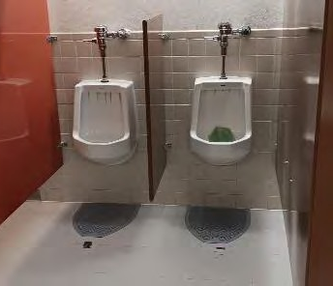
Urinal mounted too high.
The top of the urinal rims are installed 22 inches above the floor level. ADASAD 605.2 requires the rim to be no more than 17 inches above the floor.
Suggested Solution: Re-mount one urinal lower to the required height. See the accessible toilet stall description where reducing the number of urinals from two to one is suggested. Alter plumbing so that the flush lever is not more than 48 inches above the floor.
Projected Cost of Correction: $ 5,000
Priority 2 due to balancing cost with high use by senior citizens
Total projected costs of facility corrections: $14,100 plus tax

5.M. Shuler Theater
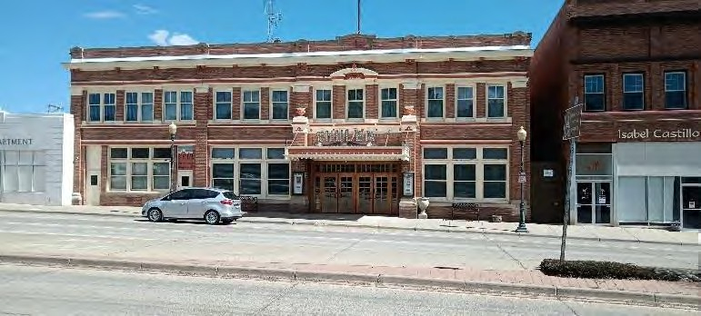
131 North Second Street

Use: Stage and Movie Theater
Approximate construction date: 1914 with periodic alterations
Activities and Offerings:
- Stage performances
- Movies
- Rehearsals
- Lectures
- Facility tours

Special Conditions: The theater is a registered historic property by the State of New Mexico. 2010 Americans With Disabilities Act Standards for Accessible Design (ADASAD) 202.5 exempts historic properties from ADA compliance when that compliance threatens or destroys the historic significance of the facility.
The northern portion of the building was constructed as a fire station at the same time that the rest of the theater was constructed. The upper level of the fire station space remains in use as the day area and sleeping rooms of the fire station and is connected to the rest of the newer fire station addition. The fire station portion of the Shuler Theater building along with the rest of the fire station is reviewed in a separate section of this ADA Transition Plan.
The lower level section that was a fire station (north end of the lower level) has been altered and is leased to a for-profit tenant so it is not included in this review or ADA Transition Plan.

The interior doors between the east end of the lobby and the auditorium are made up of three double doors side-by-side. Each of the six doors measures 28 inches wide rather than 36 inches typically required for accessibility. Since replacing the doors with 36 inch doors would significantly alter the highly visible lobby and auditorium the doors are exempt from being required to be replaced. The doors can be propped open before and after shows to form openings nearly four feet wide.

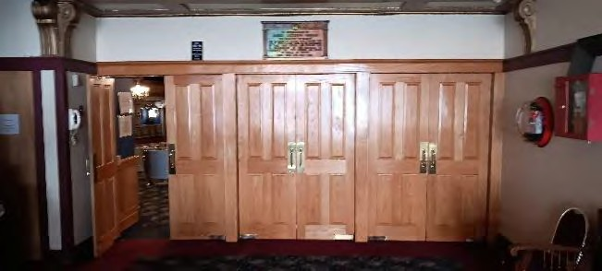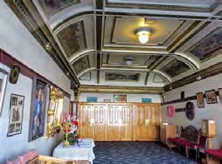
Non-complying lobby doors can be left unaltered due to historic exemption
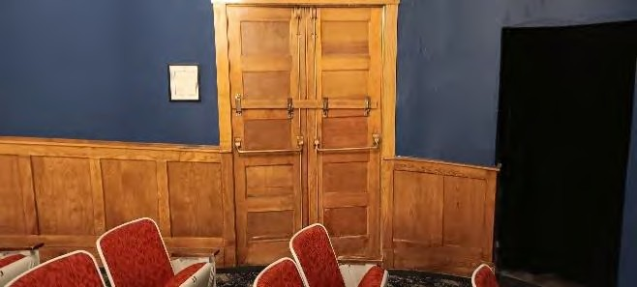
Emergency exit doors located on the north and south exterior walls of the auditorium are also less than 36 inches and exempt for the same reasons as the lobby doors. The total emergency exit door opening width (when the pictured pair of doors is open) and placement of exits from the auditorium meet current International Building Code opening width and placement requirements.
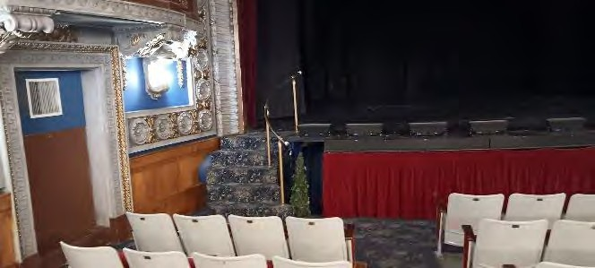
Emergency exit door widths exempt.
Stage and Dressing Room Access – ADASAD 206.2.4 requires an accessible route throughout a facility with some exceptions. Since providing access would require significant alterations to the auditorium and stage area and to the historical features ADASAD 205 exempts the stage and the dressing areas below the stage from being significantly altered to allow for an accessible route. There is sufficient space at the stage level out of view from the auditorium seating that if a disabled person using the stage is in need of access to a dressing room a temporary dressing room can be prepared based on that particular user’s needs.
Accessible route exempt to the stage and dressing rooms.
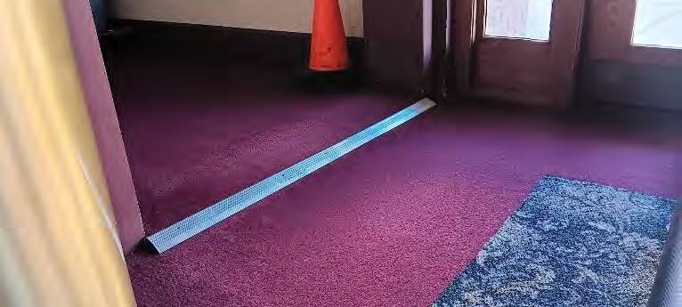
- Floor level at hall to restrooms
Allowable floor transitions Steep slope of floor transition above aluminum strip
The floor level of the restrooms and hall are about two inches higher than the lobby floor. There is a ramp approximately four inches long from the lobby floor up to the hall floor forming a slope of 1:2. Vertical floor surface transitions of more than ½ inch are required to be constructed as a ramp at a slope of not more than 1:12 so the transition of 2 inches vertically requires a ramp length of at least 24 inches.
Suggested Solution: Temporarily pull up the carpet to the edge of the exterior door then build up the floor to slope 1 inch per foot which will place the bottom of the ramp aligned with the edge of the exterior door. Taper the east edge of the new ramp (opposite side of the ramp from the door) at 1 inch per foot down to the east. Re-install the same carpet. Add transition strips similar to the existing to cover the carpet gaps and to draw visual attention to the change in slope at the top and bottom of the new ramp.
Projected Cost of Correction: $ 1000
Priority 3 due to transition already being ramped.

- Restroom Doors
The force required to open the restroom doors is around 10 pounds. ADASAD 404.2.9 requires the opening force to be not more than 5 pounds.
Suggested Solution: Adjust the door closers at the restrooms.
Projected Cost of Correction: $ 0
Priority 1 due to being readily achievable.

- Accessible Toilet Stall
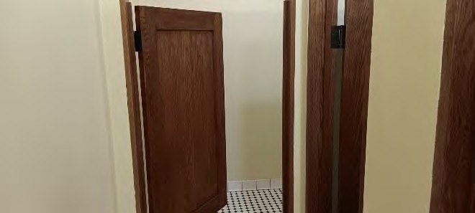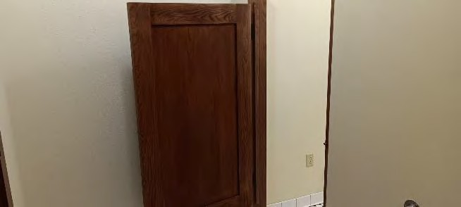
Accessible stall doors lack pulls and closers.
Doors have pulls on the inside of the door but not the outside of the door and do not self-close. ADASAD 604.8.1.2 requires pulls on both sides of the accessible stall doors and requires accessible stall doors to be self-closing.
Suggested Solution: Add missing pulls. Replace one hinge on the accessible stall doors with a spring hinge to self close and to require not more than 5 pounds of opening force.
Projected Cost of Correction: $ 500
Priority 2 due to low cost.

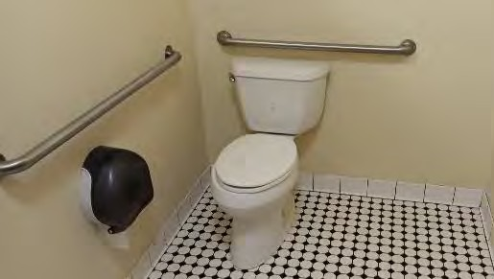
- Men’s Accessible Toilet
The toilet flush lever is on the restricted side of the toilet. ADASAD 604.6 requires accessible toilets to have their flush valve lever on the open side of the toilet.
Suggested Solution: Replace the men’s room toilet with an accessible height toilet that has the flush lever on the right side of the toilet.
Projected Cost of Correction: $ 2000
Priority 5 due to non-compliance being relatively minor.
Flush lever on restricted side of the toilet

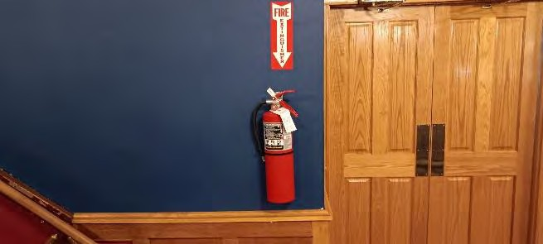
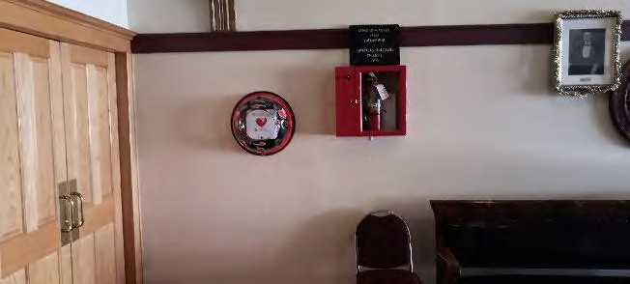
- Extinguisher and Defibrillator Mounting Defib and extinguisher mounted too high
Extinguisher height exempt due to wainscot
Extinguishers and defibrillator are mounted so that the parts that require reaching are more than 4 feet above the floor. ADASAD 308 requires that all items that need to be reached are mounted at no more than 4 feet above the floor level when it can be done without destroying the architecturally significant features.
Suggested Solution: Re-mount the extinguishers and defibrillator to an allowable height. At the auditorium lowering the extinguisher height by a few inches would require damaging the wood wainscot or require the extinguishers to extend more than four inches over the walking surface.
Relocating the auditorium extinguishers would be contrary to fire code requirements for extinguisher placement by the primary exit doors so it is suggested to leave the extinguisher locations and heights unchanged at the auditorium.
Projected Cost of Correction: $ 300
Priority 3 due to installations being rarely used.

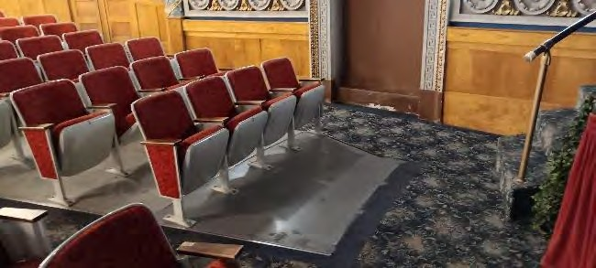
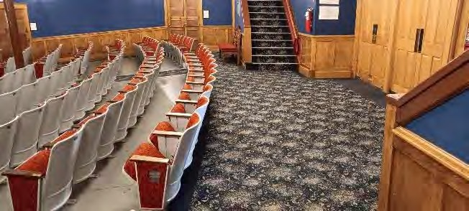
- Wheelchair Spaces in the Auditorium
Fixed seats have been removed in corner. Wheelchair space at back of the auditorium of auditorium for wheelchair space but is in the circulation path and lacks a fixed lacks sufficient floor space and lacks a (standard) companion seat next to it.
Wheelchair floor space is provided for seating in the auditorium at a portion of the front row where three fixed seats were removed and at the back of the fixed seating where there is level floor space for an undefined number of wheelchairs. The existing wheelchair spaces do not comply with ADASAD 221 and 802 for several reasons. ADASAD 802.1.1 requires the wheelchair spaces to have a floor slope not exceeding 1:48. The existing floor under the ground level seating area slopes 1:12. ADASAD 802.1.5 requires that the wheelchair seating space not overlap circulation paths. The space behind the fixed seating currently used for accessible wheelchair space at the back of the auditorium is in the main circulation path. Installing barriers to separate the wheelchair space from circulation space would project too far into the circulation space to effectively and safely allow for circulation. ADASAD 221.2.1 requires at least six designated wheelchair spaces in the auditorium when there are between 301 and 500 seats in the auditorium. ADASAD 221.3 requires at least one “companion seat” beside each wheelchair space. Among other specifications for the companion seat ADASAD 802.3 requires the companion seat to be aligned shoulder to shoulder with the parked wheelchair and of the equivalent size, quality, and comfort as the general seating nearby. The floor height under the companion seat is required to be at the same floor height as the wheelchair space. ADASAD 221.2.3.1 requires that the wheelchair spaces be dispersed horizontally, for instance not all located in the northern quarter or front half. Two wheelchair spaces are permitted to be side-by-side if each has a companion seat to the other side. ADASAD 221.2.3.2 requires that the wheelchair spaces be dispersed vertically (front to back of the auditorium) and at the balcony, although since wheelchair access to the Shuler Theater balcony isn’t feasible the wheelchair spaces will have to be all located at the ground floor.

Suggested Solution: To provide at least the six required accessible wheelchair spaces it is suggested that two side-by-side spaces be placed in the back row of the ground floor fixed seating as described below, and four individual spaces be distributed evenly around the rest of the lower level auditorium as described below. Removing four of the existing fixed back row seats together would open a space approximately 80 inches wide. ADASAD 802.1.2 requires a width of at least 66 inches when two wheelchair spaces are side-by-side. The required companion seat for each wheelchair space can be provided by the adjacent existing fixed seating. Since a nearly level floor is required under the wheelchair space and the companion seat the sloped floor level at this location can be raised under the two wheelchair spaces and two fixed companion seats so that the new level floor is a continuation of the existing level floor at the auditorium entry. It is suggested that a railing or other barrier be placed beside the fixed companion seats to prevent someone from trying to walk in front of the fixed seats without seeing the vertical offset between the existing sloped floor and the newly constructed level floor. This back row solution would fully comply with ADASAD requirements for those two wheelchair spaces. Provide new carpet and edging at new level floor near auditorium doors. Finish edges of new level floor. Grind and fill old mounting screws locations where seats are removed from sloped floor. Patch paint.
Since ADASAD 221.2.3 requires the wheelchair spaces to be distributed relatively evenly throughout the auditorium at least four other spaces should be spread accordingly and not all against an outside aisle for instance. Each of the four spaces can be formed by removing four fixed seats for each new wheelchair space with the four removed seats being configured of two from one row and two from the row immediately in front to form a space measuring 40 inches by 72 inches. Each of the existing fixed seats with knee & foot space measures approximately 20 inches wide by 36 inches. ADASAD 802.1 requires that each wheelchair space measure at least 36 inches wide by 60 inches when the individual spaces are accessed from the side (aisle) rather than pull in straight from the front or back of the space. It also prohibits the space from overlapping the circulation path (aisle). Since these four suggested wheelchair spaces would each have a fixed adjacent companion seat on the same sloped floor these spaces would fully comply with ADASAD except for the sloped floor under the wheelchair space. This suggested solution is as compliant as can reasonably be accomplished given the existing conditions. The existing wheelchair space at the northeast corner of the auditorium seating can have the fixed seats replaced so that the empty space can no longer be used as a wheelchair space, or can be made the required five feet deep for one of the required wheelchair spaces by removing two adjacent seats behind the existing space. If seats behind were not removed to allow for a 60 inch depth at the wheelchair space then the 60 inch depth of the wheelchair space would extend over most of the circulation path in front of the stage as it currently does which is not allowed by ADASAD.
For operations it's important to note that if the admission price for ground floor seating is charged at a higher price than for balcony seating and a user requests an accessible balcony seat with or without a wheelchair space then the user and one companion can’t be forced to pay more for a ground floor seat unless the lower cost balcony seating is already sold out.
Projected Cost of Correction: $ 5000
Priority 2 due to degree of non-compliance and frequent use but requiring planning, disruption, and funding.

- Assistive Listening System
The Assistive Listening System is reported to include three receivers, none of which are considered hearing-aid compatible. For 425 to 450 seats in the auditorium ADASAD 219 requires at least 18 receivers, at least five of which should be hearing-aid compatible which are usually accomplished by the use of neck loops and related equipment. Neck loops can be plugged into any sound source such as the receiver loaned to the user by the Theater. The neck loop wirelessly relays sound from the device to the user’s telecoil. A telecoil also known as a t-coil is a small copper wire neatly coiled inside some hearing aids and cochlear implants. The t-coil receives electromagnetic audio signals when switched on and helps those with hearing loss hear the audio being amplified more clearly for better speech intelligibility. Not all hearing aids have t-coils, but most cochlear implants do.
Suggested Solution: Supplement or replace the existing receivers so that there are at least 18 receivers, at least five of which are hearing-aid compatible.
Projected Cost of Correction: $ 2200
Priority 3 due to existing system already present and seldom used.

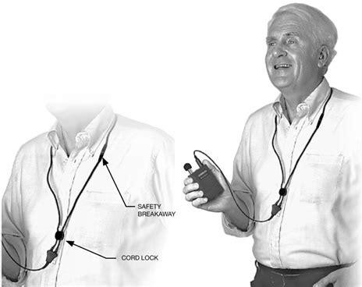
Neck loop with hearing-aid compatible Assistive Listening system.

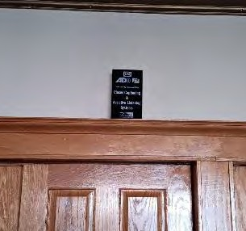
- Assisted Listening Sign
The Assisted Listening System complies with ADASAD 219 and 706. The required sign in the lobby identifying the availability of the Assisted Listening System has lettering not more than one inch high and is placed over seven feet above the floor. ADASAD Table 703.5.5 shows that the sign is placed too high compared to the lettering size.
Suggested Solution: Relocate the sign to a logical location in the lobby for viewing from less than six feet away and so that the letters are between 40 and 70 inches above the floor.
Projected Cost of Correction: $ 0
Priority 3 due to non-compliance being relatively minor.
Sign letters too small

- Stair Handrails
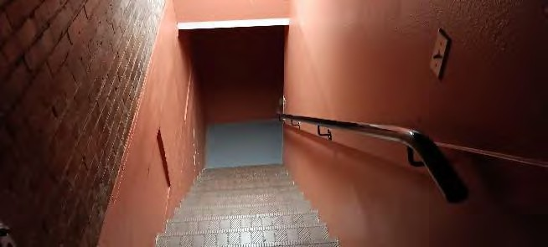
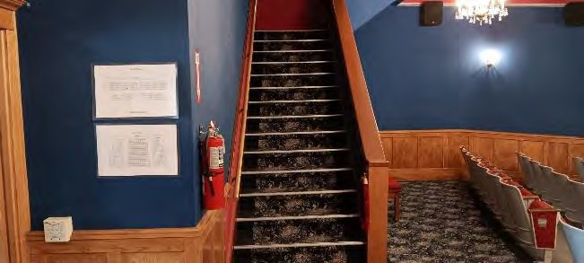
Non-complying handrail heights and extensions, and missing handrails.
ADASAD 504.6 and 505 requires stairs to have handrails each side of the stairs. ADASAD does not exempt the handrails to areas that are not wheelchair accessible such as to the balcony seating and to dressing rooms located under the stage. There is a handrail to the balcony seating on only one side of the stairs and is mounted with the top of the railing at 28 inches above the stair nosing. ADASAD 505.4 requires the top of the handrails to be at a constant height in the range of 34 to 38 inches above the stair nosing. The stairs to both the balcony and to the dressing rooms have no extensions at the top and bottom of the stairs or have extensions that don’t comply with ADASAD 505.10.2 and 505.10.3.
Suggested Solution: Adjust the mounting height of handrails. Add handrails so that each side of the stairs have handrails. Add or alter the handrail extensions to the top and bottom of the stairs where feasible without causing the extensions to project into a path of travel or cause other issues. Handrail extensions are not feasible at all locations. Patch and paint/stain old mounting holes.
Projected Cost of Correction: $ 5000
Priority 5 due to non-compliant handrails already present.
Total projected costs of facility corrections: $16,000 plus tax

5.N. Transportation – Raton Municipal Airport
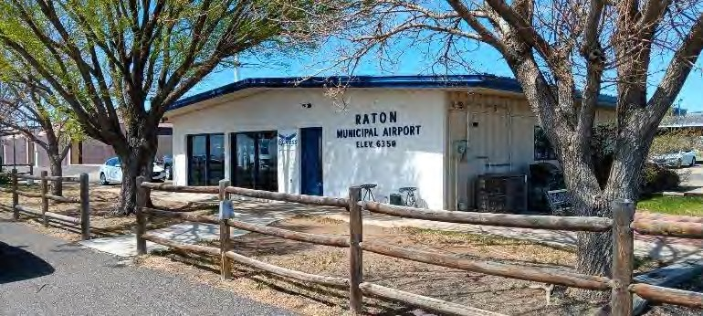
33788 US Highway 64

Use: Municipal Airport
Approximate construction date: 1970 followed by periodic remodels

Activities and Offerings:
- Airport without scheduled commercial flights
- Waiting and Pilot Lounge
- Aircraft fuel sales
- Aircraft parking
- Car rental

Special Conditions: The airport is located approximately ten miles south of the Raton city limits. Operation of the airport is subcontracted to a private for-profit business. Hangers are a mix of privately owned and City owned. The City owned are leased to the airport operator. Hangers were not reviewed for this ADA Transition Plan. Only the terminal building was reviewed.

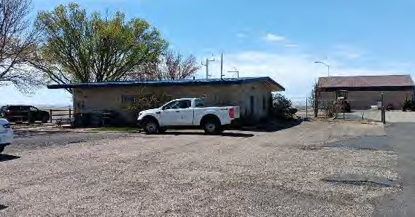
- Accessible Parking:
No designated accessible parking.
There is no designated accessible parking at the airport terminal. 2010 Americans With Disabilities Act Standards for Accessible Design (ADASAD) 208.2 requires public parking areas with up to 25 spaces to have at least one ‘van accessible” parking space with an adjacent access aisle. A small public parking area is located at the back of the terminal building which is the opposite side from the tarmac. At least one van accessible parking space is required.
Suggested Solution: Provide markings, signage, and an accessible path from the ‘van accessible’ parking to the front door of the terminal building. The accessible parking should be the closest parking to the front door when feasible. If the accessible parking is placed on the tarmac then directional signage should direct users where to find the accessible parking from the rest of the terminal parking area. ADASAD 502.3.4 prohibits access aisles beside van accessible MUNICIPAL AIRPORT page 2 parking from being located in the “vehicular way”. Additional requirements apply related to dimensions, signage, markings, slopes, and surfaces.
Projected Cost of Correction: $ 400
Priority 1 due to being readily achievable.

- Entry Airlock size and hardware
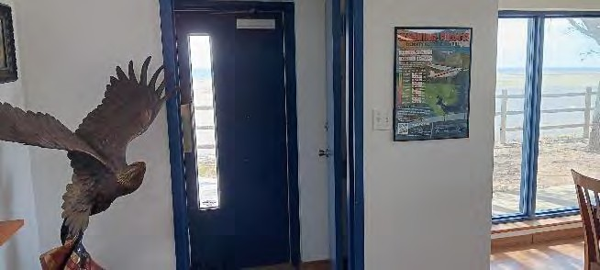

Entry airlock door too close between doors Required clearance between doors
The front and back doors to the terminal building each have an airlock vestibule so that the doors are approximately four feet apart when both are cloased. The airlock doors swing outward in the direction of travel when exiting. ADASAD 404.2.6 requires when doors swing in the same direction to provide at least four feet from the fully open door edge to the next door opening. The interior door of each airlock has a knob instead of a lever handle. ADASAD 404.2.6 requires accessible doors to have levers rather than knobs.
Suggested Solution: Either 1) keep the interior door always propped open as it was found during this review, 2) remove the interior door from its frame, or 3) alter the interior door to swing into the building interior and replace the knob with a lever. If the accessible parking and accessible route to the building are to the front east side of the building then only the east entry is required to be accessible and the back west exit can be left without altering.
Projected Cost of Correction: $ 1500 for re-mounting the east door with a new wood frame and hardware
Priority 2 due to non-compliance being at the public entry and moderate cost.

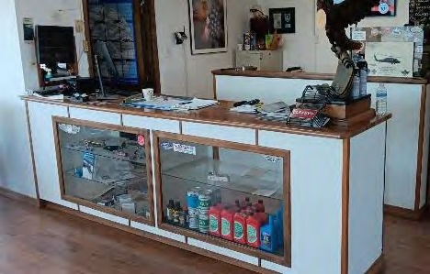
- Service Counter
The service countertop height is over 41 inches above the floor. ADASAD 904.4.1 requires the height to be not more than 36 inches above the floor for a length of at least 36 inches.
Suggested Solution: Alter or replace the service counter.
Projected Cost of Correction: $ 4000
Priority 4 due to staff ability to accommodate the public at existing counter.
Service counter too high.

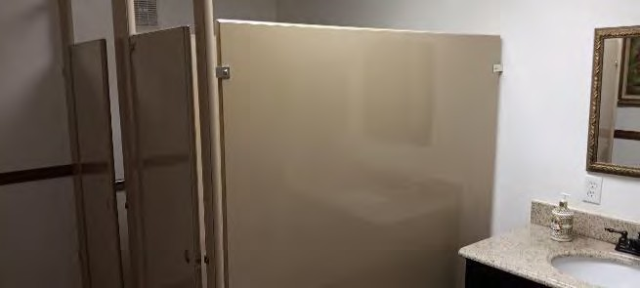
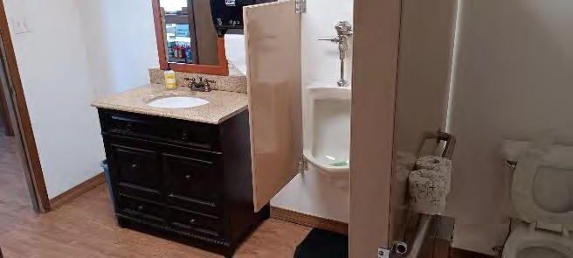
- Restrooms
Non-complying women’s room Non-complying men’s room.
The men’s and women’s restrooms were constructed before ADA requirements so they mostly do not comply for clear floor spaces, counter heights, fixture heights, stall configurations, grab bar sizes, fixture heights, and more.
Suggested Solution: Remodel both restrooms. The remodel will likely require moving or removing plumbing fixtures and altering the hall door locations or swings. It might be found necessary to reduce the women’s room from two toilets to one.
Projected Cost of Correction: $ 40,000
Priority 4 due to moderate use and high cost.
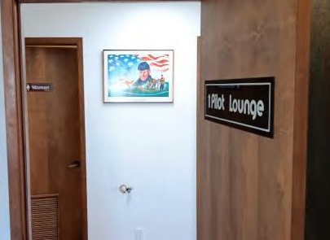
- Room Signs
Non-complying room signs, locations and heights. Sign height requirements. Required sign location beside door.
Room signs have no braille or raised characters and are mounted at a height of over five feet above the floor. ADASAD 703 has many requirements for signs, including room signs include raised characters with braille, and a mounting height range as pictured below. It also prohibits signs on the door unless the door swings inward as those pictured do, and if the door has a closer which the pictured doors to not.
Suggested Solution: Replace room signs with new complying signs at an acceptable height and location. Note that many other requirements apply including character size, open space in front of the signs, font, and visual contrast. Clean and patch door from damaged finishes after old signs are removed.
Projected Cost of Correction: $ 400
Priority 2 due to being readily achievable.
Total estimated costs of facility corrections: $46,300 plus tax

5.O. Transportation – Raton Bus Stop
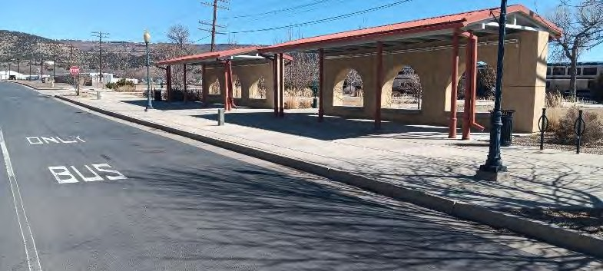
201 South First Street
Use: Intercity bus transit station, Greyhound
Approximate construction date:2010
Activities and Offerings:
- Passenger outdoor boarding
- Waiting at open air structure

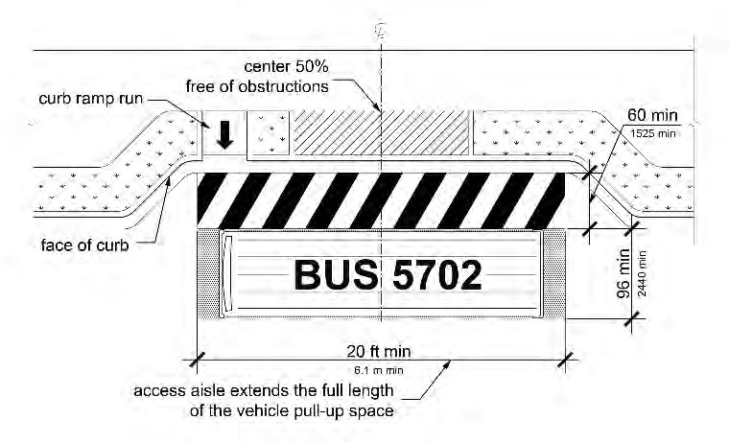
- Boarding Area - No curb ramp
No curb ramp 2024 Public Right-Of-Way Accessibility Guidelines (PROWAG) R311.5 requires the access aisle (boarding area at street level) to have an accessible route (curb ramp) to connect to the accessible pedestrian access route (sidewalk). PROWAG R311.3 requires the access aisle (boarding area) to be at street level rather than sidewalk level. For the Raton configuration this requirement does not prohibit a bus from pulling up close to the curb to allow boarding from the sidewalk level if the driver chooses to. R311.3 requires street level boarding capability and does not require sidewalk level boarding capability.
Suggested Solution: Add at least one curb ramp from the sidewalk to the street level at the location that busses board.
Unlike the diagram provided, when the curb ramp is added to the Raton site the new curb ramp will be required to have flared sides since the existing sidewalk extends to the existing curb with no buffer or green space between. Additional requirements found in PROWAG apply to the ramp.
Projected Cost of Correction: $ 2000
Priority 1 per NCHRP guidelines.
Diagram showing the required curb ramp between the sidewalk and the boarding area.

Total projected cost of facility corrections:
$2,000 plus tax

5.P. Transportation – Raton Amtrak Station
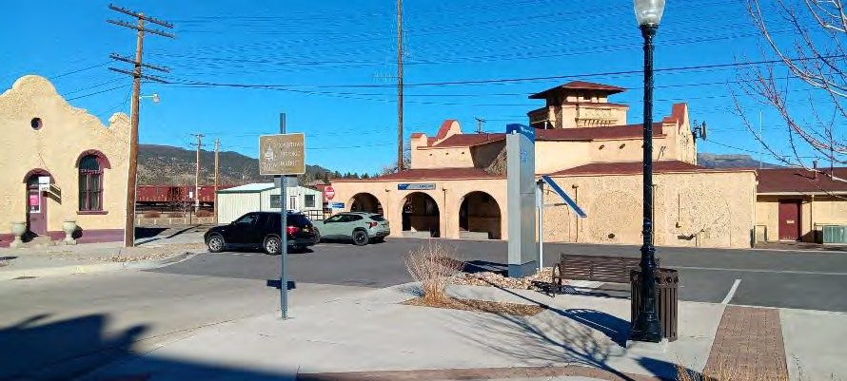
201 South First Street
Use: Intercity rail transit station
Approximate construction date: 1910 with numerous remodels over time to interior and parking.
Activities and Offerings: Passenger waiting
Special Conditions:
- The Station building and parking are owned by the City of Raton and leased to Amtrak. The south half of the building is used and maintained by BNSF Railroad and only used by railroad personnel.
- The railroad siding and boarding area is owned by BNSF Railroad and operated by Amtrak so it is not included in this ADA review.
- Tickets are sold from a small detached structure on site, not from the Station interior.
- The detached structure used for ticket sales is operated and maintained by Amtrak so it is not included in this ADA Transition Plan.
- Passenger waiting and a public restroom are at the Station interior.

The Raton Station building is scheduled to have a significant remodel in 2025 or 2026 when public portions of the interior will be expanded into some spaces that are currently non- public, and restrooms will be expanded and reconfigured. Ticket sales are expected to be relocated to the remodeled Station interior at that time. All will be constructed to comply with current Americans With Disabilities Act Standards For Accessible Design (2010 ADASAD) and other applicable building codes
The siding where boarding occurs is reported by the Raton Amtrak staff to be scheduled for reconstruction by Amtrak as a raised accessible platform complying with ADASAD. Station signage, timetables, and related ADASAD requirements are currently provided and are the responsibility of Amtrak.

EXTERIOR NOTES
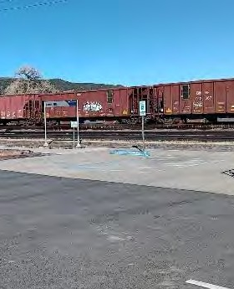
- Accessible Parking:
Pavement markings are worn and faded.
Suggested Solution: Repaint pavement markings on at least one of the two accessible spaces and access aisle. Note that only one accessible space is required for the 16 existing off-street parking spaces to comply with ADASAD Table 208.2 so the second accessible space is optional for compliance. Note that designating the access aisle adjacent to the accessible space is required by ADASAD which gives no additional instructions about pavement markings or symbols painted on the parking surface. New Mexico building code 14.7.2.19. I (5) and (6) requires that the parking space markings include a blue disabled symbol on the accessible parking space surface and the access aisle marked with blue hatched pavement markings.
Projected Cost of Correction: $400
Priority 1 due to being readily achievable

Faded and worn pavement markings at accessible parking spaces

INTERIOR NOTES
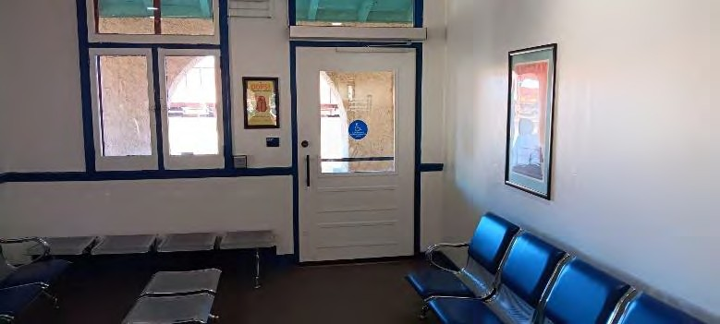
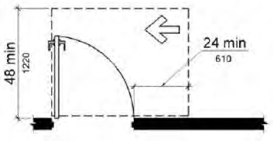
- East Door waiting room
Bench obstructs required clear floor spaces at door, sign, and at opener button
The door has an exit sign with braille. Under the sign is a movable bench. An 18 inch wide clear floor space is required centered under the sign by ADASAD 703.4.2. The door has an opener with a door actuator button mounted on the wall beside the door. Under the button is a movable bench. While an obstruction the size and shape of the bench is allowed in ADASAD 308.3.2 when a user reaches for the push-button, it is obviously the intent of some of the ADA requirements to avoid a seated person from blocking access to the door actuator button. In addition the bench is close to the latch side of the door. ADASAD 404.2.4.1 requires no obstructions within 24 inches of the latch side of the door on the pull side of the door when the door is approached from beside the door (approached from the northwest side of the door in this case). The benches approximately 4 feet in front of the door obstruct accessible approach directly from the front (west) side of the door.
Suggested Solution: Remove the bench from within 15 inches of the center of the door actuator button. This would allow compliance with requirements for clearances around the door actuator button, the exit sign with braille, and the latch side approach of the door.
Projected Cost of Correction: $0 Priority 1 due to being readily achievable.
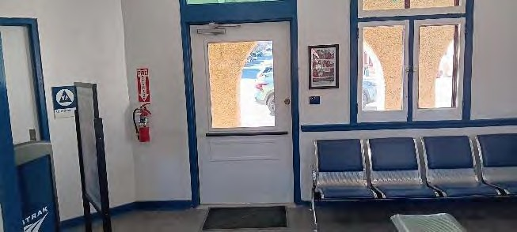
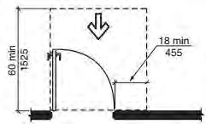
- West Door waiting room
Bench obstructs required clear floor space at door and sign.
The door has an exit sign with braille. Under the sign is a movable bench. An 18in wide clear floor space is required centered under the sign by ADASAD 703.4.2. The bench is close to the latch side of the door. ADASAD 404.2.4.1 requires no obstructions within 18in of the latch side of the door on the pull side of the door when the door is approached from directly in front of the door.
Suggested Solution: Remove the bench from within 9inof the center of the sign and within 18in of the latch edge of the door.
Projected Cost of Correction: $0
Priority 1 due to being readily achievable.

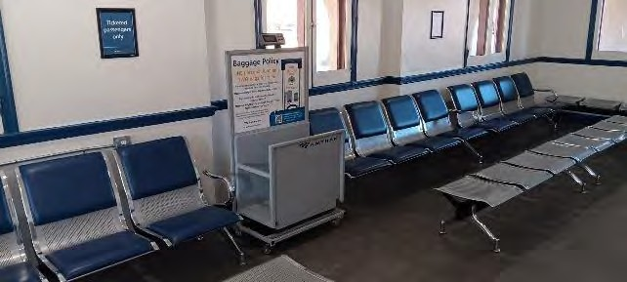
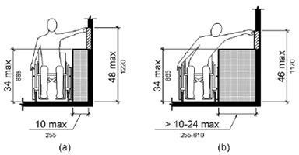
- Luggage Scale
Luggage scale operation buttons located too high and benches obstruct clear floor space
Operable buttons on the luggage scale provided by Amtrak are located so that the user must reach approximately 52 inches above the floor over the rest of the scale. ADASAD 308.3.2 allows for a maximum height above the floor to the operable buttons of 46 inches if the user has to reach over an obstacle the size and shape of the scale.
Suggested Solution: Relocate the scale command buttons with digital display to an accessible location such as the top of the front of the scale.
If the controls are relocated, a wheelchair user would approach the scale from the side rather than head on, and would operate the scale by reaching over the side of the wheelchair. This would require a clear floor space at least 48” measured parallel to the scale’s operation buttons and at least 30” wide measured perpendicular to the scale and buttons. The clear floor space should be centered on the relocated operator buttons and allow space for a wheelchair user to insert luggage onto the scale without obstructions such as benches. The wheelchair user must be able to approach and maneuver to the clear floor spaces described. The silver backless benches currently located near the scale would obstruct the approach and maneuvering space so either the scale would then need to be relocated to an area with more clear floor space and maneuver space, or some of the silver backless benches removed from their current locations to provide the needed floor space.
Projected Cost of Correction: unknown
Priority 2 due to requiring alteration by Amtrak with non-standard equipment.

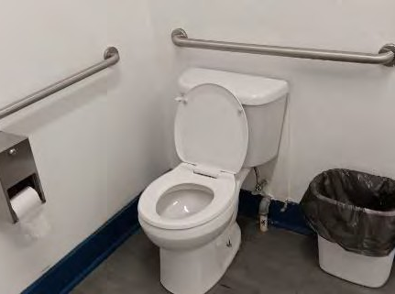
- Restroom
Toilet flush control lever is located on the half of the toilet closest to the side wall. The handle is required to be on the open side of the toilet in ADASAD 604.6.
Suggested Solution: If the planned remodel does not occur in the near future then replace the toilet with an accessible height toilet that has the flush lever on the open side of the toilet.
Projected Cost of Correction: $2000
Priority 5 due to non-compliance being relatively minor.

Flush lever is on the wrong side of the accessible toilet.
Total projected costs of facility corrections: $2,400 plus tax.

5.L.Visitor Center
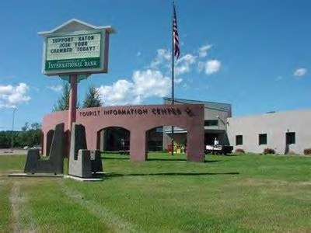
100 Clayton Road

Use: tourist information and general office Approximate construction date: 1997
Activities and Offerings:
- In-person directions and information for area attractions
- City staff and related offices

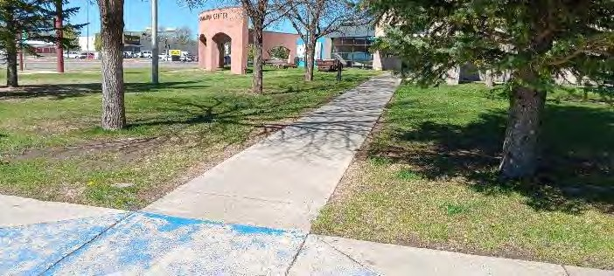
Special Conditions: The existing accessible parking slopes around 4% (1/2 inch per foot). 2010 ADA Standards for Accessible Design (ADASAD) 502.4 and 302 require accessible parking to slope not more than 2% (1:48). The ramp from the accessible parking to the entry sidewalk slopes around 10% (1:10) while ADASAD 405.3 requires the ramp to slope not more than 8.33% (1:12).
Since both the parking slope and ramp slope are only slightly out of compliance and it would be costly to correct it is suggested to leave them unaltered. The entry sidewalk west of the ramp already slopes at the maximum allowable 5% (1:20) so extending the top of the ramp westward would also require replacing approximately 100 feet of the entry sidewalk to keep the sidewalk slope acceptable, or construct additional ramps within the entry sidewalk length.
Accessible parking and ramp slope more than allowed.
Suggested to leave as-is.

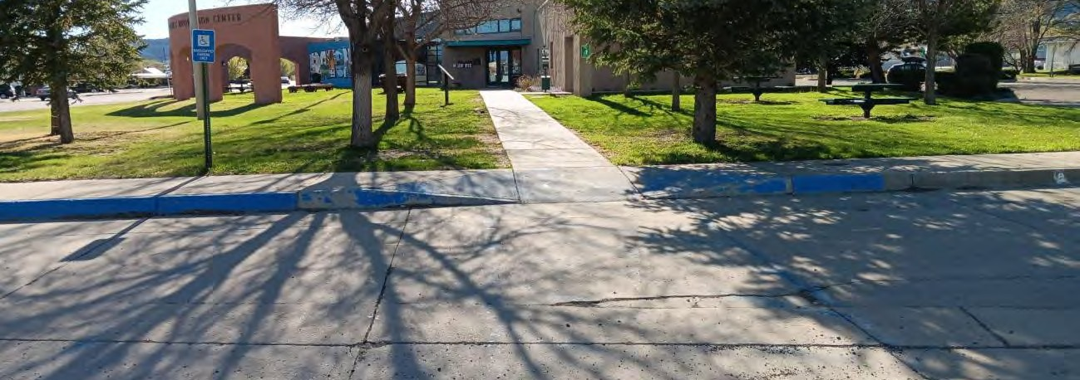
- Accessible Parking
South space is indicated as accessible but lacks an acceptable route to it. Accessible spaces each side of the access aisle have no pole signs. A ‘van accessible’ sign is missing. Pavement markings are faded and worn.

There are three accessible parking spaces designated with faded pavement markings. The only accessible parking sign is located at a space that has no accessible route to the space without the user either stepping over a curb or traveling on the street behind another parked car. There are approximately 35 parking spaces on site. ADASAD 208.2 requires at least two accessible spaces when there are between 25 to 50 parking spaces, with at least one of the two accessible spaces required to be van accessible.
Suggested Solution: Install the two missing pole signs at the two accessible spaces each side of the access aisle. The new pole sign should designate the first space south of the access aisle as being ‘van accessible’. Remove the pole sign from the second space south of the access aisle and remove or paint over the blue pavement markings at that space so that it is no longer implied to be accessible. Repaint remaining pavement markings at the two accessible spaces and access aisle. Additional requirements found in ADASAD apply to dimensions, markings, signs, colors, heights, and more.
Projected cost of correction: $1000
Priority 2 due to accessible parking being present but not correctly marked.
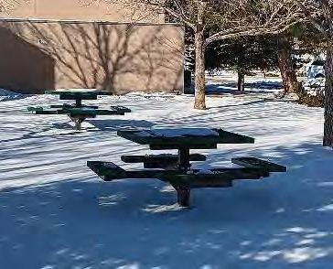
- Picnic Tables
Picnic tables are provided. None have a required knee space for a wheelchair or an accessible route (hard surface sidewalk) to reach the table.
Suggested Solution: Remove one of the seats and seat support arms from one of the tables to allow for a knee space. Construct level concrete pad under at least the accessible space at the table so that the top of the table is 32 inches to 34 inches above the new surface. Provide concrete sidewalk to connect the table to existing sidewalks and accessible parking. Additional dimensional requirements apply as found in 2010 ADA Standards for Accessible Design (ADASAD).
Projected cost of correction: $2500
Priority 2 due to no tables being usable by a wheelchair user, and moderate cost.

No accessible picnic tables or route to
an accessible table.

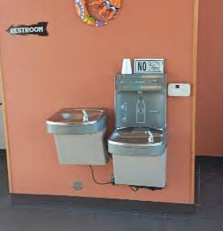
- Drinking Fountains
Fountains have no barriers beside them. 2010 ADA Standards for Accessible Design (ADASAD) 307.3 requires objects that protrude into a room or walking space more than 4” horizontally with a bottom edge over 27” above the floor to have a barrier near floor level so that a visually impaired person using a cane to navigate can detect the barrier and are less likely to walk into the protrusion (fountains extending from the wall).
Suggested Solution: Add a half wall each side of the fountains (two walls total) with the nearest edge of each new finished wall at least 15” from the centerline of the adjacent fountain.
Projected cost of correction: $2,000
Priority 3 due to fountains remaining accessible in their current condition.
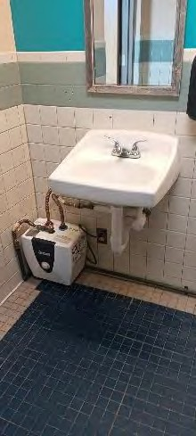
- Water Heaters
Water heater location at men’s room obstructs the required clear floor space under the lavatory. ADASAD 606.2 requires a clear floor space of at least 30” wide centered under the the lavatory.
Suggested Solution: Relocate men’s water heater to shelf high on the wall or to a location out of view.
Projected cost of correction: $3,000
Priority 2 due to the water heaters obstructing the knee space.
Water heater in space of men’s room lavatory knee space.

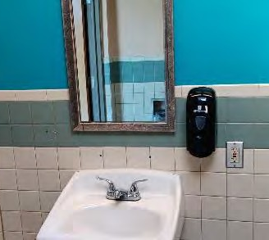
- Mirrors Suggestion
Restroom mirrors are mounted too high at around 47” above the floor. ADASAD 603.3 requires mirrors over lavatories and countertops to be mounted at a height of not more than 40” from the floor to the bottom edge of the reflective surface.
Suggestion: Replace mirrors so that the bottom of the reflective surface (not the bottom of the mirror frame) is not more than 40” above the floor
Projected cost of correction: $500
Priority 2 due to non-compliance not restricting access and being readily achievable.
Mirrors mounted too high.

- Grab Bars
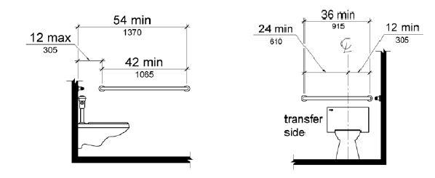
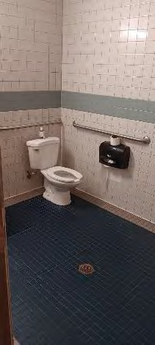
Grab bars beside the three toilets (men’s, women’s, and staff restrooms) are mostly mounted at the wrong horizontal and vertical locations. ADASAD 604.5.1 requires the 42” grab bar beside the toilet to be mounted 12” from the back wall. The existing are mounted around 14”. ADASAD 604.5.2 requires the 36” grab bar behind the toilet to be mounted 12” + 24” from the centerline of the toilet. The existing are mounted around 6”+30”. ADASAD 609.4 requires the tops of horizontal grab bars to be mounted 33” to 36” above the floor. Note that vertical grab bars are required by ANSI A117.7 which is a similar accessibility code enforced by NM Construction Industries Division for new construction and for alterations rather than enforcing ADASAD. ANSI requires a the vertical grab bars when feasible in addition to the identical ADASAD requirements for horizontal grab bars. Since this report is based on ADASAD requirements and not ANSI requirements the lack of a vertical grab bar is not included in the suggestion below. Note that staff areas are not required to be altered unless and until a readily achievable alteration is accommodating to a disabled staff member or volunteer. The suggested change can be postponed until needed at areas not normally accessed by the public.
Suggested Solution: Relocate the horizontal grab bars as described above. Relocating at the staff restroom can be postponed until needed.
Projected cost of correction: $200
Priority 5 due to non-compliance being relatively minor.

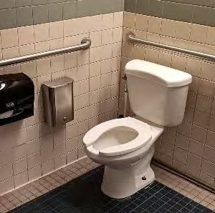
- Toilet Height:
The three accessible toilet seats (women’s, men’s, staff) are too low at approximately 16” from the top of the seat to the floor. ADASAD 604.4 requires the tops of accessible toilet seats to be 17” to 19” above the floor. Note that staff areas are not required to be altered unless and until a readily achievable alteration is accommodating to a disabled staff member or volunteer. The suggested change can be postponed until needed at areas not normally accessed by the public.
Suggested Solution: Replace the men’s and women’s accessible toilets, or replace the seats at the men’s and women’s accessible toilet , so that the top of the seats are 17” to 19” above the floor. Flush levers are required to be on the open side of the toilet so the women’s room toilet will be a special order so that the lever is on the right (non-standard) side of the toilet tank. Altering the toilet or seat at the staff restroom can be postponed until needed.
Projected cost of correction: $2,000
Priority 1 due to frequent public use and current conditions limit accessibility.
Accessible toilets too low.

- Toilet Partition Doors
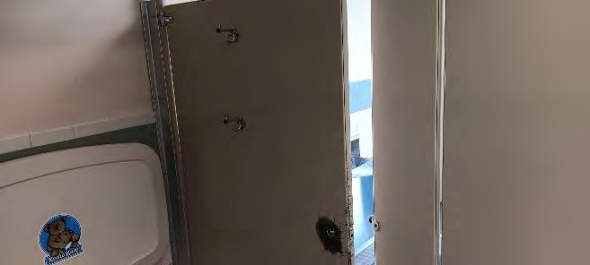
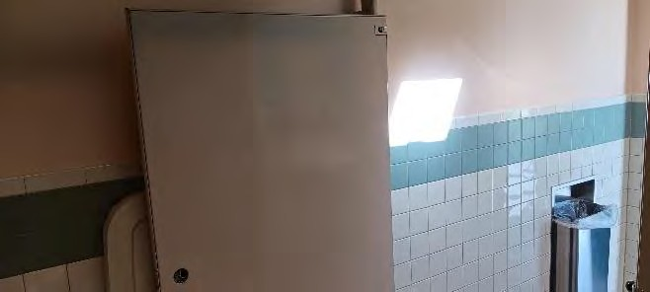
Stall doors are not self-closing, lack pulls, and have hooks mounted too high.
Stall doors at the men’s and women’s accessible toilet stalls are not self-closing, lack a pull on each side of the door, and have coat hooks mounted too high. ADASAD 604.8.1.2 requires accessible stall doors to be self closing and have pulls both sides mounted minimum 34” and maximum 48” above the floor. Pulls should be operable with a closed fist without grabbing or twisting. ADASAD 308 requires items that need to be reached such as coat hooks to be mounted at a maximum 48” above the floor when there is sufficient floor space in front of the hooks.
Suggested Solution: Repair or replace one accessible stall door in the men’s room and women’s room (2 total) to allow for the self closing and pull hardware. Relocate or supplement the existing coat hooks to a maximum of 48” above the floor
Projected cost of correction: $3,500
Priority 2 due to frequent use by the public.

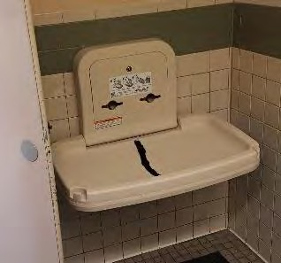
- Diaper Change Stations
Diaper stations are located in the required space of the accessible toilet stalls. ADASAD Advisory 604.8.1.1 prohibits a diaper change station when closed from overlapping the required toilet stall space. The toilet stalls are at or smaller than their minimum size without the change station.
Suggested Solution: Relocate the diaper change stations to outside of the accessible toilet stall.
Projected cost of correction: $500
Priority 2 due to being readily achievable.
Closed diaper station encroaches into the required accessible toilet stall dimensions.
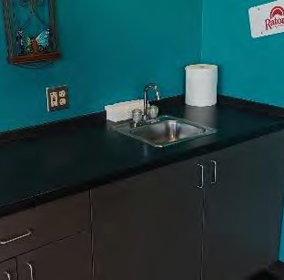
- Coffee Counter Sink Knobs
The bar sinks at the public area near the reception counter, and at the staff break room have knobs that require grabbing and twisting to operate. ADASAD 606.4 requires faucets to operate without grasping or twisting of the hand or wrist. Note that staff areas are not required to be altered unless and until a readily achievable alteration is accommodating to a disabled staff member or volunteer. The suggested change can be postponed until needed at areas not normally accessed by the public.
Suggested Solution: Replace the faucet knobs with handles at the public access area. Replacing the faucet knobs at the staff break room can be postponed until needed by a staff member or volunteer
Projected cost of correction: $300
Priority 2 due to being readily achievable but limited use by the public.
Knobs instead of levers at coffee bar in lobby.

Total Projected Cost of Corrections at Visitor Center: $15,500

Part Six: Itemized Correction Priority Table

Location | Problem area | Non-compliance | Solution | Cost | Priority
Downtown city right-of-way | Pedestrian path surfaces | Various ADA violations | Make surfaces ADA compliant | $200,000 | 5
 | Accessible parking | General lack of accessible parking | Designate accessible parking with signs and pavement markings | $50,000 | 2
2nd Street right-of-Way | Detectable warning surfaces | Warning surfaces are missing from most crosswalks | Install detectable warning surfaces at crosswalks | $20,000 | 5
1st Street right-of-Way | Corner of North 1st and Savage Avenue | No curb ramp | Replace curbs with curb ramps | $8,000 | 2
 | Savage Avenue south side | Steep section of sidewalk and steep cross slope | Reconstruct North end of alley and adjacent sidewalks. | $50,000 | 2
200 block North 1st Street including Clark Avenue | 1st Street South end of west sidewalk | Sidewalk missing for 25ft at south end of block, ramp missing. | Construct missing sidewalk with curb ramp | $5,000 | 4
 | Clark Avenue South side | No curb ramp at alley crossing | Replace curbs with curb ramps | $5,000 | 2
100 block South 1st Street + Cook Avenue | Cook Avenue north side | Especially uneven concrete joints | Replace affected sidewalks | $5,000 | 2
2nd Street right-of-Way | Pedestrian path surfaces | Many sidewalks are not ADA compliant | Misc adjustments | $200,000 | 4
 | Path width | Various obstacles protrude into pedestrian areas | Adjust path widths | $100,000 | 4
 | Accessible parking | General lack of accessible parking | Add new accessible parking spaces | $50,000 | 2
 | Signal heads | Ped. signals lack sound and vibration | At the six locations identified either relocate the pole or reconfigure the ramps. | $1,000,000 | 5
 | Curb ramps | General lack of (compliant) curb ramps | Adjust or construct new curb ramps | $376,000 | 5
 | Detectable warning surfaces | Warning surfaces are missing from many crosswalks | Install detectable warning surfaces at crosswalks | $5,000 | 5
400 block North 2nd Street | Sidewalk | Sidewalk has cracked and buckled | Replace portion of sidewalk. Widen sidewalk with curb ramps | $5,000 | 5
 | Underpass sidewalks | Vertical offsets at concrete joints measuring around 1 inch high | Replace sidewalk at offsets or grind the concrete to provide offsets allowable by ADA | $10,000 | 4
 | North underpass northeast side | Lack of curb cuts and crosswalks | Construct curb ramps | $25,000 | 4
 | North. 2nd Street northwest of north Underpass | No corresponding curb ramps Across the street | Construct curb ramps and alter islands to allow for pedestrian crossings | $15,000 | 5
 | North 2nd Street east side | No curb ramp at end of crosswalk | Reconstruct sidewalk to include curb ramp. | $8,000 | 4
 | North 2nd Street east side | Curb ramp too steep, too narrow, and no top landing | Reconstruct the curb ramp to provide the required landings and slopes | $8,000 | 5
 | North 2nd Street west side | Directional sign less than 5 feet above the sidewalk | Remount signs to at least 6’-8” above the sidewalk surface | $100 | 1
200 block North 2nd Street | Sidewalk | Sidewalk slope too high | Reconstruct the sidewalk between building entries to reduce the running slope to around 5%. | $15,000 | 4
 | Southwest corner of North 2nd and Park Avenue | The concrete has deteriorated | Reconstruct the curb ramp and adjacent sidewalks to eliminate vertical offsets. | $5,000 | 5
 | Northeast corner of North 2nd and Cook Avenue | The concrete has deteriorated | Reconstruct the curb ramp and adjacent sidewalks to eliminate vertical offsets | $5,000 | 5
 | Northwest corner of North 2nd and Cook Avenue | Step at the bottom of curb ramp | Reconstruct the curb ramp and adjacent sidewalks to eliminate vertical offsets | $25,000 | 5
 | East sidewalk | A trench cover rests on top of the sidewalk | Alter the trench so that the top of the trench cover will fit flush with the adjacent concrete | $500 | 3
 | Southeast corner of South 2nd and Rio Grande Avenue | Concrete is deteriorated causing gaps and offsets | Replace deteriorated concrete | $20,000 | 5
 | Southwest corner of South 2nd and Rio Grande | Abrupt transition at bottom of curb | Reconstruct or grind curb ramp for smooth transition from street surface to bottom of ramp. | $8,000 | 5
 | East side of South. 2nd Street | Curb cuts and slopes are too high | Replace affected sidewalk to eliminate obsolete curb cuts. | $20,000 | 5
400 block South 2nd Street | East side of 2nd Street | Step causes tripping hazard and causes a cross slope greater than 5 | Reconstruct affected portion of sidewalk to allowable cross slope and eliminate the step | $8,000 | 4
 | East side of street | Sidewalk approximately 38 inches wide | Relocate light pole. Remove fence and widen sidewalk | $30,000 | 5
 | Both sides of street | Tree branches within 6’-8” of the walking surface | Trim trees | $100 | 1
700 block South 2nd Street | Southwest corner of South. 2nd Street and Mora Avenue | Curb ramp slopes at 13% when not necessary | Reconstruct ramp to allowable slopes and provide a landing at the top of the ramp | $8,000 | 5
 | West side of South 2nd Street | Obsolete curb cut causing greater running slope | Replace affected sidewalk to eliminate obsolete curb cuts. | $20,000 | 5
800 block South 2nd Street | Southwest corner of South 2nd Street and Cimarron Avenue | Curb ramp and crosswalk have overly steep slopes | Reconstruct ramp so that it has a level transition at least 24 inches long. Provide a landing at the top of the ramp | $10,000 | 5
 | West Side Of South 2nd Street | Obsolete curb cut | Replace affected sidewalk to eliminate obsolete curb cuts | $15,000 | 5
 | West Side Of South. 2nd Street | Buckling sidewalk | Replace curb cuts and buckling sidewalk | $20,000 | 3
 | Northwest corner of South 2nd Street and Legion Avenue | Curb ramp has no top landing | Reconstruct ramp so that it has a top landing and acceptable slopes | $10,000 | 5
900 block South. 2nd Street | Southwest corner of South. 2nd Street and Legion Avenue | Curb ramp has no top landing | Reconstruct ramp so that it has a top landing | $15,000 | 5
 | West side of South. 2nd Street | Light pole restricting the pedestrian access route | Move light pole closer to the retaining wall | $50,000 | 5
 | West side of South. 2nd Street | Buckling sidewalk causing excessive slope | Replace affected portions of buckling sidewalk | $5,000 | 5
900 block South. 2nd Street | East side sidewalk | Sidewalk east side has settled around a storm water drop inlet | Replace affected portion of sidewalk | $5,000 | 5
 | Northeast corner of South. 2nd Street and Grant Avenue | Curb ramp is deteriorated and missing | Reconstruct curb at edge of ramp | $10,000 | 5
1000 block South. 2nd Street | Southeast corner of South. 2nd Street and Grant Avenue | Deteriorated curb ramp concrete causing offsets, gaps, and uneven slopes | Reconstruct deteriorated ramp and adjacent deteriorated sidewalk | $5,000 | 5
 | West side of street | Sidewalk is buckling causing vertical offsets | Replace affected concrete sidewalk | $5,000 | 5
 | East side of street | Sidewalk is buckling causing vertical offsets | Replace affected concrete sidewalk | $5,000 | 5
 | West side of street | Sidewalk is buckling causing vertical offsets | Replace affected concrete sidewalk | $5,000 | 4
 | West side of street | Light pole in the sidewalk restricting the pedestrian access | Move light pole closer to the outside edge of the | $50,000 | 5
 | West side of street | Sidewalk is too narrow, and is limited further by retaining wall | Widen sidewalk by removing the fence and retaining wall | $20,000 | 5
 | East side of street | Deteriorating concrete | Replace affected concrete sidewalk | $5,000 | 5
 | East side of street | Settled concrete near storm water drop inlet | Reconstruct settled sidewalk | $5,000 | 5
 | East side of street | Deteriorated concrete causing vertical offsets | Reconstruct crumbled area of sidewalk | $5,000 | 5
 | East side of street | Shrubs reducing the usable width of the sidewalk | Trim bushes | $100 | 1
 | West side of street | Steel cover at trench doesn’t fit trench causing vertical offsets | Alter the concrete or steel cover to fit snug | $500 | 3
 | East side of street | Settled concrete near storm water drop inlet causing vertical offsets | Reconstruct settled sidewalk | $5,000 | 5
 | East side of street | Buckled sidewalk causing offsets and trip hazard | Replace buckled sidewalk | $5,000 | 2
1100 block South. 2nd Street | West side of street | Settled concrete causing vertical offset | Reconstruct the settled sidewalk | $5,000 | 5
 | East side of street | Steel cover at trench doesn’t fit trench causing vertical offsets | Alter the concrete or steel cover to fit snug | $500 | 4
 | West side of street | Deteriorated and broken concrete at isolated location | Replace the deteriorated concrete | $5,000 | 5
1200 block South. 2nd Street | East sidewalk | Sign 5 feet above sidewalk | Repair or replace leaning signpost. Raise sign | $500 | 2
 | East sidewalk | Heaved sidewalk causing 2 inch vertical step | Replace heaved sidewalk, fill holes against edge of asphalt driveway | $5,000 | 5
 | East side of street | Deteriorated and broken concrete at isolated location | Replace the deteriorated concrete | $5,000 | 5
 | West side of street | Deteriorated and broken concrete. Settled concrete at storm sewer drop inlet causing vertical offsets | Replace the deteriorated concrete | $5,000 | 5
 | East side of street | Concrete sidewalk maintains a constant width of around 4ft | Widen the sidewalk to at least 5ft x 5ft | $5,000 | 5
 | East side of street | Sidewalk concrete settled or underground electrical box cover | Replace the concrete around electrical box to eliminate the step | $5,000 | 5
1300 block South. 2nd Street | Southeast corner Of South 2nd Street and Hart Avenue | Base of signal post extends into ramp space. | Reconstruct ramp to allow for clearance to signal post and to provide the required top landing at the ramp | $10,000 | 5
 | East side of street | Concrete sidewalk maintains a constant width of around 4ft | Widen the sidewalk to at least 5ft x 5ft | $5,000 | 5
 | East side of street | Sloped edge of driveway curb cut is broken and heaved causing a vertical step | Replace the heaved and broken slab | $5,000 | 5
 | East side crosswalk | Asphalt connection to slab has settled causing about a 1 inch step | Patch the asphalt to provide a level transition | $500 | 5
300 block North. 3rd Street | North 3rd Street 200 block east side | No sidewalk or curb ramp at southeast corner of Savage Ave | Extend sidewalk and construct curb ramp | $8,000 | 4
 | Northwest corner of 3rd and Clark Avenue | Bottom of curb ramp at 3rd Street abruptly transitions to a steep slope | Reconstruct the curb Ramp To Third Street with the required transitional space | $10,000 | 1
 | Clark Avenue south side | No curb ramp at alley | Replace step from sidewalk to alley with curb ramp | $5,000 | 2
100 block North. 3rd including adjacent Park Avenue | North Third Street 200 block west side | No curb ramp at southwest corner of Clark Avenue | Replace curb with curb ramp | $8,000 | 2
100 block South. 3rd including adjacent Cook Avenue | Southeast corner of North Third Street and Cook Avenue | Trench under sidewalk is heaving | Replace trench and adjoining concrete | $10,000 | 1
 | North Side Cook Avenue | Steps occur from the sidewalk to the alley and to the post office driveway | Replace ends of sidewalks with smooth transition to alley surface and driveway surface | $20,000 | 1
200 block South. 3rd + Adjacent Rio Grande Avenue | South side of Rio Grande Avenue | Steep cross slope when crossing alley. | Regrade and replace alley driveway and adjacent sidewalks | $20,000 | 3
300 block South. 3rd including adjacent Apache Avenue | Southeast corner of South. 3rd and Rio Grande | No curb ramp to South 3rd Street | Replace stepped curb with curb ramp | $8,000 | 2
 | Southwest corner of South. 3rd and Rio Grande | Curb ramp slope measures 12.5% slope | Ramp from the church steps to the street | $20,000 | 5
 | West side Of South. 3rd Street | 10.5% slope at ramp to public senior housing | Supplement ramp with new u shaped ramp | $40,000 | 5
 | Northwest corner of South. 3rd and Apache Avenue | No curb ramps next to public senior housing | Replace stepped curbs with curb ramps and handrails | $20,000 | 2
Legion Drive South Third Street. | Accessible parking north | Is no designated accessible parking at the playground / picnic area | Designate a ‘van accessible” parking space and access aisle | $500 | 2
 | Accessible parking At Gabrielle Field | There is no designated accessible parking | Designate a ‘van accessible” parking space and access aisle | $500 | 2
 | Accessible parking at soccer and little league fields | There is no designated accessible parking | Designate a ‘van accessible” parking space and access aisle | $500 | 2
 | North ramp railing | Most of the ramp has a handrail at only one side | Add the missing handrail and rail extensions | $5,000 | 5
 | Accessible path of travel soccer and little league fields | There is no accessible path of travel between parking, bleachers, concessions, and Field | Provide accessible routes of travel consisting of concrete sidewalks etc | $7,000 | 4
 | Batting cages parking and accessible path of travel | There is no accessible parking or accessible path of travel to the batting cages | Provide accessible sidewalk. Designate a ‘van accessible’ parking space. | $6,000 | 4
 | Play area surfaces | Needs soft surfaces in playground use zones | : replace gravel at the playground use zone | $19,000 | 5
 | Tables | Tables are required to be accessible with required knee space | Provide at least one accessible table with the other tables | $2,500 | 4
 | Restrooms | Park restrooms are not accessible by ADA standards | Construct new accessible restrooms | $220,000 | 2
Optomist Park | Accessible parking | The only parking is on-Street parking | Indent The Street curb | $20,000 | 4
 | Accessible path of travel | An accessible path of travel is Required Between Each Park feature. | Provide concrete or asphalt sidewalks | $15,000 | 5
 | Play area surfaces | Needs soft surfaces in playground use zones | Replace gravel at the playground use zone | $26,000 | 5
 | Tables | Tables are required to be accessible with required knee space | Provide at least one accessible table with the other tables | $2,500 | 4
Tennis and pickleball courts | Parking areas | No designated accessible parking and no accessible Route To The Court gates | Construct accessible parking with markings, signage, access aisle, and accessible route | $30,000 | 4
Ripley Park | Accessible parking | Only designated space is not near curb | Relocate the accessible parking space with markings, access aisle, and signs | $4,000 | 1
 | Accessible path of travel | An accessible path of travel is Required Between Each Park feature. | Provide concrete sidewalks connecting the accessible parking | $20,000 | 5
 | Play area surfaces | Needs soft surfaces in playground use zones | Replace gravel at the playground use zone | $20,000 | 5
 | Tables | Tables are required to be accessible with required knee space | Provide at least one accessible table with the other tables | $2,500 | 4
 | Gazebo | The ramp and steps lack handrails each side | Add handrails each side of the gazebo steps and ramp | $8,000 | 5
Romero Park | Accessible parking | There is no designated accessible Parking Near The Park | Provide at least two accessible parking spaces | $30,000 | 4
 | Accessible path of travel | An accessible path of travel is Required Between Each Park feature. | Provide concrete sidewalks connecting the accessible parking | $50,000 | 4
 | Play area surfaces | Needs soft surfaces in playground use zones | Replace gravel at the playground use zone | $20,000 | 5
Roundhouse Memorial Park | Dog Park accessible route | There is no accessible Route to the fenced dog Park | Asphalt or concrete walking surfaces that connect the dog park gate to an existing asphalt walking trail | $40,000 | 5
 | Tables | Tables are required to be accessible with required knee space | Provide at least one accessible table at each of the two shelters | $4,000 | 4
 | Footbridge surface | Surface is made of steel grates that have openings approximately five inches long | Install plank decking above the existing steel grates | $30,000 | 5
 | Footbridge abutment surface | Beside the concrete has settled causing a step of approximately one inch | Build up asphalt to provide a level transition | $300 | 2
 | Asphalt to concrete transition | A one inch step in the walking path | Build up asphalt to provide a level transition | $200 | 2
Veteran’s Park | Accessible Parking | Parking for Veteran’s Park is located at Legion Park. | NA | Included in Legion Park projected costs | NA
 | No curb ramps | There are no curb ramps or marked crosswalks connecting the parking area at Legion Park to Veteran’s Park. | Add crosswalks and curb ramps. Each requires at least one crosswalk and two curb ramps. | $4,000 | 5
 | Accessible Route within Veteran’s Park | Lacks required steps and compliant sidewalks | Construct sidewalks and ramps connecting the curb, add benches | $10,000 | 5
Aquatic Center | Parking signs | Parking signs are mounted too low | Mount same signs higher | $400 | 2
 | Entry sidewalk joints | Expansion joints in the sidewalks deteriorated | Add sealant | $400 | 2
 | Hand sanitizer dispenser | Wall sanitizer is mounted too high | Remove or relocate the sanitizer dispenser | $100 | 2
 | Bill changer | Changer is too high and inaccessible | Remove or relocate the bill changer | $0 | 1
 | Accessible showers | Lack the required hand held shower head and seat | Replace showerhead and add seat | $5,000 | 3
 | Toilet partition doors | Stalls are not self-closing | Replace accessible stall door hinges with self-closing hinges | $300 | 5
Raton City Hall | Accessible parking | Only 1 of 4 mandated parking spots | Provide at least four total spots | $2,000 | 1
 | Public entry doors | Doors have obstructions within 2 inches | Reverse swing direction of the doors | $6,000 | 4
 | Service counters | Countertop heights of 42 inches above the floor | Alter or replace each of the two service counters | $10,000 | 5
 | City commission chamber | No accessible route to reach the top of the dais | Construct a ramp to the dais | $4,000 | 5
 | Restrooms | All three pairs of restrooms are not compliant | Reconfigure the pair of public restrooms | $15,000 | 5
 | Door knobs | Doors in the staff only areas have knobs instead of levers | Replace knobs with lever hardware | $10,000 | 3
 | Drinking fountains | Mounting height and dimensions for seated use | Replace the fountain outside Of The Municipal Court | $6,000 | 3
 | Service counters | Counters are too high | Remove or reconstruct the two service counters | $10,000 | 2
 | Fire extinguishers | Extinguishers are mounted too high | Relocate the fire extinguishers | $2,000 | 5
 | Room signs | No braille | Remove, replace, or supplement the room identification signs | $1,000 | 3
City Admin. building | Restroom signs | Restroom signs are mounted too high | Remount the restroom signs | $200 | 1
 | Interior door knobs | Meeting room doors have knobs instead of levers | Replace knobs with lever hardware | $4,000 | 5
Raton Convention Center | Southwest accessible parking | Surface is too steep | See entry below | See entry below
 | Southwest exterior ramp | Ramp is too steep | Construct a new ramp, railing, and landing | $9,000 | 5
 | Entry sidewalk joints | Joint expansion has created cracks in the sidewalk | Add sealant | $300 | 1
 | Restroom signs | Sign are mounted too high | Remount signs | $200 | 2
 | Misc. Room signs | Lacks raised characters | Remove, replace, or supplement with new signs | $500 | 2
 | Drinking fountains | Fountains lack the hi-low pair | Supplement with a second fountain | $8,000 | 3
 | Flooring transitions (auditorium) | Transitions are offset by more than 1/2 inch | Replace the flooring transition strips | $500 | 2
 | Auditorium floor lever | South Hall auditorium door is mounted too high. | Lower the door level | $1,200 | 2
 | L- shaped stairs | Stairs have guard railing but not handrails | Install handrails | $5,000 | 5
 | Assistive listening system | Assistive listening system equipment is not provided | Provide and maintain the required assistive listening system | $2,200 | 3
Fire & Emergency Station #1 | Exterior Door 2nd Street | Door has an uneven surface at the bottom | Replace with a door that has a smooth bottom | $5,000 | 5
Fire & Emergency Station #2 | Accessible parking | Space is 10ft wide with an access aisle 5ft wide | Widen the accessible space southward | $200 | 1
 | Restroom signs | Signs have no braille or raised characters | Replace or supplement room signs | $100 | 1
 | Restroom dispensers | Soap dispensers are mounted too high | Re-mount dispensers | $100 | 1
Fire & Emergency Station #4 | Accessible parking | No accessible parking is marked | No accessible parking is marked
 | Accessible route to entrance | There is a step of around two inches from the deck to the door | Replace the wood deck and provide a ramp | $10,000 | 3
 | Front door | Door has an uneven surface at the bottom | Replace with a door that has a smooth bottom rail | $5,000 | 4
 | Coffee bar | Countertop is 36 inches above the floor | Replace at least part of the countertop and cabinets | $4,000 | 5
 | Restrooms | Restrooms are not ada compliant | Major remodel | $48,000 | 3
Arthur Johnson Memorial Library | Accessible parking | Sign is mounted too low | Raise the sign | $200 | 3
 | Ramp edge | Entry ramp lacks a curb or low barrier | Add barrier to the ramp and add a handrail extension | $2,000 | 5
 | Room signs | Signs are located on door faces | Relocate the signs | $800 | 2
 | Upper women's south room lavatory | Wood frame reduces available knee space | Either alter the lavatory support or replace the lavatory | $1,800 | 4
 | Upper women's south room toilet partition | Partition door has no pull handle | Install pull on the push side of the door | $200 | 4
 | Upper level men’s south toilet | The toilet flush lever is on the restricted side of the toilet | Replace the upper level men’s south room toilet | $2,000 | 5
Parish Hall | Accessible parking | Dividing surface has too high a slope | Remark and re-sign the accessible parking spaces | NA | 2
 | Flooring transition | Abrupt step of approximately 1/2in in ceramic | Install a beveled transition strip | NA | 2
Raton Senior Center | Accessible parking | Markings are mostly missing | Re-mark surfaces and add access aisles | $700 | 1
 | Restroom signs | Signs lack braille and raised characters | Replace restroom signs with compliant signs | $200 | 1
 | Women’s south room accessible lavatory | Towel dispenser projects into required floor area | Move the towel dispenser to an acceptable location | $200 | 1
 | Women and men's south stalls | The accessible toilets stalls are too narrow | Misc renovations | $8,000 | 2
 | Men’s south room urinals | Urinals are mounted too high | Re-mount urinals | $5,000 | 2
Shuler Theater | Floor level from hall to restrooms | Floor in The Restrooms and Hall is ~2in higher than the lobby | Remove carpet, add transition strips | $1,000 | 3
 | Restroom doors | Doors are too difficult to pull | Adjust the door closers | $0 | 1
 | Accessible toilet stall doors | Doors lack pulls on one side and are not self-closing | Add pulls, replace hinge | $500 | 2
 | Men’s south accessible toilet | Flush lever is on the restricted side of the toilet | Replace with an accessible height toilet | $2,000 | 5
 | Extinguisher and defibrillator mounting heights | Extinguisher and defibrillator are mounted too high | Re-mount both to accessible height | $300 | 3
 | Wheelchair spaces in the auditorium | Misc. Ada violations | Provide 6 accessible wheelchair spaces | $5,000 | 2
 | Assistive listening system | Additional 15 receivers are needed, 5 should be hearing aid compatible | Add receivers | $2,200 | 3
 | Assisted listening sign | Sign is mounted too high | Relocate the sign to a logical location | $0 | 3
 | Stair handrails | Only one set of rails, rails are mounted too high | Re-mount rails and add additional set | $5,000 | 5
Raton Municipal Airport | Accessible parking | No designated accessible parking at the airport terminal | Provide markings, signage, and an accessible path | $400 | 1
 | Entry airlock size and hardware | Doors are too wide | Re-mount the East door with a new wood frame and hardware | $1,500 | 2
 | Service counter | Counters are too high | Alter or replace the service counter | $4,000 | 4
 | Restrooms | Misc. Ada violations | Various renovations | $40,000 | 4
 | Room signs | Signs lack braille and raised characters | Replace signs with compliant signs at an appropriate height | $400 | 2
Raton Bus Stop | Boarding area | No curb ramp | Add at least one curb ramp | $2,000 | 1
Amtrak Station | Accessible parking | Pavement markings are worn and faded | Repaint pavement markings | $400 | 1
 | East door waiting room | Bench obstructs floor spaces at door, sign and opener button | Relocate bench | $0 | 1
 | West door waiting room | Bench obstructs floor spaces at door, sign and opener button | Relocate bench | $0 | 1
 | Luggage scale | Scale buttons are located too high | Relocate the scale buttons | NA | 2
 | Restroom | Flush lever is on the restricted side of the toilet | Replace with accessible toilet | $2,000 | 5
Visitor Center | Accessible parking | Parking designations are faded | Install designation poles | $1,000 | 2
 | Picnic tables | Lacking knee space for wheelchairs | Remove a seat to add space | $2,500 | 2
 | Drinking fountains | Fountains have no barriers around them | Add a half wall | $2,000 | 3
 | Water heaters | Heater obstructs floor space in lavatory | Relocate to high shelf | $3,000 | 2
 | Mirrors | Mirrors are mounted too high | Replace mirrors with taller ones | $500 | 2
 | Grab bars | Bars are mostly mounted in the wrong direction | Relocate bars | $200 | 5
 | Toilet height | Toilets are mounted too low | Replace toilets | $2,000 | 1
 | Toilet partition doors | Doors are not self-closing and lack a pull on the inside | Repair or replace 1 door in each restroom | $3,500 | 2
 | Diaper change stations | Stations are located in floor space of accessible stalls | Relocate outside of stalls | $500 | 2
 | Coffee counter sink knobs | Coffee Station has knobs instead of handles | Replace with handles | $300 | 2

Part Seven: Grievance Procedures

7.A. Draft ADA Public Notice
This two-page document is recommended for adoption by the City of Raton when implementing the ADA Transition Plan. The City administration may choose to adopt and use this recommended Notice or may choose to develop another appropriate Notice to the Public regarding ADA compliance for services, programs, and activities by the City of Raton.

7.B. The Americans With Disabilities Act (ADA) Public Notice
In accordance with the requirements of title II of the Americans with Disabilities Act of 1990 ("ADA"), the City of Raton, New Mexico will not discriminate against qualified individuals with disabilities on the basis of disability in its services, programs, or activities.

Employment: The City of Raton does not discriminate on the basis of disability in its hiring or employment practices and complies with all regulations promulgated by the U.S. Equal Employment Opportunity Commission under title I of the Americans with Disabilities Act (ADA).

Effective Communication: The City of Raton will generally, upon request, provide appropriate aids and services leading to effective communication for qualified persons with disabilities so they can participate equally in the City of Raton programs, services, and activities, including qualified sign language interpreters, documents in Braille, and other ways of making information and communications accessible to people who have speech, hearing, or vision impairments.

Modifications to Policies and Procedures: The City of Raton will make all reasonable modifications to policies and programs to ensure that people with disabilities have an equal opportunity to enjoy all the City of Raton programs, services, and activities. For example individuals with service animals are welcomed in the City of Raton facilities even where pets are generally prohibited.

Anyone who requires an auxiliary aid or service for effective communication, or a modification of policies or procedures to participate in a City program, service, or activity, should contact as soon as possible but no later than 48 hours before the scheduled event, the office of:
ADA Coordinator Jaden Welch Raton City Hall, 224 Savage Avenue Raton, NM 87740
office phone: (575) 445-9551 email: jwelch@cityofraton.com

The City will not place a surcharge on a particular individual with a disability or any group of individuals with disabilities to cover the cost of providing auxiliary aids or services.

The ADA does not require the City to take any action that would fundamentally alter the nature of its programs or services or impose an undue financial or administrative burden.

Complaints that a City program, service, or activity is not reasonably accessible to persons with disabilities should be directed to the City of Raton ADA Coordinator.

7.C.Draft ADA Grievance Procedure
This two-page document is recommended as the Grievance Procedure for the City of Raton when implementing the ADA Transition Plan. The City administration may choose to adopt and follow this recommended procedure or may choose to develop another appropriate procedure for addressing ADA related grievances received from the public.

7.D. The Americans With Disabilities Act (ADA) Grievance Procedure
This Grievance Procedure is established to meet the requirements of the Americans with Disabilities Act of 1990. It may be used by anyone who wishes to file a complaint alleging discrimination on the basis of disability in the provision of services, activities, programs, or benefits by City of Raton, New Mexico.

The City's Personnel Policy governs employment-related complaints of disability discrimination which is separate from the procedure described herein.

The complaint from one or more members of the public should be in writing and contain information about the alleged discrimination such as name, address, phone number of complainant and location, date, and description of the potential problem. Alternative means of filing complaints such as personal interviews or an audio recording of the complaint will be made available for persons with disabilities upon request. The complaint should be submitted by the grievant and/or his/her designee as soon as possible but no later than 60 calendar days after the alleged violation to:
ADA Coordinator Jaden Welch Raton City Hall, 224 Savage Avenue Raton, NM 87740
office phone: (575) 445-9551 email: jwelch@cityofraton.com

Within 15 calendar days after receipt of the complaint the ADA Coordinator or designee will meet with the complainant to discuss the complaint and the possible resolutions. Within 15 calendar days of the meeting the ADA Coordinator or designee will respond in writing, and where appropriate, in format accessible to the complainant, such as large print, Braille, or audio tape. The response will explain the position of the City Raton and offer options for substantive resolution of the complaint.

If the response by the City ADA Coordinator or designee does not satisfactorily resolve the issue then the complainant and/or his/her designee may appeal the decision within 15 calendar days after receipt of the response to City Manager or designee. Within 15 calendar days after receipt of the appeal the City Manager or designee will meet with the complainant to discuss the complaint and possible resolutions. Within 30 calendar days after the meeting the City Manager or designee will respond with a final resolution of the complaint in writing or in a format accessible to the complainant.

All written complaints received by the City ADA Coordinator or designee, appeals to the City Manager or designee, and responses from these two offices will be retained by the City for at least three years.

7.E. Sample ADA Grievance Form

CITY OF RATON, NEW MEXICO
AMERICANS WITH DISABILITIES ACT (ADA) GRIEVANCE FORM
The Americans With Disabilities Act requires public entities to assure that the disabled public can participate in public activities and services, and access public ways when reasonably possible, and avoid intentional or unintentional discrimination based on physical disability. This form is to be submitted when notifying the City government if an individual or group feels that they are not reasonably allowed participation or access to a City program, employment, facility, or right-of- way because of the user’s physical disability.

- Name of Grievant:

Mailing Address of Grievant:

City: State: Zip Code:

Phone: email:

- Date that alleged discriminatory act or condition occurred:

- Location or City Service involved:

- Describe the alleged act or condition causing the grievance, and suggested correction. Provide additional pages if needed.

Please send or email the completed grievance form to: Raton ADA Coordinator 224 Savage Avenue / P.O. Box 910
Raton, NM 87740 email: jwelch@cityofraton.com

Signature of Grievant Date
DRAFT GRIEVANCE FORM

7.F. Public Outreach
Public input is essential for the Self-evaluation and Transition Plan process. The ADA regulation requires that state and local governments provide an opportunity for people with disabilities, and other interested individuals or organizations, to review and comment on the self-evaluation and transition plan. This allows for people with disabilities and organizations to contribute to the process of generating accessibility solutions that are more effective and creative. Also, involving the public enhances the accountability of the self-evaluation and transition plan process and helps ensure the prudent use of public resources that are limited. One of the most important benefits of public input is that it can help the City prioritize the removal of barriers to accessibility that are highly significant to the public.
The topic of the ADA Transition Plan was placed on the Raton City Commission Meeting agenda for its scheduled meeting on February 25, 2025. The agenda was advertised in the local newspaper (Huerfano World Journal) printed and online versions, local radio (KRTN), and on the websites of the City and the radio station. At the Commission meeting the ADA Transition Plan was described to the City Commission, those in attendance, and the local media (newspaper and radio) reporters. The presentation was given by Raton ADA Coordinator Jaden Welch, North Central New Mexico Economic
Development District Representative Patrick Million, and Alpha Design Representative Dave Little. The purpose of this presentation was to inform the Commission and the public of the purpose of the Transition Plan, to describe the current status of the plan preparation, and to receive public comments. Despite the City’s efforts to engage the public through newspaper, radio, and online announcements there was no public comment offered or received at this presentation or following it. The City of Raton will continue to allow public input in the future and will provide updates to this Transition Plan as needed.

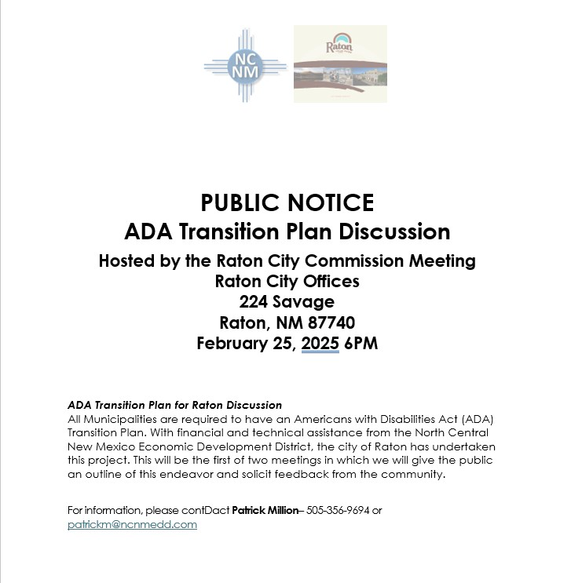
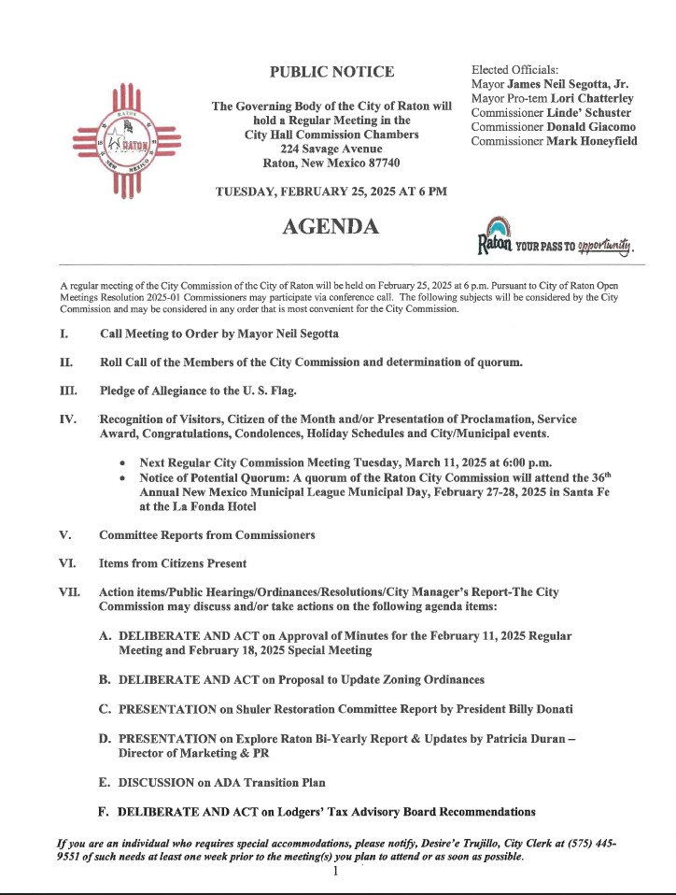

National Cooperative Highway Research Program NCHRP Project Number 20-7 dated May 2009.

