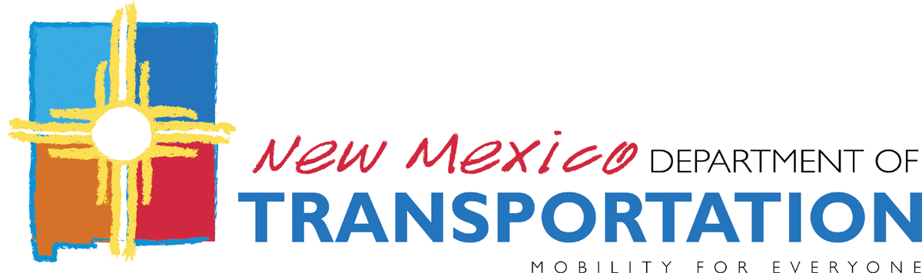

MEMORANDUM

Date: February12, 2014
From: Steve Eagan, Safety Project Engineer, Traffic Technical Support Bureau
To: NMDOT Staff, NM MPOs, NM RTPOs
Subject: New Mexico Highway Safety Improvement Program:
FFY 2014 2015 2016 and 2017 Solicitation for Safety Project Applications

As part of the mission of the New Mexico Highway Safety Improvement Program (NM HSIP), to reduce traffic crashes causing fatalities and serious injuries in New Mexico, the New Mexico Department of Transportation (NMDOT)issues this announcement soliciting proposals for either engineering type stand-alone transportation safety improvement projects or non-construction transportation safety programs for consideration for discretionary funding in the appropriate current FFY 2014 and forthcoming FFY 2015, 2016, and 2017 program years of the current NM State Transportation Improvement Program (STIP).Total annual federal safety funding levels authorized to New Mexico are in the area of $20,000,000.

See attachment for the NM HSIP Safety Project/ ProgramForm andInstructions.

Local governments must send their applications first to their respective Metropolitan Planning Organization (MPO) or Regional Transportation Planning Organization (RTPO) for review, processing, and approval and then have the MPO or RTPO submit the applications to the NMDOT General Office, Traffic Technical Support Bureau.

As youwillnotice the planning safety project/ program review phase of the NM HSIP is now a continuous year-round program with no set deadlines for submitting applications. Every 90 days (orincase of an urgent need for quicker reviews evenmore frequently) the NM HSIP Safety ProjectSelection Committee will review andtake action on each application that have been receivedduring that time period by the NMDOT General Office Traffic TechnicalSupportBureau.

Also, the NM HSIP will now accept direct applications for road safety audits under established guidelines using Federal HSIP funds to further study specific roadway locations for significant evidence of traffic hazard exposure that could justify a follow-up application for an appropriate safety countermeasure project or program.

Also, there are new members added to the NM HSIP Safety Project Selection Committee. Rotating every 90 days by a method that each of three groups can choose amongst themselves are the 6-member NMDOT District Traffic Engineers group, the 5-member MPOs group, and the 9-member RTPOs group. Each group can name one voting representative member to serve on the Committee for the next 90 day period.

Questions? Contact: Steve Eagan, Safety Project Engineer, Traffic Technical Support Bureau, NMDOT, Email: steve.eagan@state.nm.us Phone: 505-476-3545

